

**MOTEL SYSTEM**

**Software Requirement Specification**

– Hanoi, May 2022 –

**Record of changeS**

| **Date** | **A* M, D** | **In charge** | **Change Description** |
| --- | --- | --- | --- |
|  |  |  |  |
|  |  |  |  |
|  |  |  |  |
|  |  |  |  |
|  |  |  |  |
|  |  |  |  |
|  |  |  |  |
|  |  |  |  |
|  |  |  |  |
|  |  |  |  |
|  |  |  |  |
|  |  |  |  |
|  |  |  |  |

*A - Added M - Modified D - Deleted

**Table of Contents**

I. Overview 5

1. Introduction 5

2. System Functions 6

II. Functional Requirements 9

1. View Post 11

a.Home/View Post11

b.Home/Search Post 12

c.PostDetail 13

2. Login 10

a.Choose role 10

b.Login account 10

3.Create Account 10

a.Register account 10

4.Change password 11

a. Forgot password 11

b. Change password 11

5.Manage Account by Admin 12

a.View list account

b.Delete

c.Update

d.Search

e.Sort 12

f.View detail 12

6.Manage Motel by Admin 13

a.View list motel

b.Delete

c.Update

d.Search

e.Sort

f.View detail 13

7.Manage Post by Admin 14

a.View list post

b.Delete

c.Update

d.Search

e.Sort

f.View detail 12

8.Manage Account Profile 14

a.View account profile 14

9.Manage Request by Admin

a.View list request

b.Delete

c.Update

d.Search

e.Sort

f.View detail

10. Manage Room By Host

a.View list room

b.Create

c.Update | ViewDetails

d.Delete

e.Search

c.Sort

11. Manage Services By Host

a.View list Services

b.Create

c.Update

d.Delete

e.Search

c.Sort

12. Manage Bill By Host 41

a.View all Bill by host 41

b.Delete Bill by host 41

c. Update Bill by host 42

d.Sort Bill by host 43

e. Search bill by host 43

f. View bill detail by host 4

13. Manage Request By Host 40

a.View all room by host 40

b.Delete request by host 41

c. Search request by host 41

d.Sort request by host 42

e. Show details of requests from rooms 42

14. Filter Post 47

15. Manage Post By Host 48

a.View all post by host 48

b.Delete post by host 48

c. Search post by host 49

d. Sort post by host 49

e. Update post by host 49

f. Add new post by host 50

16. Manage Motel By Host 48

a.View all Motel by host 48

b.Update Motel by host 48

c. Delete Motel by host 49

d. View detail Motel by host 49

e. Search Motel by host 49

f. Sort new post by host 50

17. Manage Message By Host/Customer 41

a.View all message 41

b.Send message 41

c. Rep message 42

d.Search message 43

e. Sort message 43

18. Manage Request By Customer 48

a.View all Motel by host 48

b.Add Motel by host 48

c. Update Motel by host 49

d. Delete detail Motel by host 49

e. Search Motel by host 49

f. Sort new post by host 50

# I. Overview

## 1. Introduction

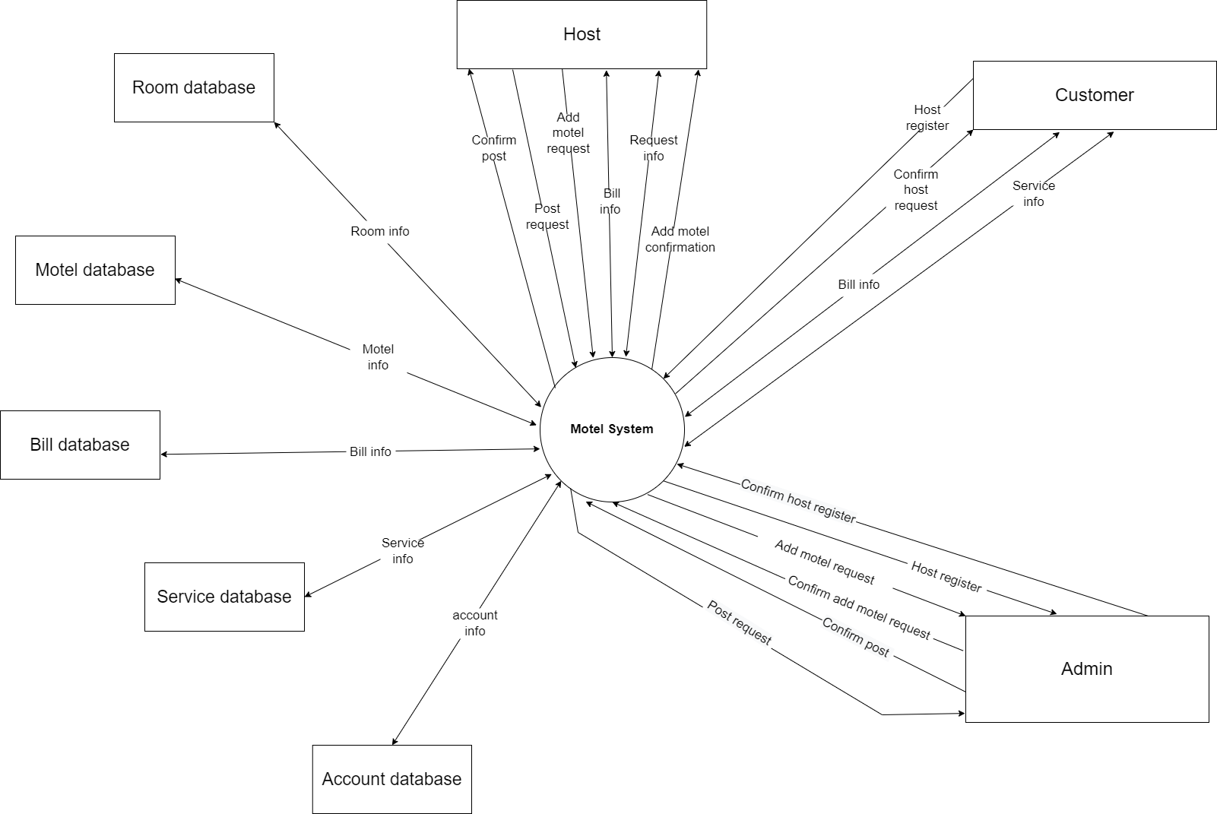

2. System Functions

#### a. Screen Flow

#### 

#### b. Screen Details

| **#** | **Feature** | **Screen** | **Description** |
| --- | --- | --- | --- |
| 1 | Login Account | Login | User input account name and password to login Home page |
| 2 | Create Account | Login | User create their account by account name, password, phone, Email |
| 3 | Change Password | Login | User can change password by some condition(User not yet login) |
| 4 | Manage Account by Admin | ManageAccountAdmin | View, add, update role for account, delete account by Admin |
| 5 | Manage Motel by Admin | ManageMotelAdmin | View, add, delete motel by Admin |
| 6 | Manage Post by Admin | ManagePostAdmin | View, add, Update status for post, delete by Admin |
| 7 | Search Post | Home | Search posts by keyword |
| 8 | View Post | Home | View posts by user |
| 9 | Manage Account Profile | Home | Update information for account |
| 10 | Choose Admin | Choose Role Login | Login by Admin |
| 11 | Choose Host | Choose Role Login | Login by Host |
| 12 | Choose Customer | Choose Role Login | Login by Customer |
| 13 | Manage Room By Host | Manage Room Host Screen | View, add, update, delete room of account |
| 14 | Manage Services By Host | Manage Services Host Screen | View, add, update, delete services of account |
| 15 | Manage Request By Admin | ManageRequestAdmin | View, update, delete request of user |
| 16 | Manage Bill By Host | Manage Bill Host | View, update, delete bill |
| 17 | Manage Message By Host | ManageMessageHost | View, add, rep, search, sort message |
| 18 | Manage Motel By Host | ManageMotelHost | View, add, update, delete, view detail, search, sort motel |
| 19 | Manage Bill By Customer | ManageBillCustomer | View, confirm, view detail bill |
| 20 | Register Motel By Customer | RegisterMotelCustomer | Register new motel in system by customer |

#### c. User Authorization

| **Screen** | **Admin** | **Host** | **Customer** | **Role 1** |
| --- | --- | --- | --- | --- |
| Choose Role Login | x | x | x | x |
| Login | x | x | x |  |
| Home | x | x | x | x |
| AdminScreen | x |  |  |  |
| ManageAccountAdmin | x |  |  |  |
| ManageMotelAdmin | x |  |  |  |
| ManagePostAdmin | x |  |  |  |
| CreateAccount | x | x | x | x |
| AccountProfile | x | x | x |  |
| ManageRequestAdmin | x |  |  |  |
| ManageRequestByAdmin | x |  |  |  |
| ManageRoomByHost |  | x |  |  |
| ManageServicesByHost |  | x |  |  |
| ManageBillByHost |  | x |  |  |
| ManageMessageHost |  | x |  |  |
| ManageMotelHost |  | x |  |  |
| ManageBillByCustomer |  |  | x |  |
| RegisterMotelByCustomer |  |  | x |  |

In which:

* Admin: Can manage everything in webpage
* Host: The motel owner
* Customer: Tenant
* Role 1: User not yet login in webpage

#### d. Non-Screen Functions

| **#** | **Feature** | **System Function** | **Description** |
| --- | --- | --- | --- |
| 1 | Change Password | Forgot password | User can change password by some condition |

# II. Functional Requirements

## View Post

**a. View post**

* **Function trigger**: When user login successfully
* **Function description**: view all posts
* **Screen layout**:

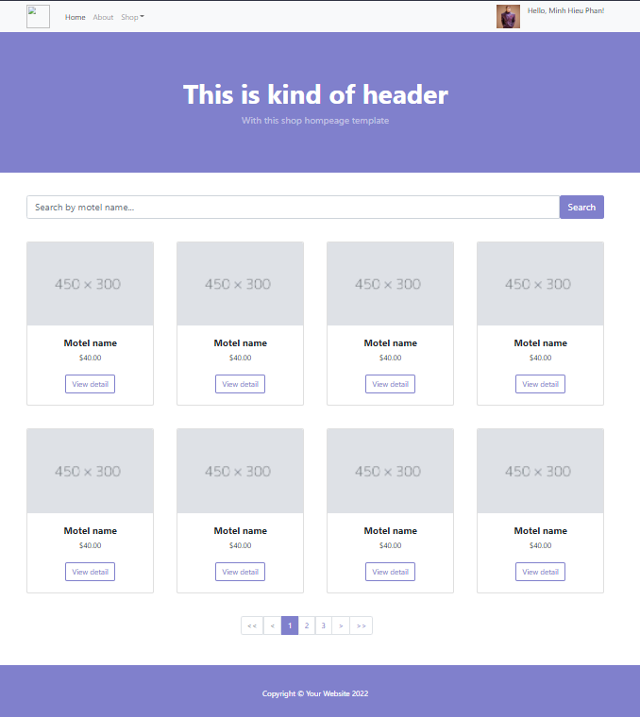

* **Function detail**: User login successfully to system, then redirect user to home page

**b. Search post**

* **Function trigger**: When user input in search bar then click search button
* **Function description**: view only post that have motel name equal user input in search bar
* **Screen layout**:



* **Function detail**: User enter text on input type text name search, only post with motel name equal input of user may appear.

**c. View detail of post**

* **Function trigger**: anyone click on see detail button on each div card can access to servlet post detail then see detail of the post they clicked before
* **Function description**: display all information that needed in a post and its own image
* **Screen layout**:

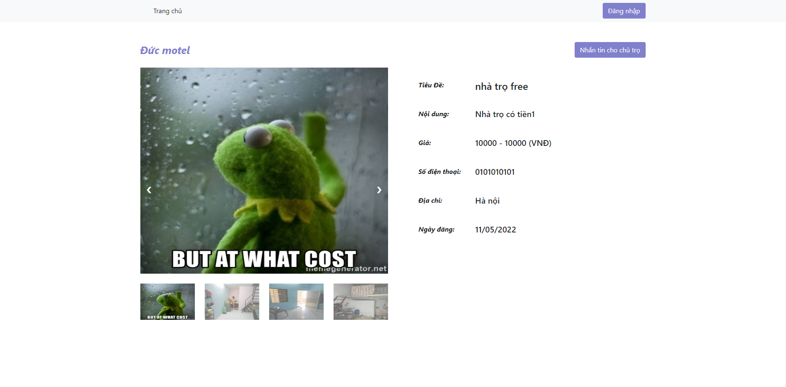

* **Function Details**: when user browse on the home page, then click on button view detail on card that contains a post, this screen will show up then let user see detail of post that they want to see by clicking on see detail button

1. **Login**

**a. Choose role**

* **Function trigger**: home page -> login
* **Function description**: Select the functions to log in
* **Screen layout**: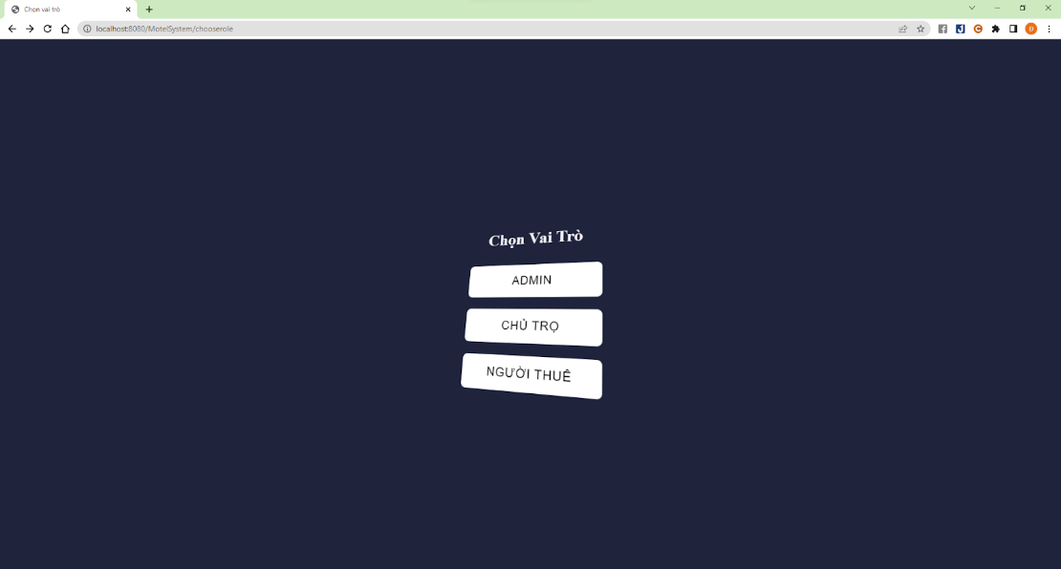
* **Function details**: User selects admin to login as admin, selects host to login as host, selects customer to login as customer

**b. Login account**

* **Function trigger**: Choose role -> login
* **Function description**: Used to login
* **Screen layout**:

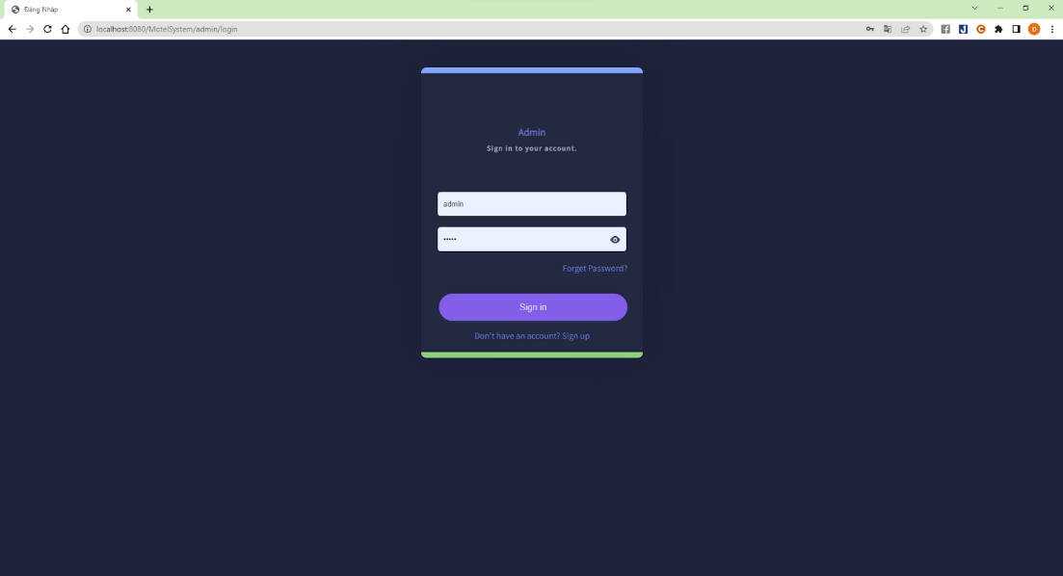

* **Function details**: User enter username and password and click on login button to login as previously selected user.

## 3. Create Account

### a. Register Account

* **Function trigger**: When users go to the login page without an account, they can choose the link to register for an account to create a new account.
* **Function description**: Create a new account for the user by user name, full name, password, phone, address, DOB, gender, imageProfile, Email.
* **Screen layout**: Register Account screen

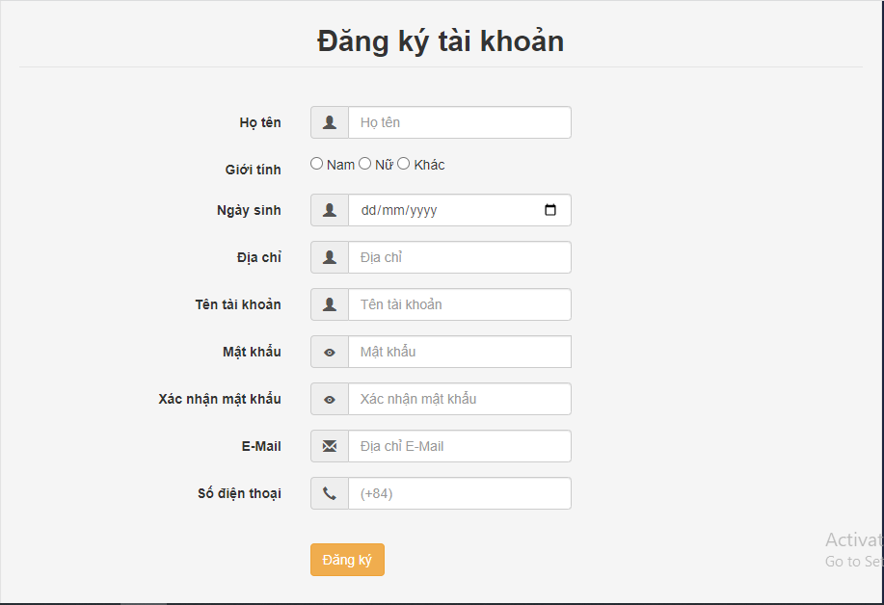

* **Function Details**: Users will enter the information that the system needs to create a new account, then click the “Register” button to let the system create an account for them.

## 4. Change Password

**a. Forgot password**

* **Function trigger**: When user want to login in but they forgot their password and click in link “Forgot password”.
* **Function description**: Send a random password and send an email to corresponding account to notify.
* **Screen layout**:

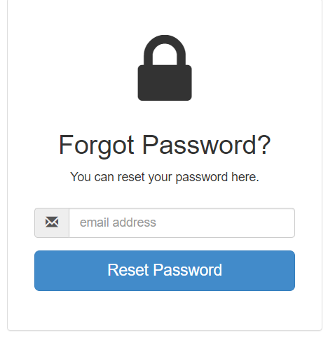

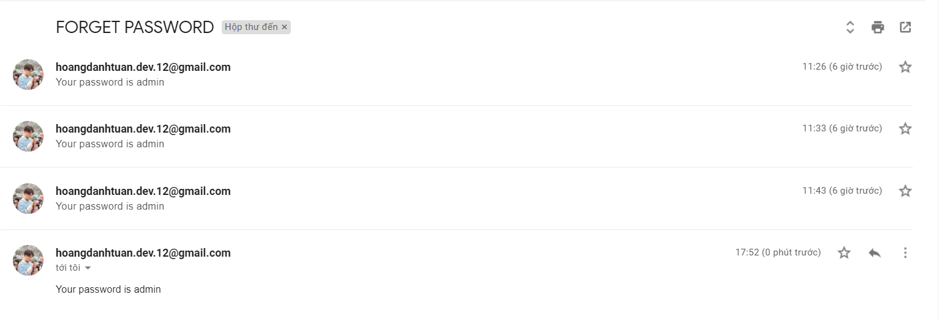

* **Function Details**: when user enter email address, the system will send a random password to email -> User can use it to login

**b. Change password**

**Function trigger:** After entering the correct old password, the new password and re-entering the new password successfully, the password will be changed

* Function description: Change account password
* **Screen layout:**

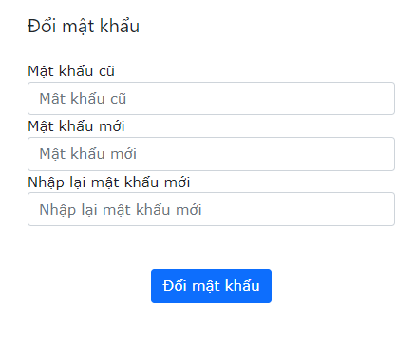

* **Function Detail:** On the homepage, the user clicks "See my profile" to fly to the profile page and change the password. The user enters the correct old password, the new password then presses change password (if successful, it will fly to the login page, otherwise it will not be changed)

## 5. Manage Account by Admin

### a. View list account

* **Function trigger**: admin click on the management account button, then the page will be navigated through the account management page, which will display the list of user accounts.
* **Function description**: display list account of all user , admin can add new account, delete account, update role of account, search for an account by the character contained in the information fields.
* **Screen layout**:

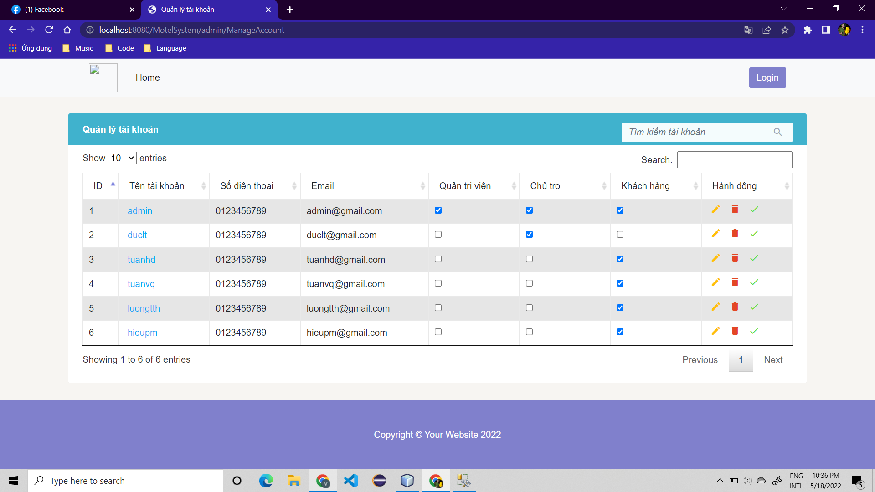

* **Function Details**: When the administrator logs in, selects the manage account button, and a page will appear showing the information of the account that the user has registered.

### b. Delete

* **Function trigger**: In ManageAccountAdmin, Admin click to delete account
* **Function description**: Delete account violate by Admin
* **Screen layout**:

before delete

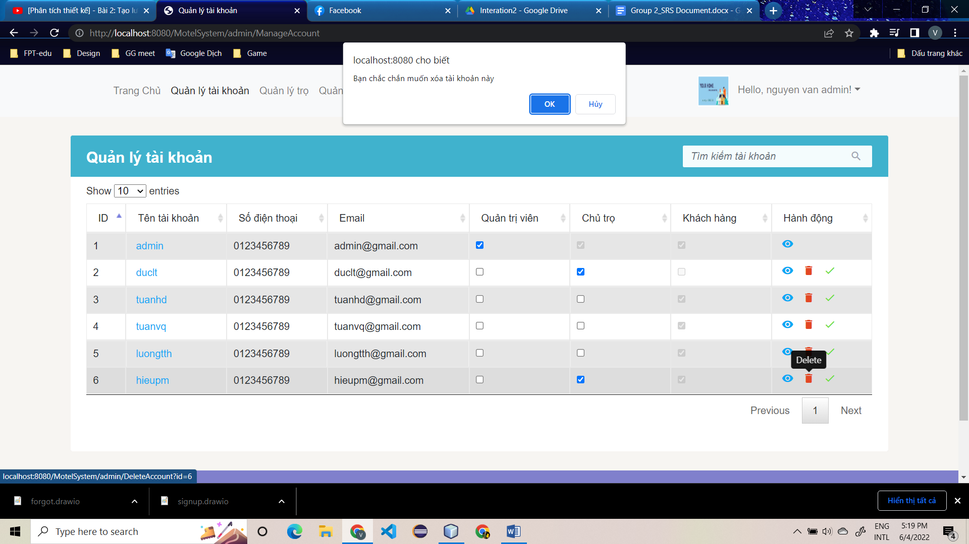

after delete

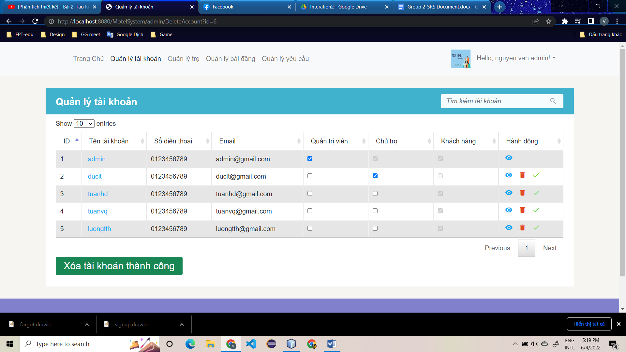

* **Function Details**: When Admin click to delete and confirm to delete account, system delete all motel of this account or delete all booking of account then delete account

### c. Update

* **Function trigger**: In ManageAccountAdmin, Admin choose role for account and click to save and send an email to corresponding account to notify.
* **Function description**: Update role for account
* **Screen layout**:

before update

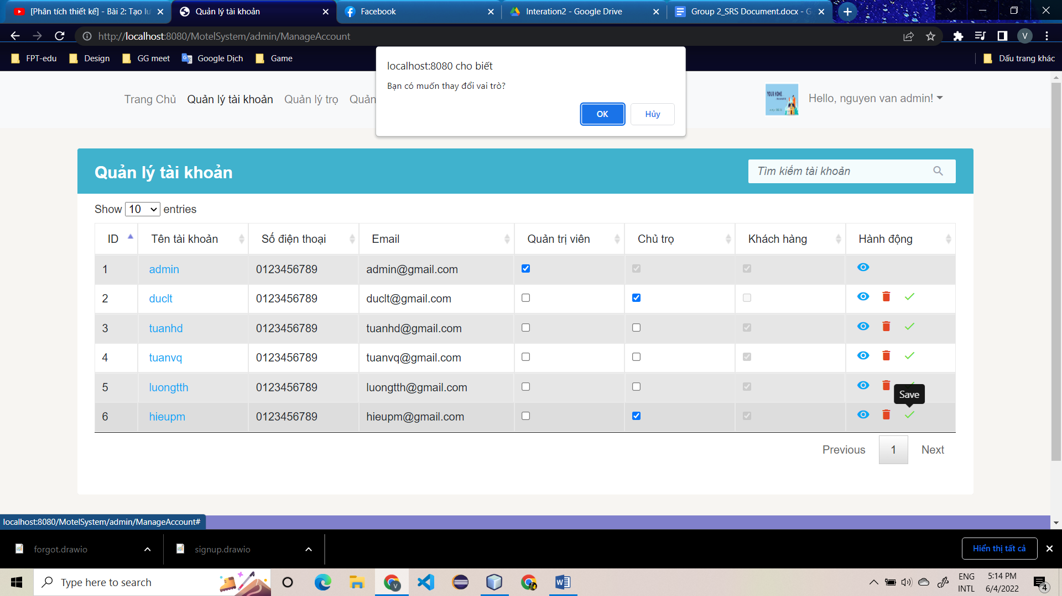

after update

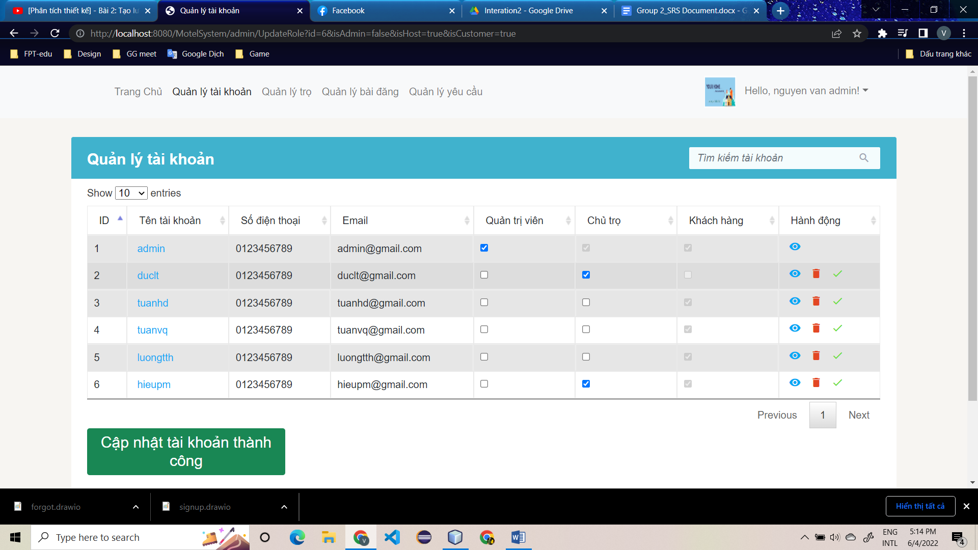

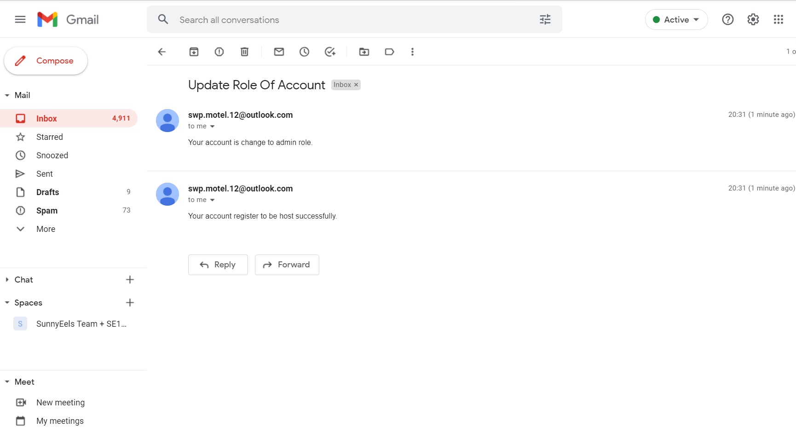

* **Function Details**: When Admin choose new role and click to save, and confirm update role for account then system add new role for this account and send an email to corresponding account to notify.

### d. Search

* **Function trigger**: Admin write keyword to search account
* **Function description**: Search account by keyword
* **Screen layout**:

before search

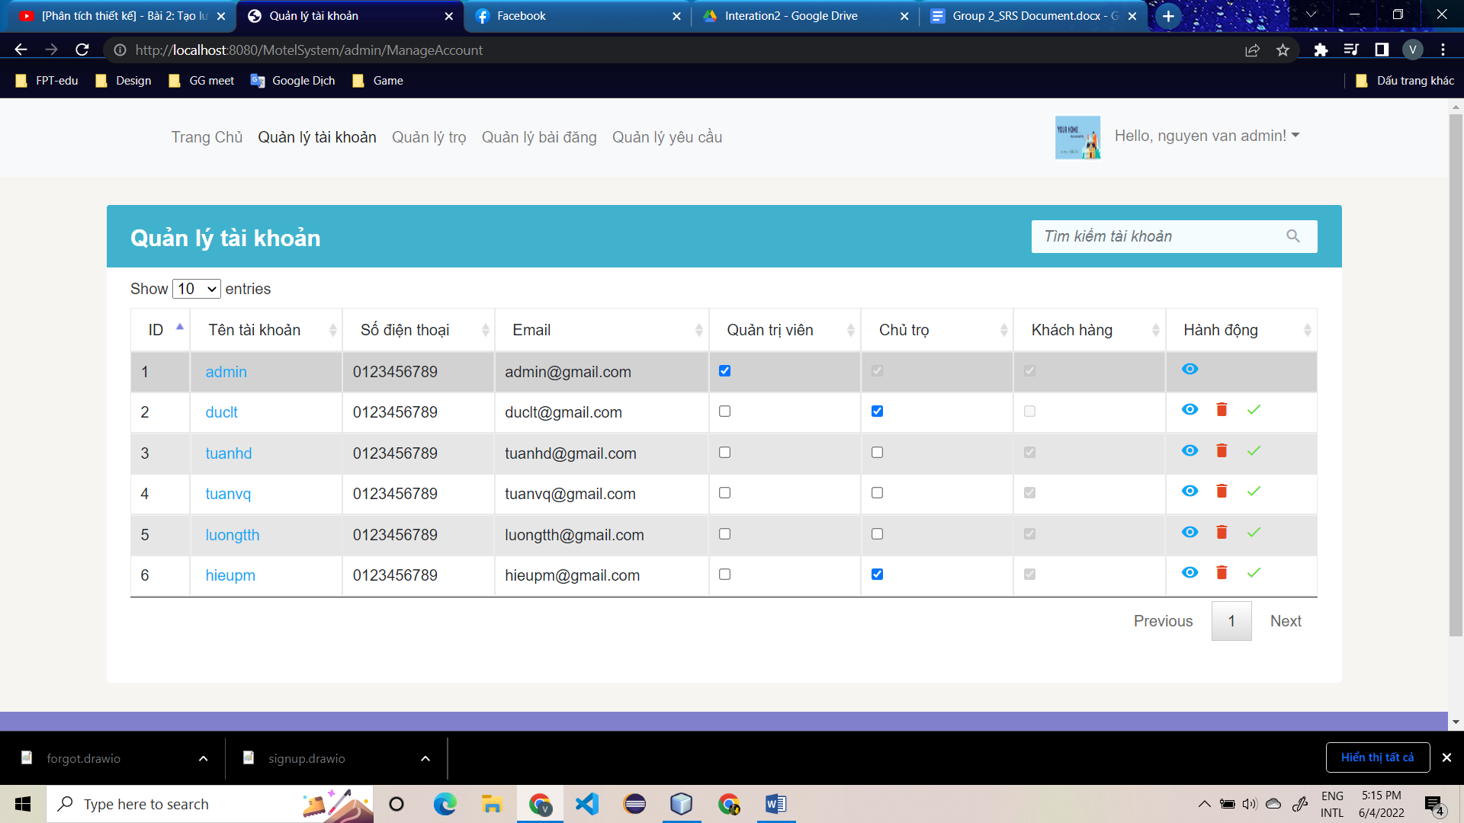

after search

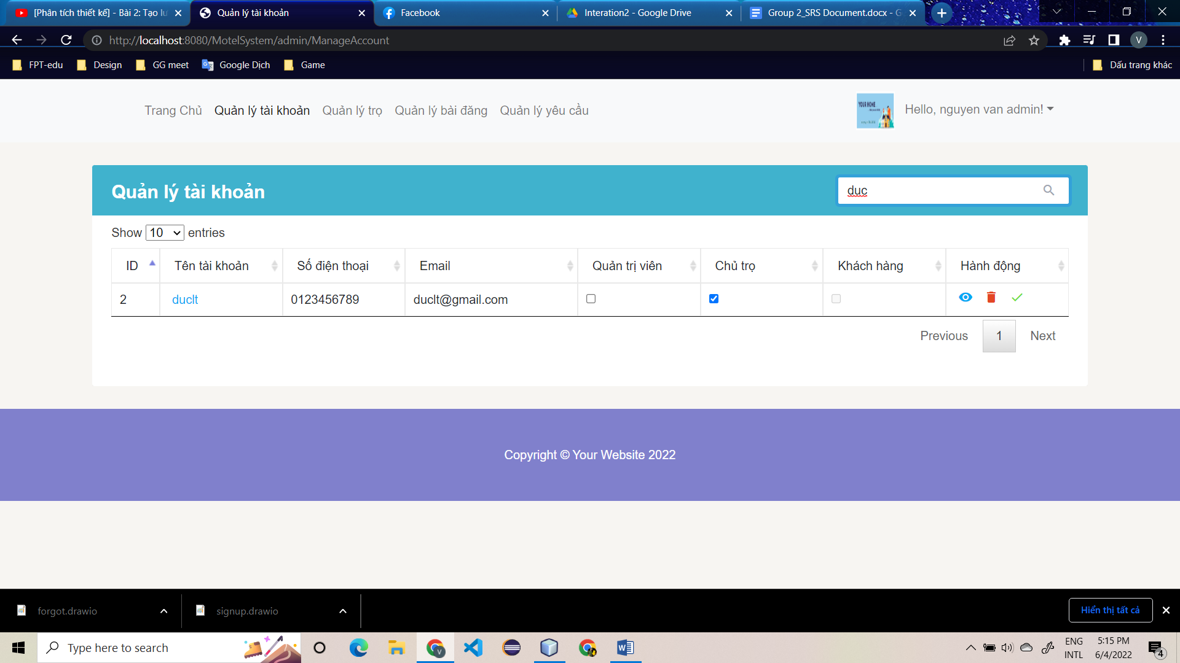

* **Function Details**: Admin write keyword and system will find account contain this keyword

### e. Sort

* **Function trigger**: Admin click to sort in each column
* **Function description**: Sort by column
* **Screen layout**:

before search

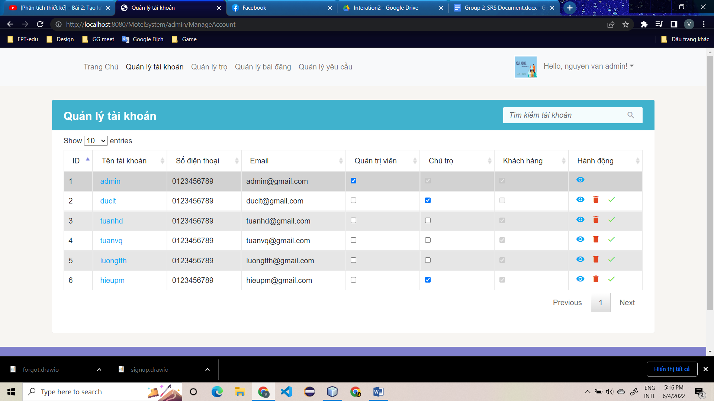

after sort

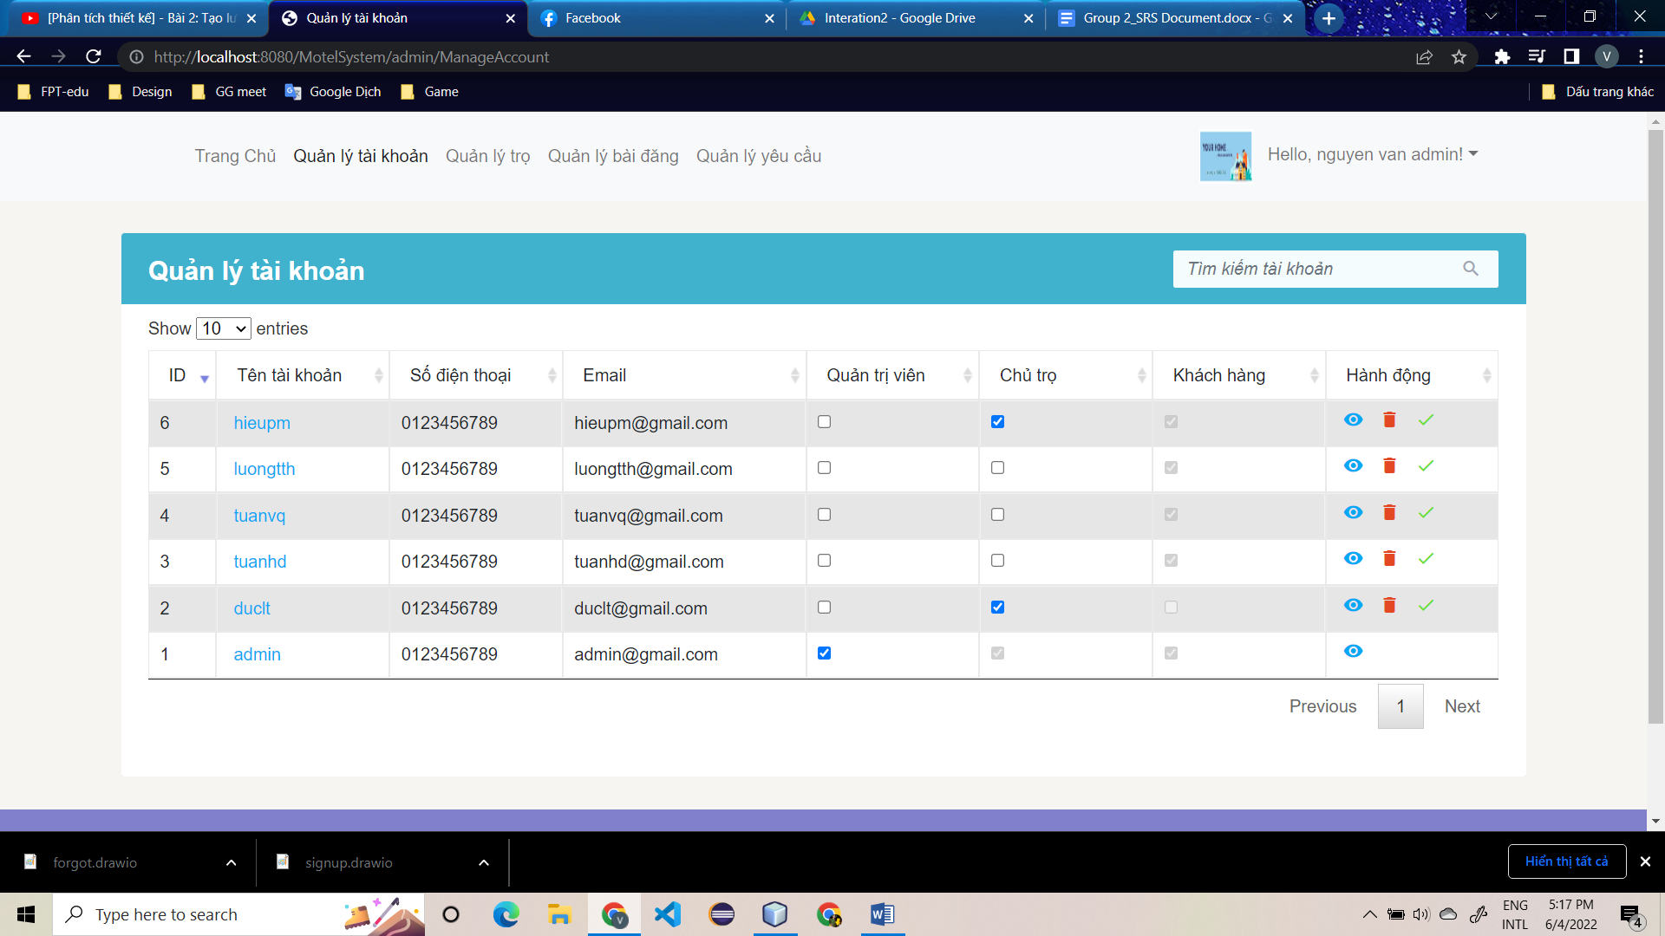

* **Function Details**: Admin click to sort in each column the system will display the information in sorted order

### f. View detail

* **Function trigger**: Admin click to view detail to view infomation about this account
* **Function description**: View all information of account
* **Screen layout**:
* 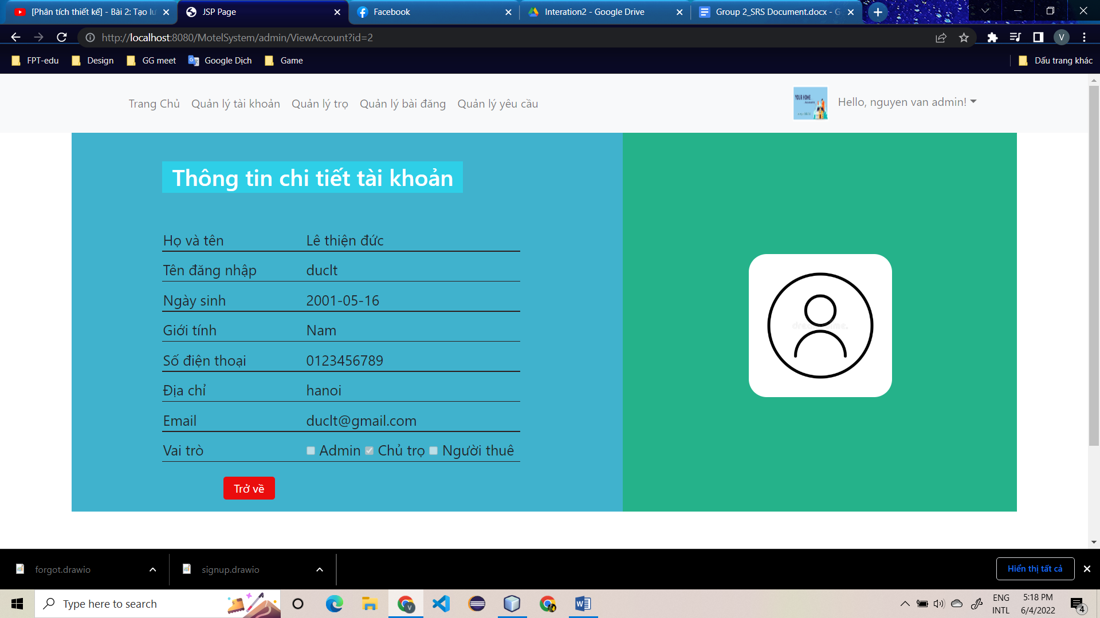
* **Function Details**: Admin click to view detail then system will change page to view detail of account

## 6. Manage Motel by Admin

**a. View list motel**

* **Function trigger**: admin click on the manage motel button, then the page will be navigated through the motel management page, which will display the list of motels
* **Function description**: display list motel of all host, admin can add new motel, delete motel, search for a motel by the character contained in the information fields.
* **Screen layout**:

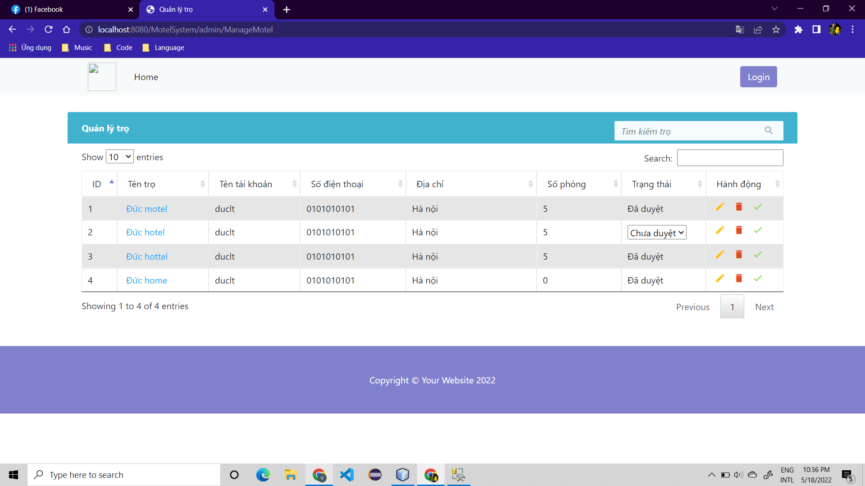

* **Function Details**: When the administrator logs in, selects the manage motel button, and a page will appear showing the information list of motel

### b. Delete

* **Function trigger**: In ManageMotelAdmin, Admin click to delete motel
* **Function description**: Delete motel violate by Admin and send an email to corresponding host to notify.
* **Screen layout**:

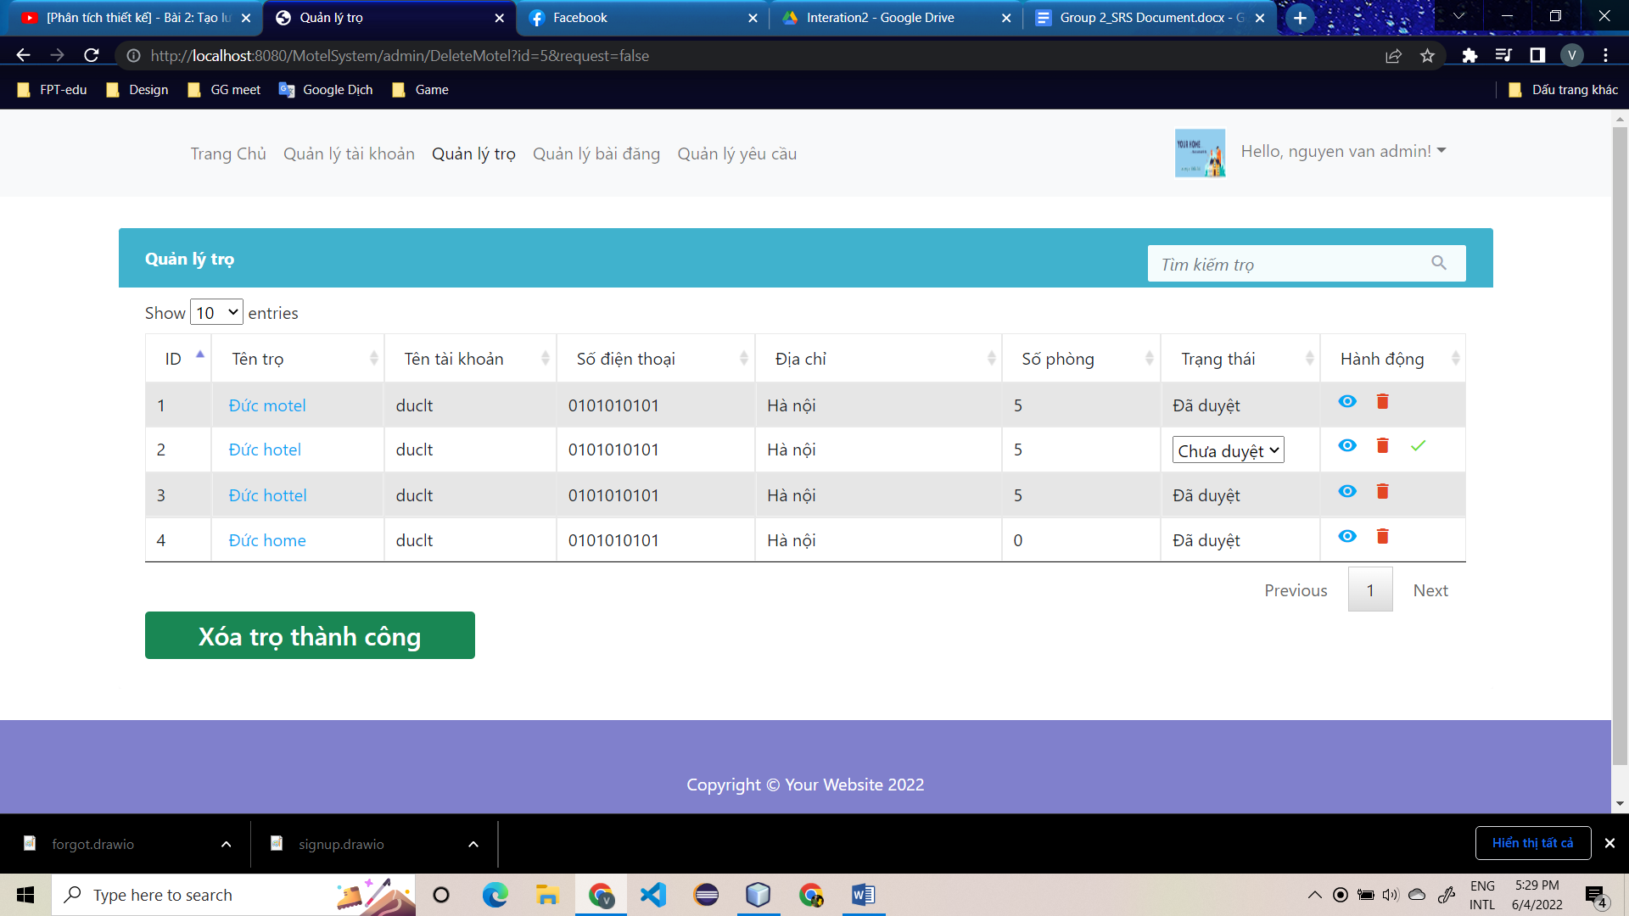

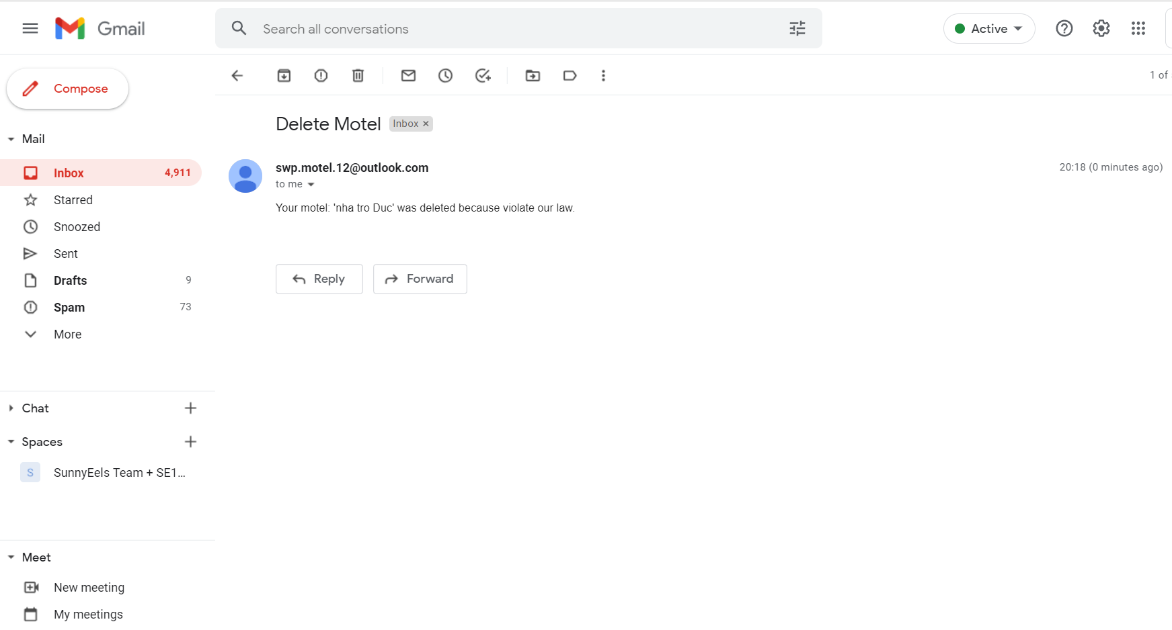

* **Function Details**: When Admin click to delete and confirm to delete motel, system delete all room of this motel then delete motel and send an email to corresponding host to notify.

### c. Update

* **Function trigger**: In ManageMotelAdmin, Admin change status of motel and click to save
* **Function description**: Update status for motel and send an email to corresponding host to notify.
* **Screen layout**:

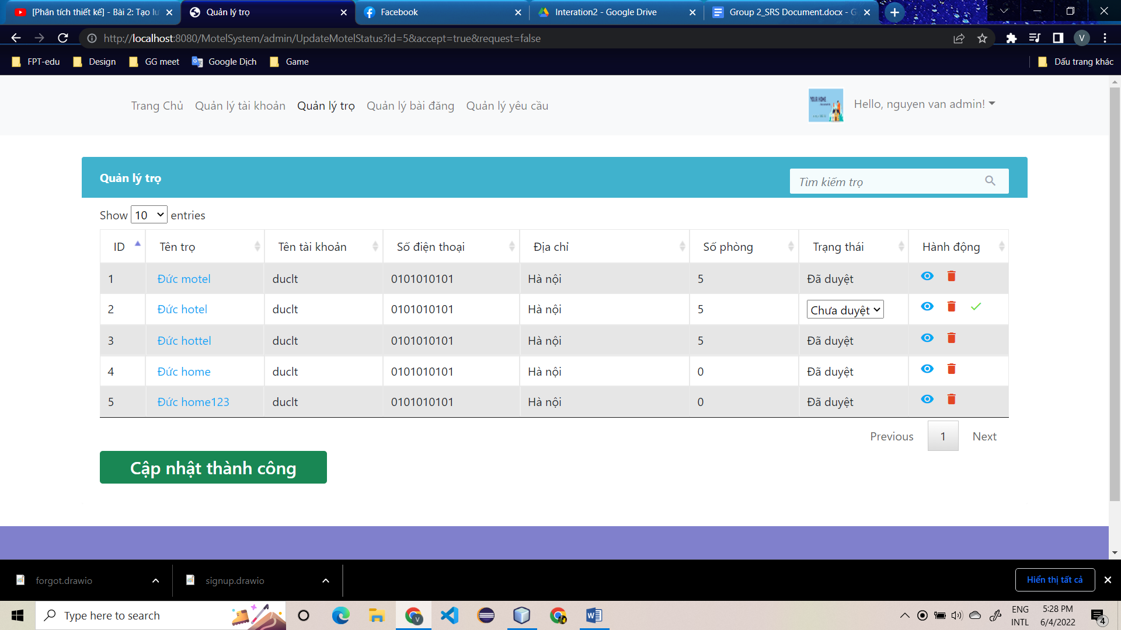

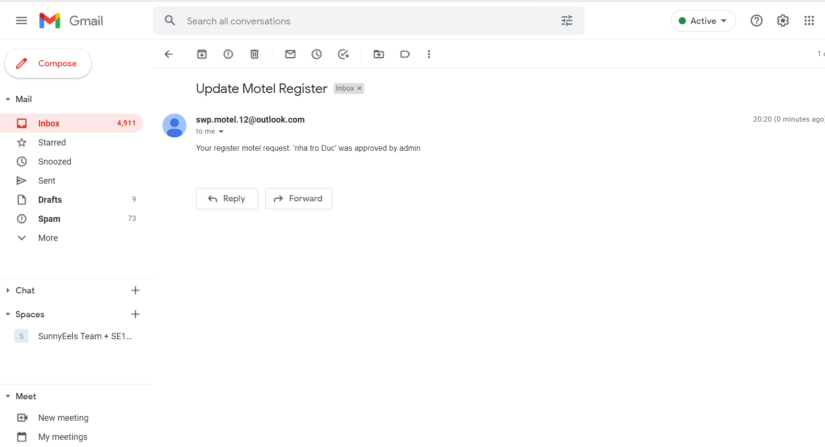

* **Function Details**: When Admin change status and click to save, and confirm update status for motel then system update status for this motel and send an email to corresponding host to notify.

### d. Search

* **Function trigger**: Admin write keyword to search motel
* **Function description**: Search account by keyword
* **Screen layout**:

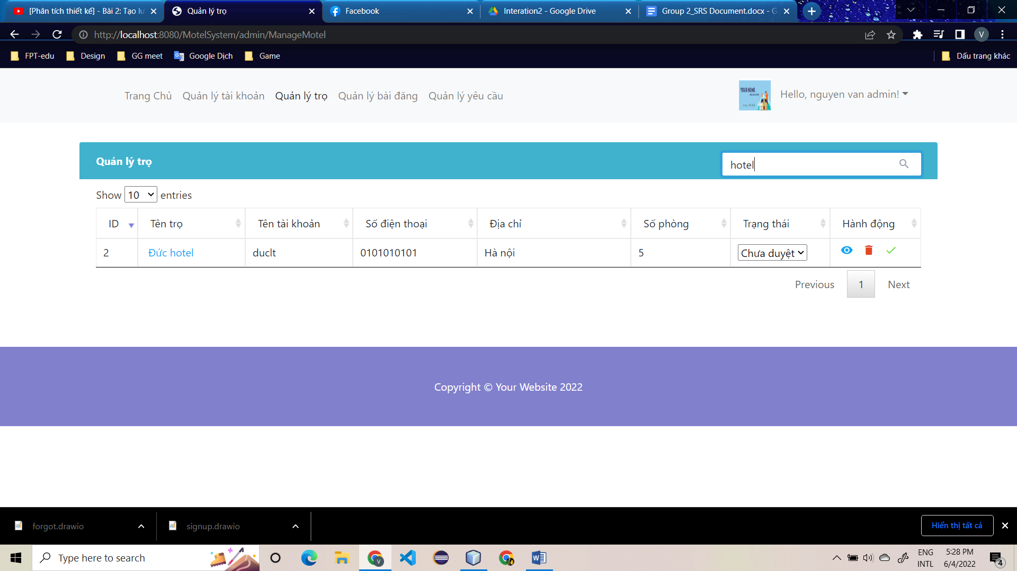

* **Function Details**: Admin write keyword and system will find motel contain this keyword

### e. Sort

* **Function trigger**: Admin click to sort in each column
* **Function description**: Sort by column
* **Screen layout**:
* 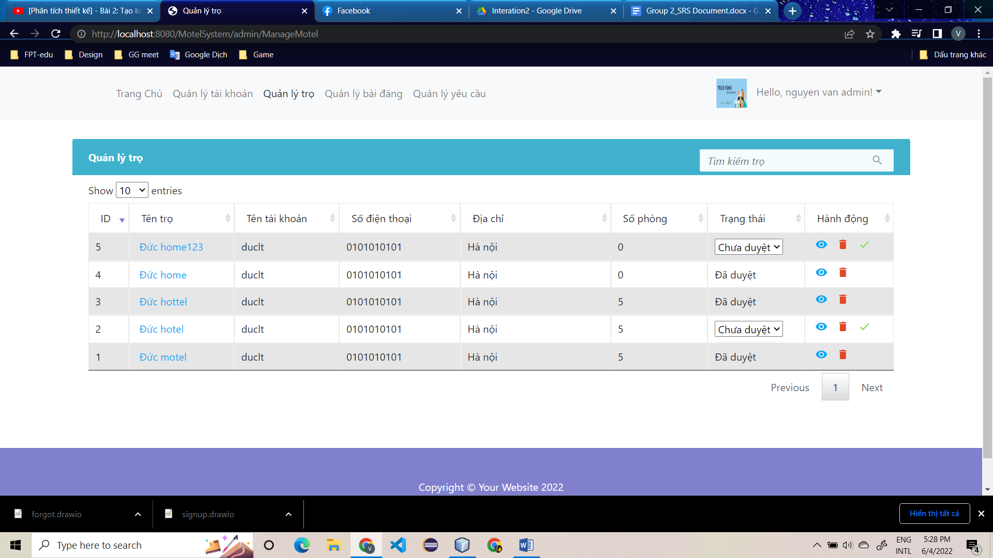

**Function Details**: Admin click to sort in each column the system will display the information in sorted order

### f. View detail

* **Function trigger**: Admin click to view detail to view infomation about this motel
* **Function description**: View all information of motel
* **Screen layout**:

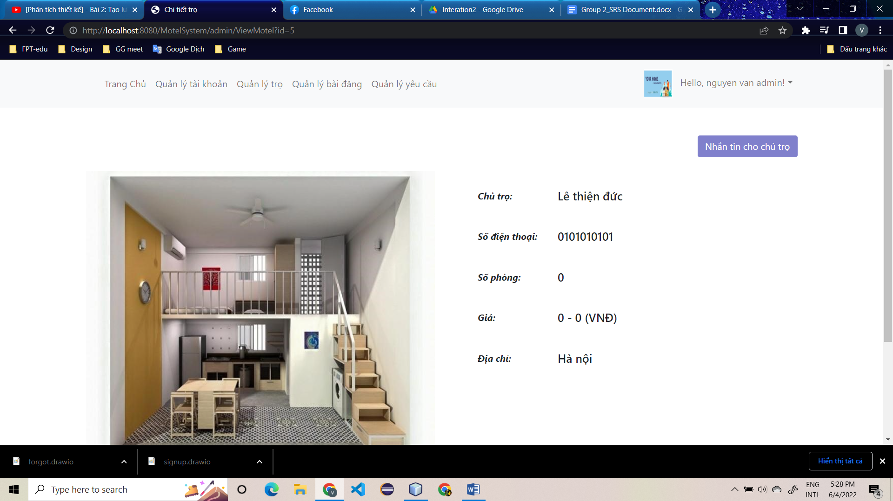

* **Function Details**: Admin click to view detail then system will change page to view detail of motel

## 7. Manage Post by Admin

### a. View list post

* **Function trigger**: admin click on the manage post button, then the page will be navigated through the post management page, which will display the list of posts
* **Function description**: display list post of all host, admin can add new post, delete post, update post, search for a post by the character contained in the information fields
* **Screen layout**:

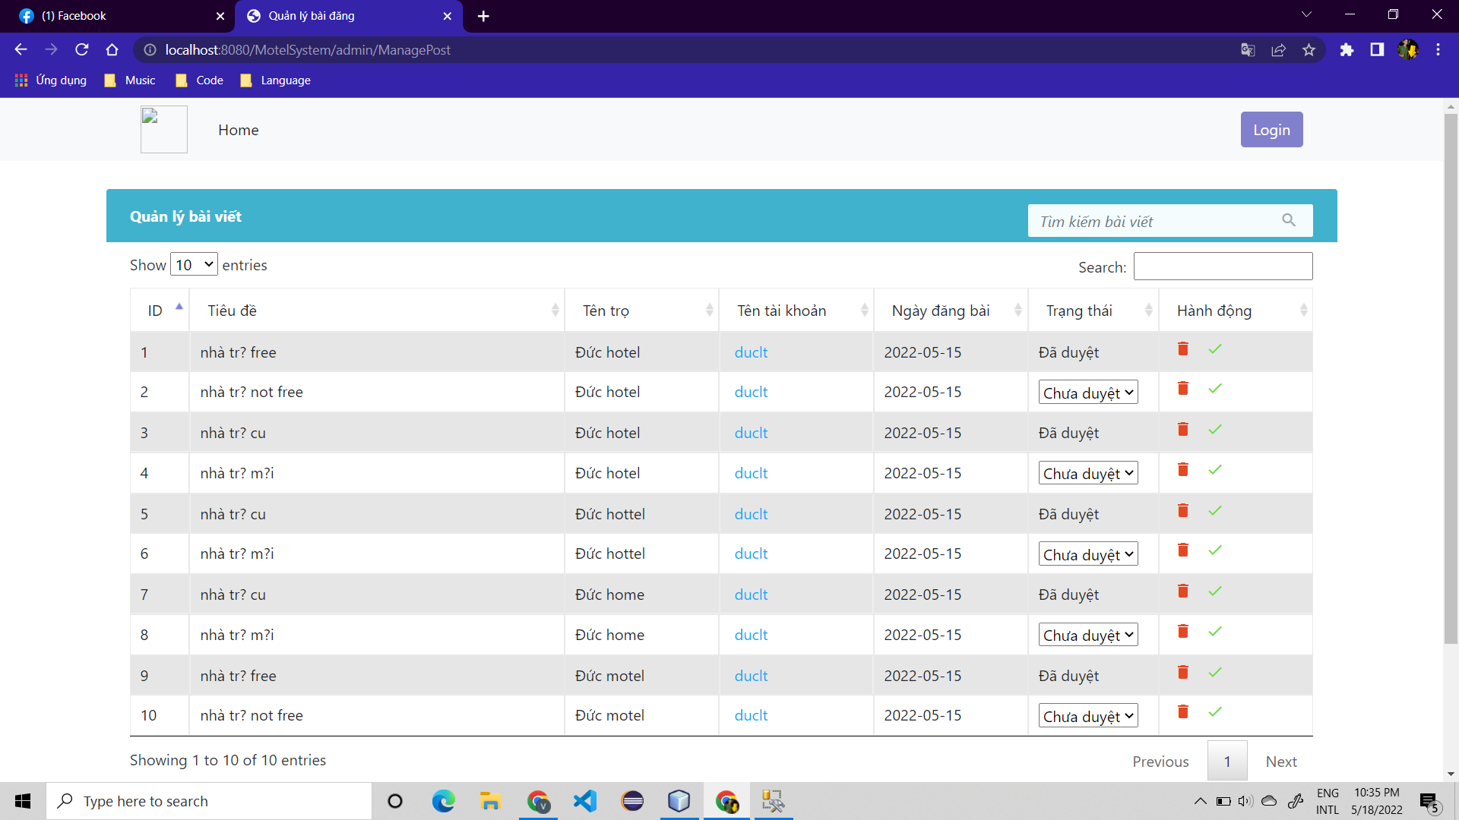

* **Function Details**: When the administrator logs in, selects the manage post button, and a page will appear showing the information list of post

### b. Delete

* **Function trigger**: In ManagePostAdmin, Admin click to delete post
* **Function description**: Delete post violate by Admin and send an email to corresponding host to notify
* **Screen layout**:

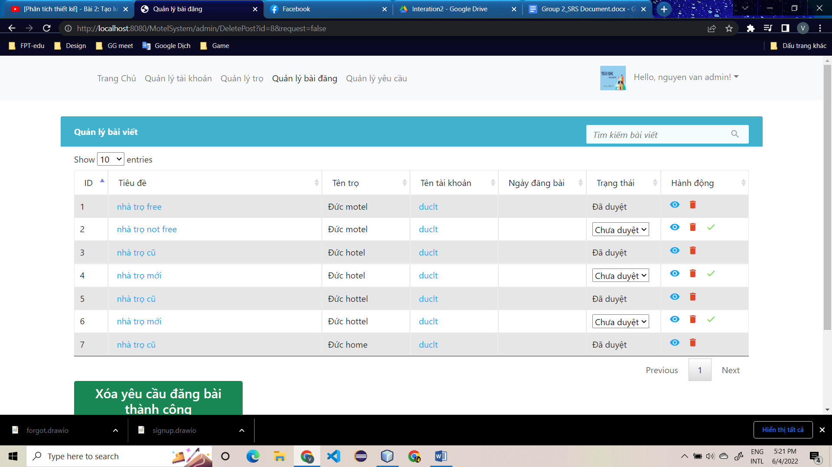

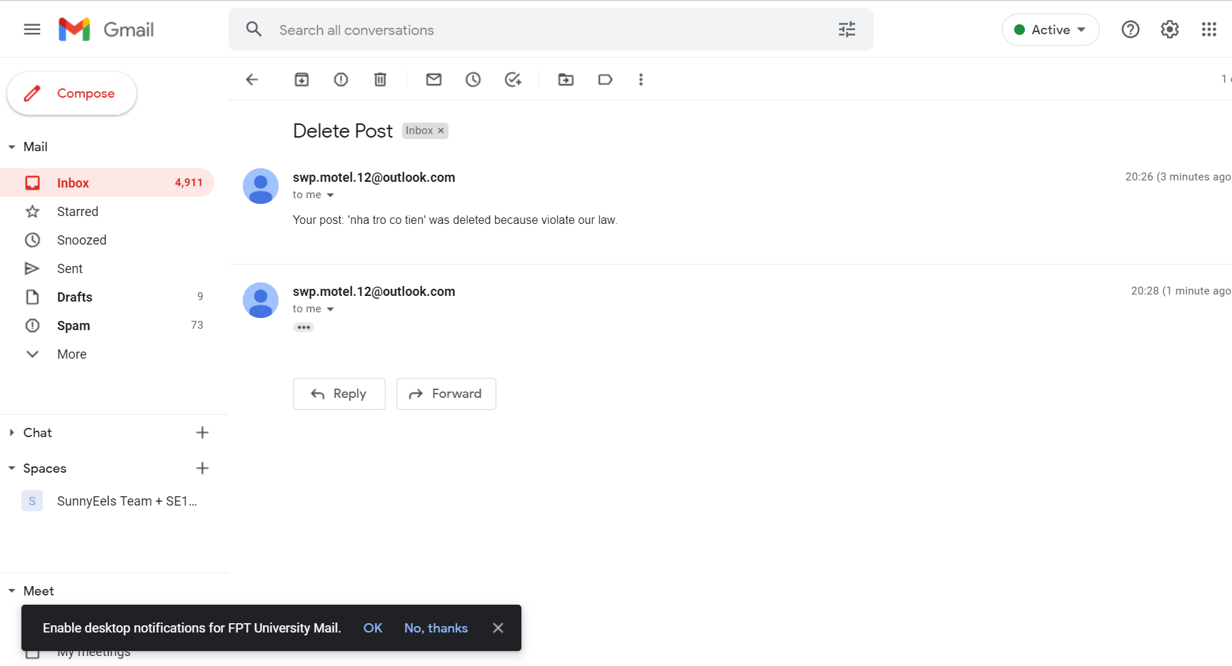

* **Function Details**: When Admin click to delete and confirm to delete post, system delete post and send an email to corresponding host to notify.

### c. Update

* **Function trigger**:In ManageMotelAdmin, Admin change status of post and click to save
* **Function description**: Update status for post and send an email to corresponding host to notify.
* **Screen layout**:

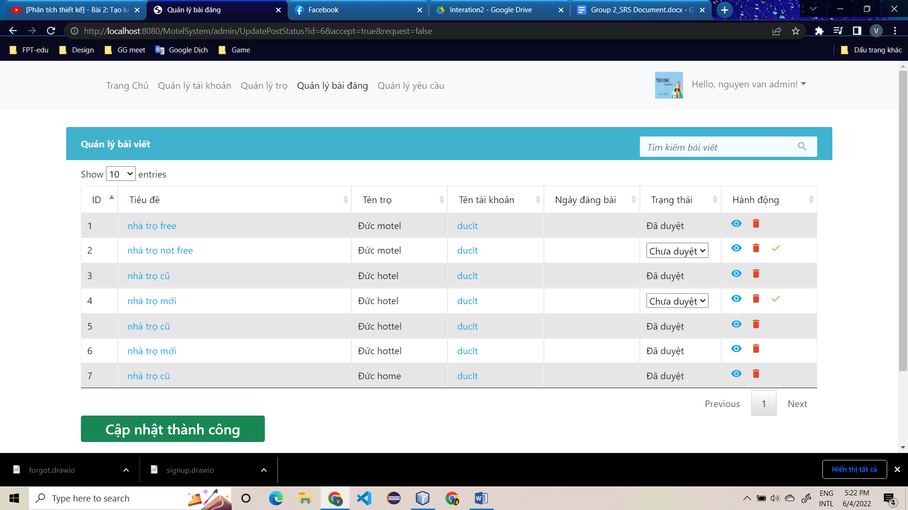

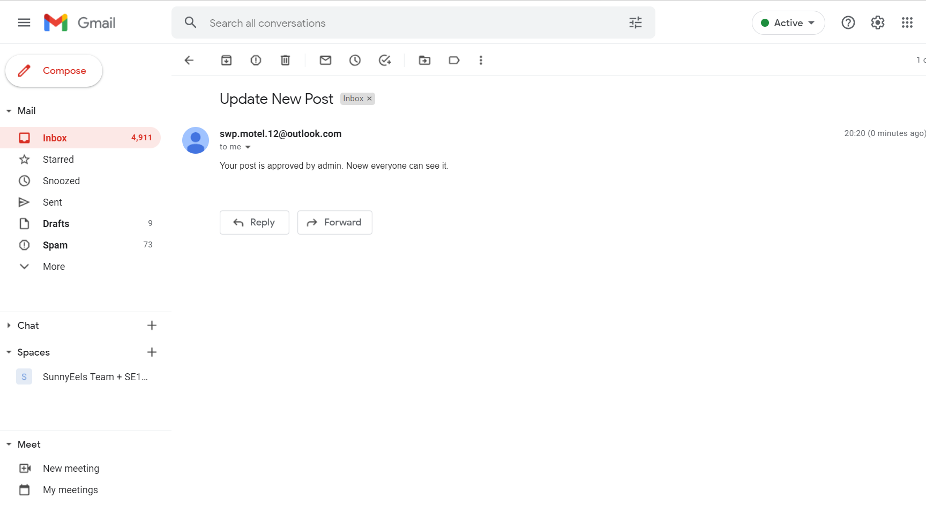

* **Function Details**: When Admin change status and click to save, and confirm update status for post then system update status for this post and send an email to corresponding host to notify.

### d. Search

* **Function trigger**: Admin write keyword to search post
* **Function description**: Search account by keyword
* **Screen layout**:
* 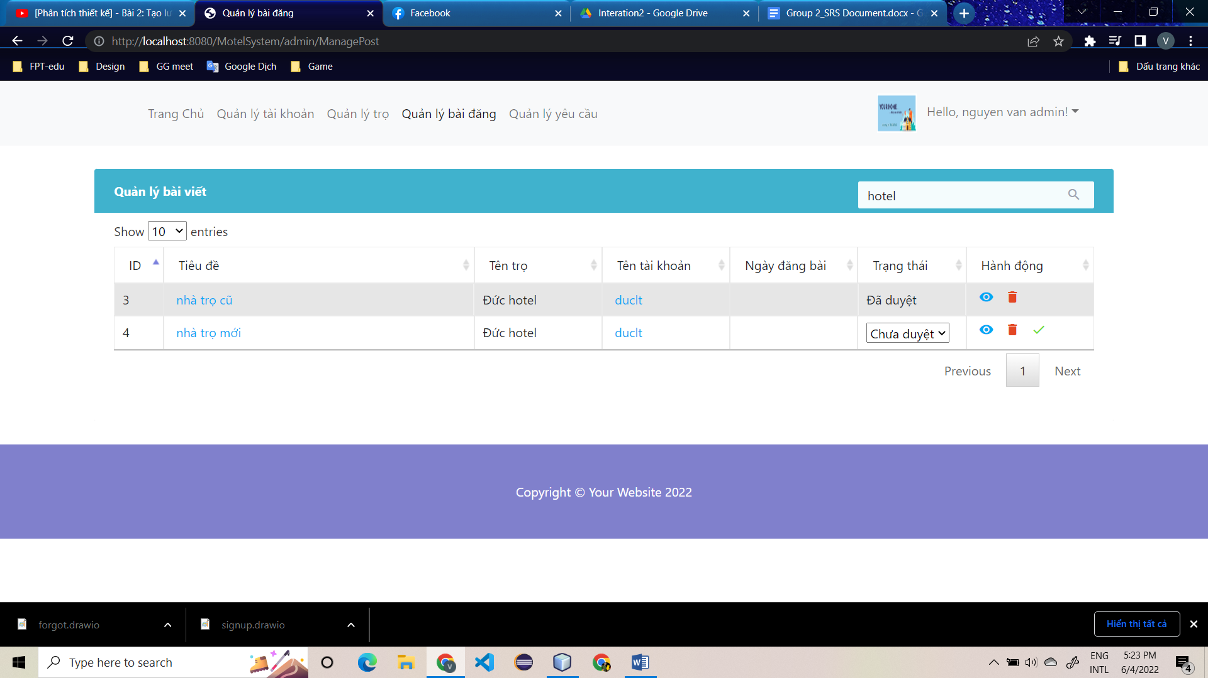
* **Function Details**: Admin write keyword and system will find post contain this keyword

### e. Sort

* **Function trigger**: Admin click to sort in each column
* **Function description**: Sort by column
* **Screen layout**:

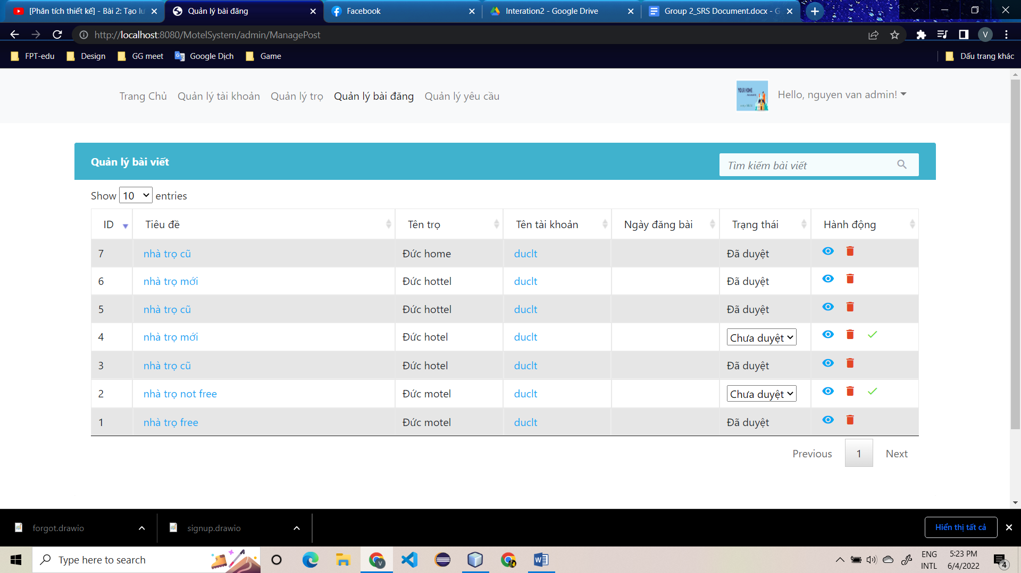

* **Function Details**: Admin click to sort in each column the system will display the information in sorted order

### f. View detail

* **Function trigger**: Admin click to view detail to view information about this post
* **Function description**: View all information of post
* **Screen layout**:
* 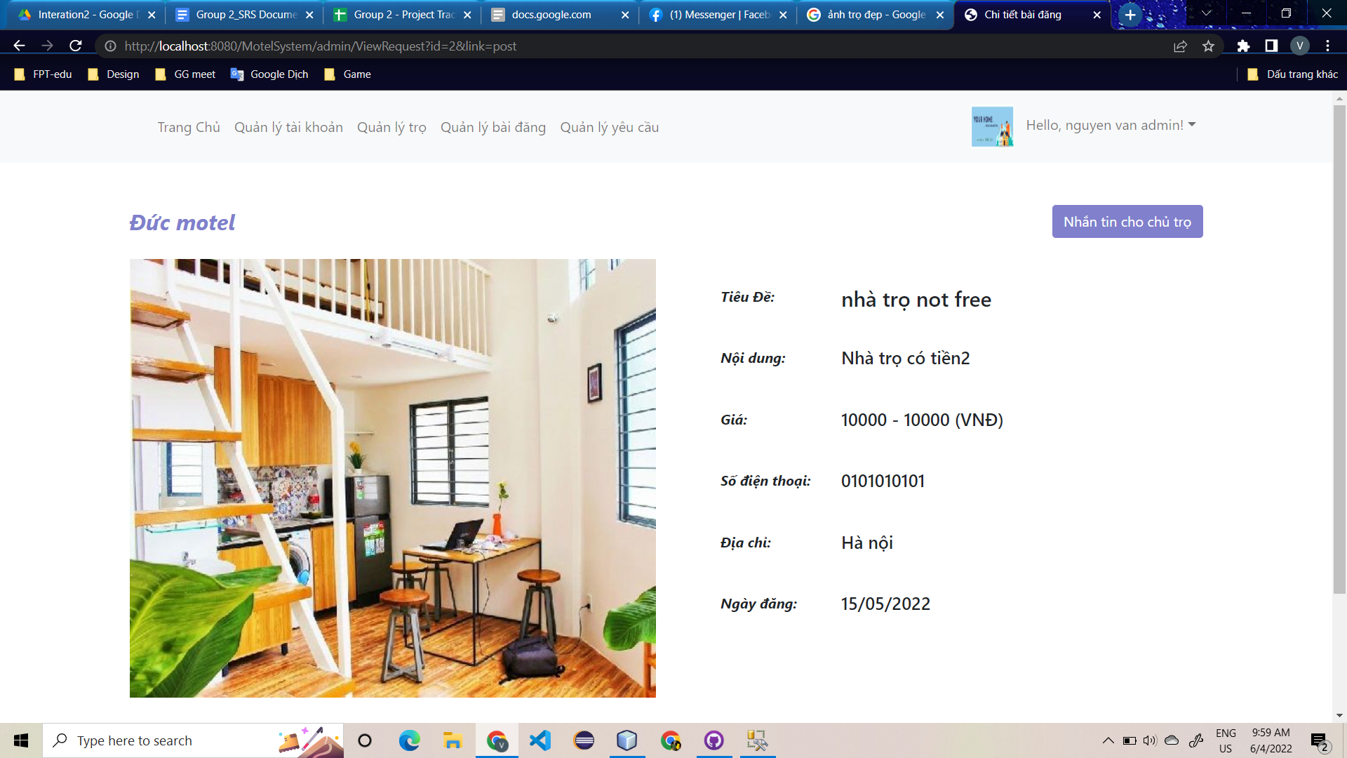
* **Function Details**: Admin click to view detail then system will change page to view detail of post**.**

## 8. Manage Account Profile

### a. View account profile

* **Function trigger**: home page (after login successful) -> Profile
* **Function description**: view information of account
* **Screen layout**:

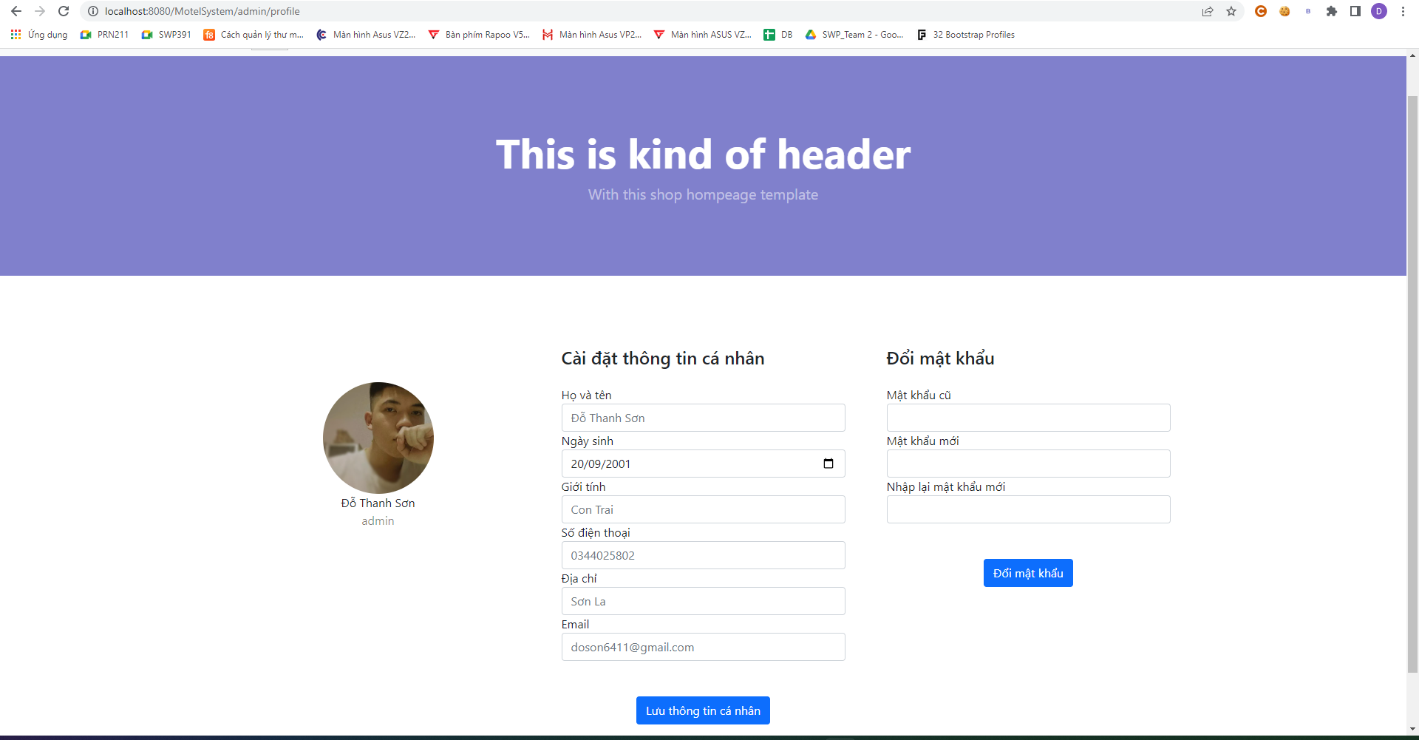

* **Function Details**: User selects profile on home page then user will see his/her personal information.

## 9. Manage Request By Admin

### a. View list request by admin

* **Function trigger**: admin click on the manage request button in nav-bar, then the page will be navigated through the request management page, which will display the list of request (status of motel and status of post)
* **Function description**: View list of request (host request a post, customer request to become host)
* **Screen layout**:

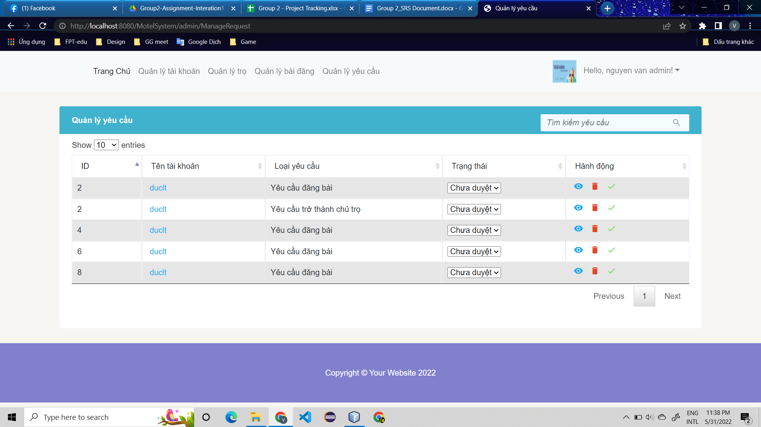

* **Function Details**: when admin login successful , admin will choose manage request

then the page will display list of request include request of customer become a host,

a host want to post

### b. Delete request by admin

* **Function trigger**: admin login successful → choose manage request in nav-bar→ choose delete icon → confirm → delete
* **Function description**: Delete a request : request from host or request from customer want to be host
* **Screen layout**:

- before delete

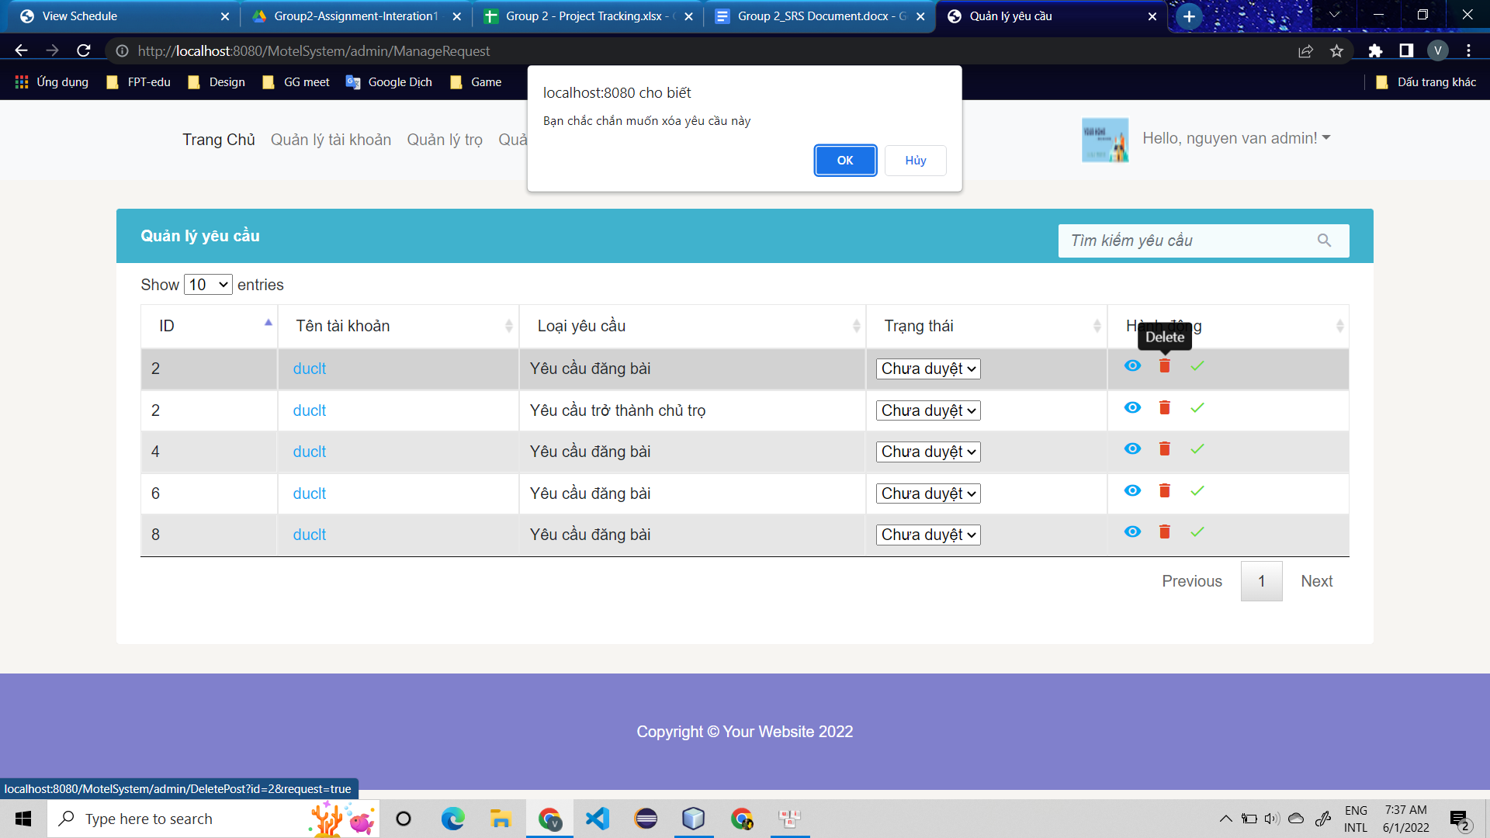

- after delete

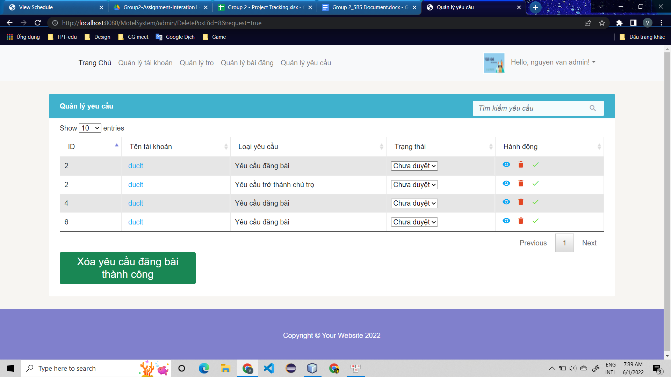

* **Function Details**: Admin after select tick icon screen will alert confirm information if admin choose OK the request will be delete and if no the request do not delete

### c. Update request detail by admin

* **Function trigger**: admin login successful → choose manage request in nav-bar→ choose “select menu” in request status (accept or not) → update
* **Function description**: display list of request not accept update status of request , can update from not accept to accept
* **Screen layout**:
* before update

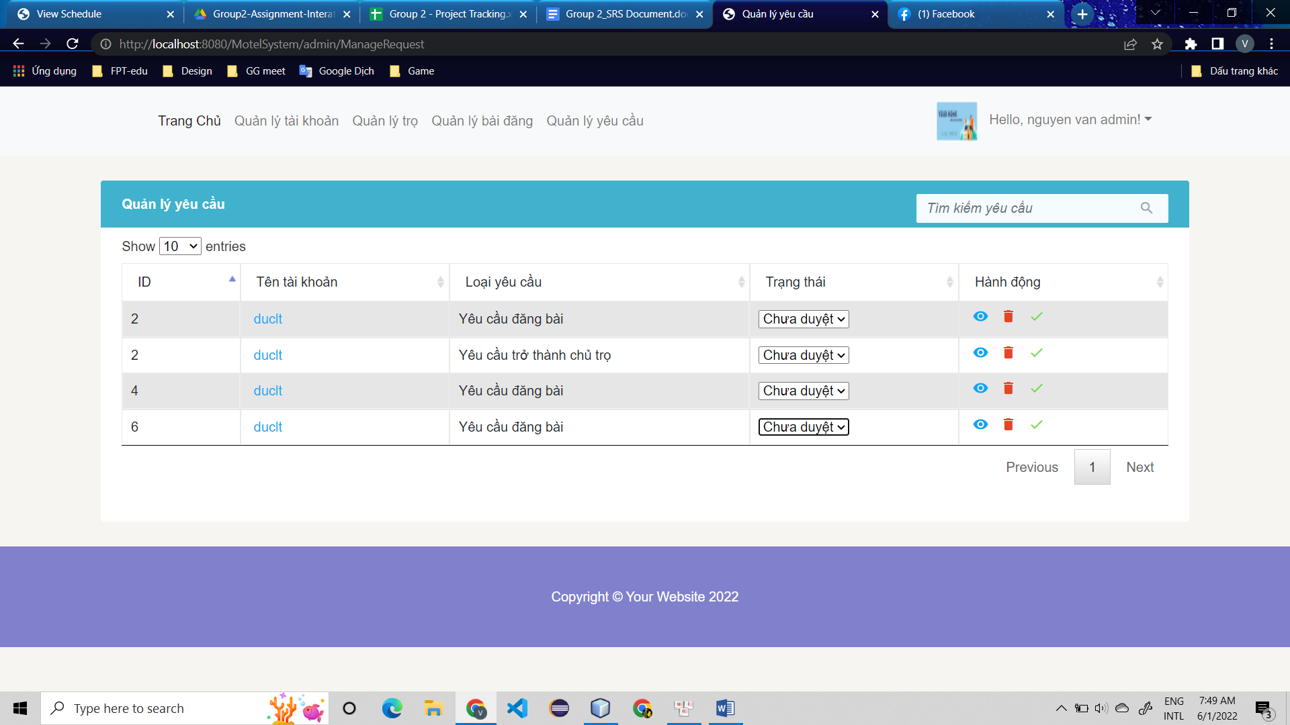

* after update

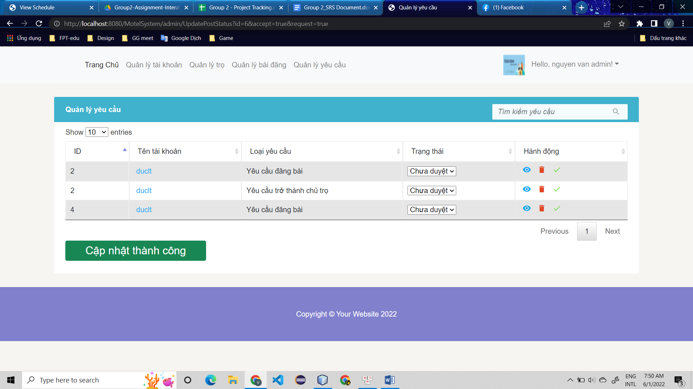

* **Function Details**: Admin will choose tick icon and choose status of request then the status of request will be update

### d. View detail request by admin

* **Function trigger**: admin login successful → choose manage request in nav-bar→

click to eye icon in last column then it will display all information of account

* **Function description :** screen display all information of one request when admin choose view detail
* **Screen layout**:

- motel detail

- post detail

* **Function Details**: admin click to eye icon in last column of each row then the system will display all information of one request admin click

### e. Search request by admin

* **Function trigger**: admin login successful → choose manage request in nav-bar→

click to box search then text what admin want to search

* **Function description**: the system display data that admin text in box search
* **Screen layout**:
* before search

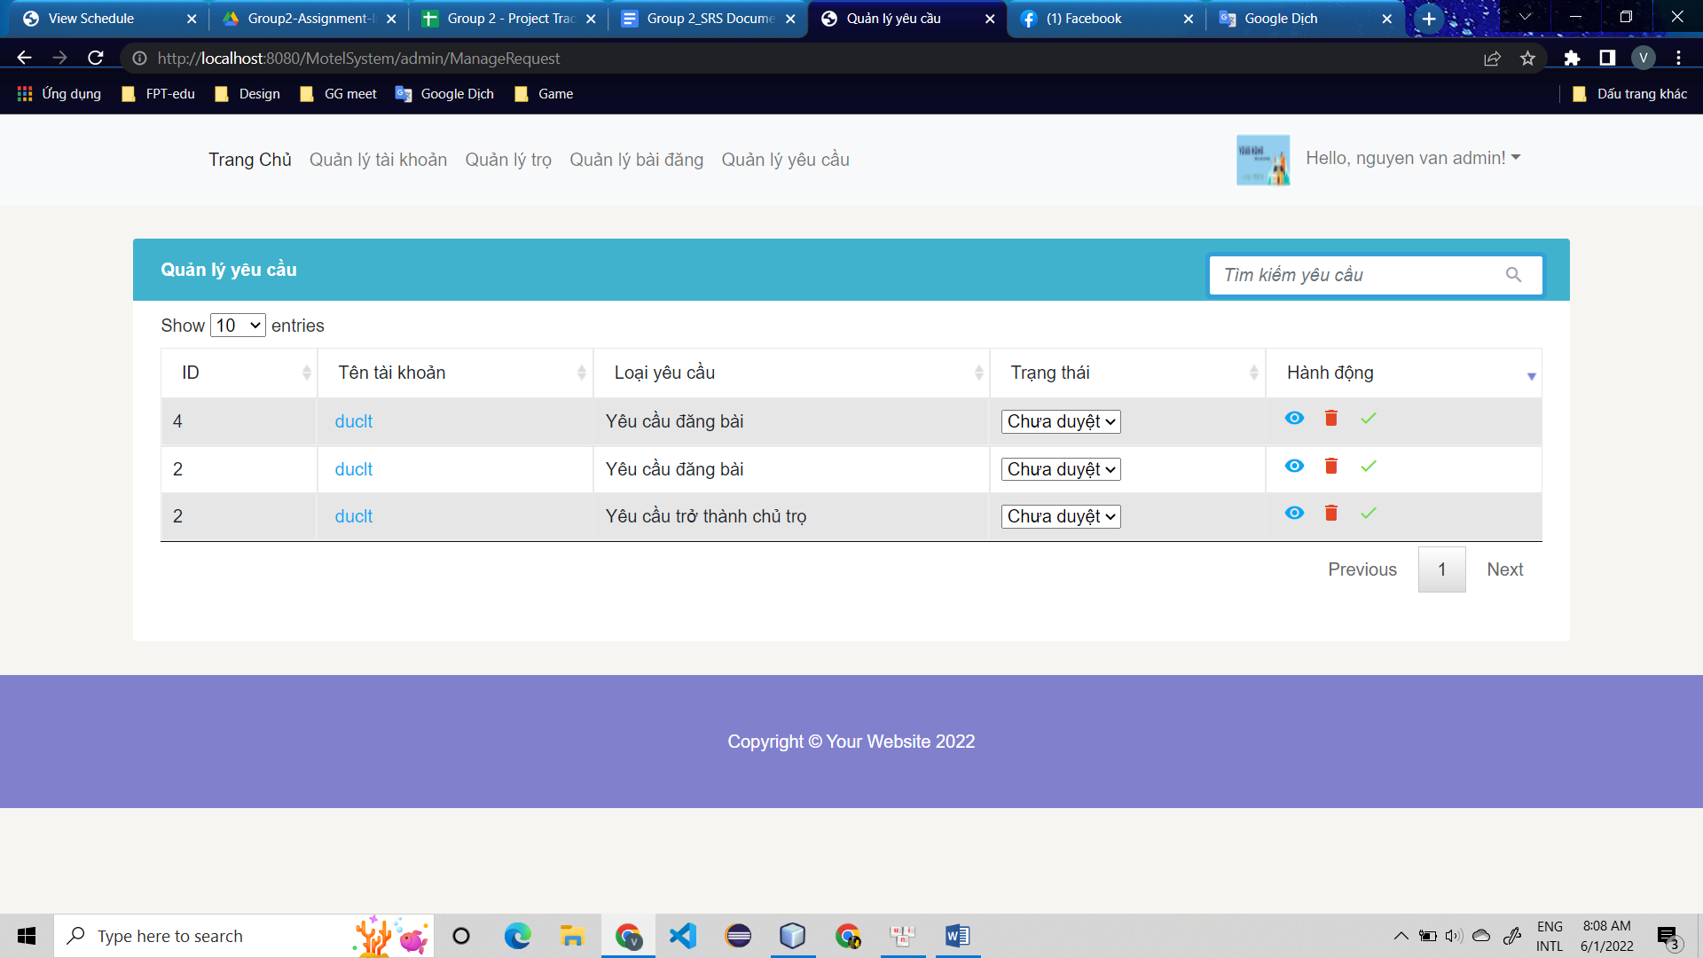

* after search

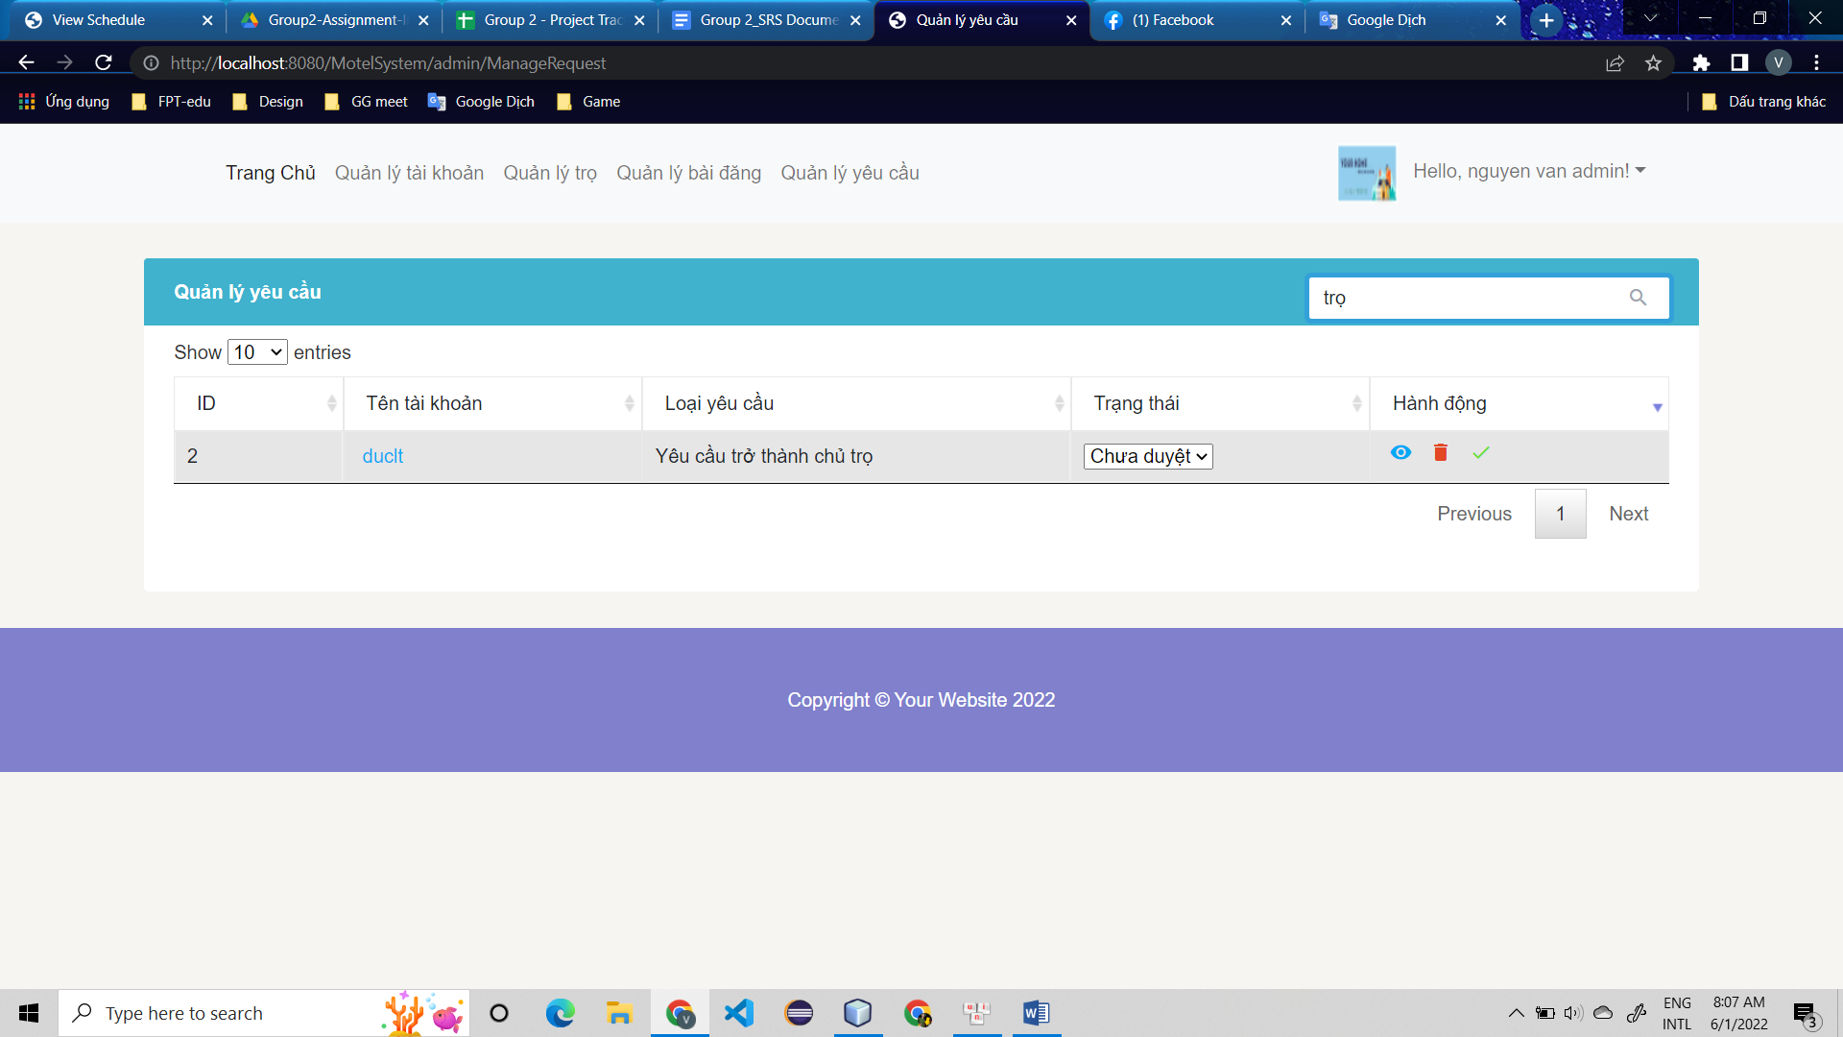

* **Function Details**: admin text in box search then system will display the data table that have text in box search

### f. Sort detail request by admin

* **Function trigger**: admin login successful → choose manage request in nav-bar→

click to triangle in table head of each column then the data in table will be sort

* **Function description**: view list of requests followed by sort , sort in each column will be different.
* **Screen layout**:
* before sort
* 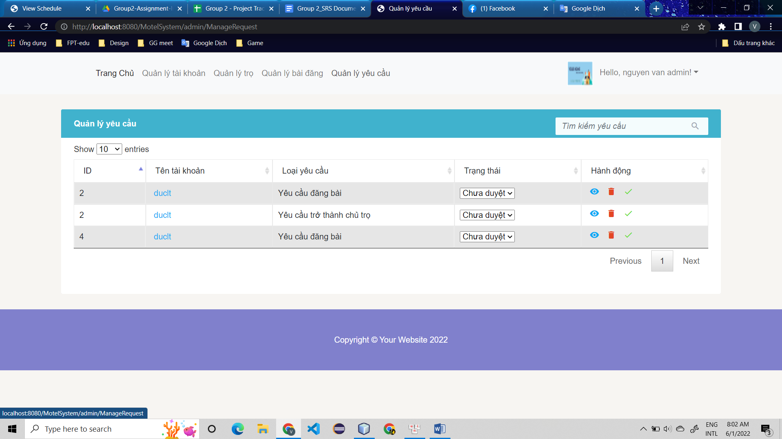
* after sort
* 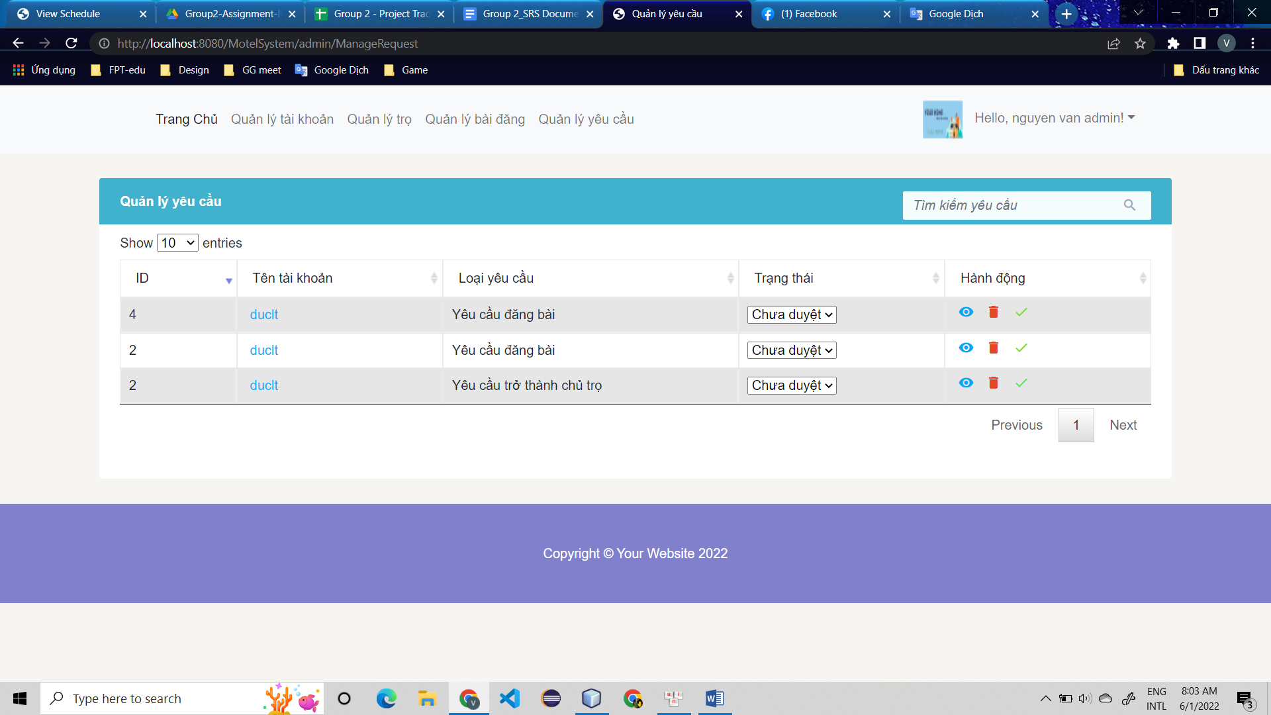
* **Function Details**: Admin choose one of five column and click to triangle in table head to sort then the data of table will be sort follow by this column

## 10. Manage Room By Host

### a. View all room by host

* **Function trigger**: home page -> Manage Room
* **Function description**: View, delete, update information of room
* **Screen layout**: 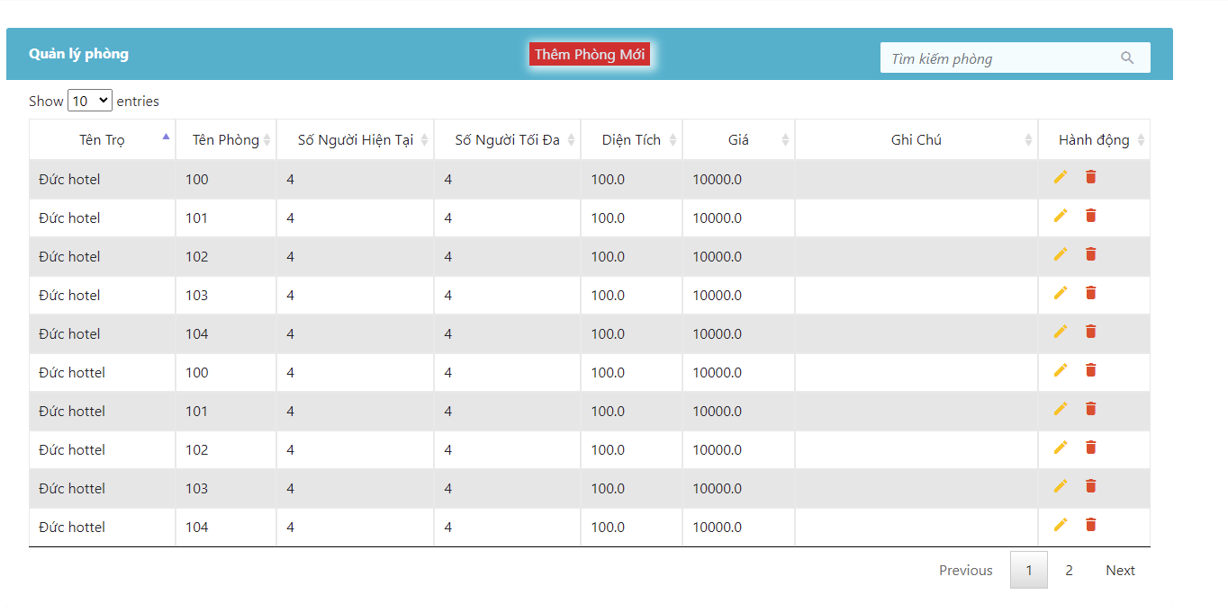
* **Function Details:** From the room management page, you can view the necessary information of a room and can perform add, edit and delete operations.

### b. Create new room by host

* **Function trigger**: Mange Room -> Create New Room
* **Function description**: Create new room
* **Screen layout**: 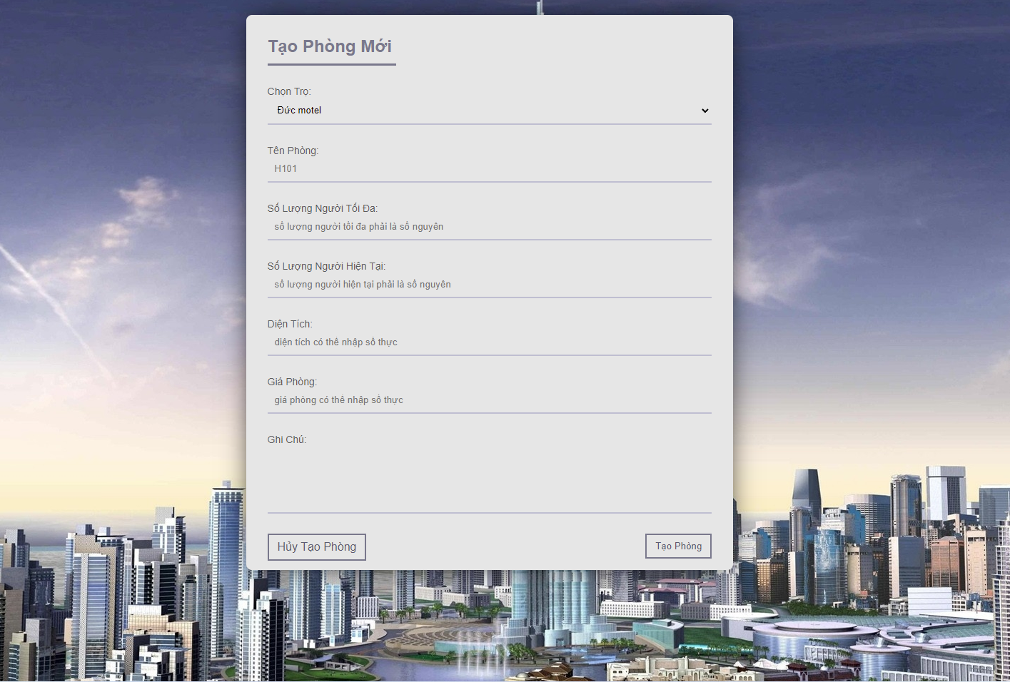
* **Function Details:** After the user clicks on the create new room button, the web will move to a page for the user to fill in the information of a room and press the create room button to complete the creation of a new room.

### c. Update/view details room by host

* **Function trigger**: Manage Room -> icon edit
* **Function description**: Update information of room
* **Screen layout**: 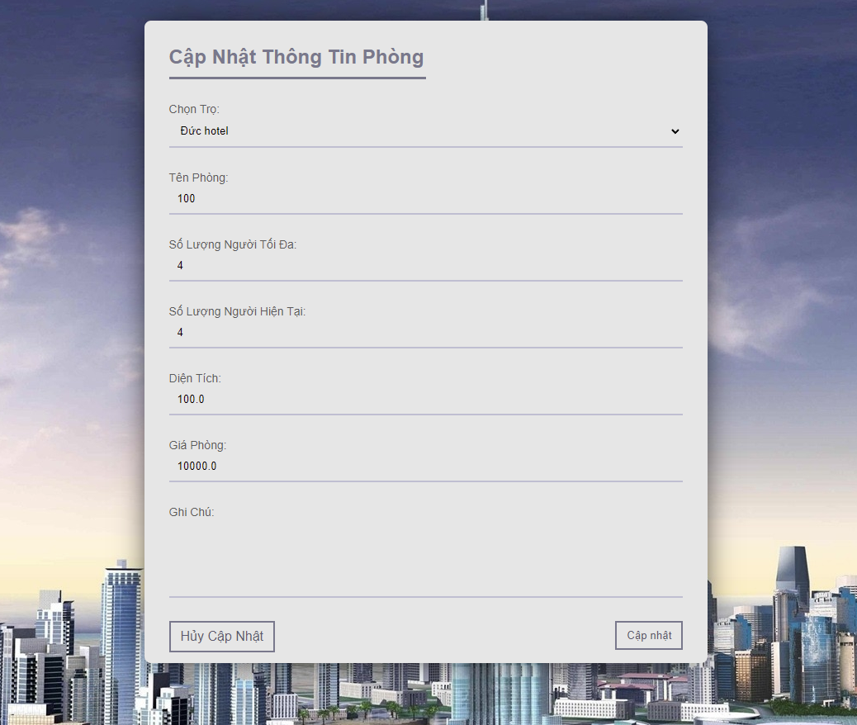
* **Function Details:** After the user clicks on the edit icon, the web will move to a page for the user to view the detailed information of a room and edit the information that the user wants. Click the update room button to finish updating the room's information

### d. Delete room by host

* **Function trigger**: Manage Room -> icon delete and click to ok or cancel
* **Function description**: Delete room of motel
* **Screen layout**: 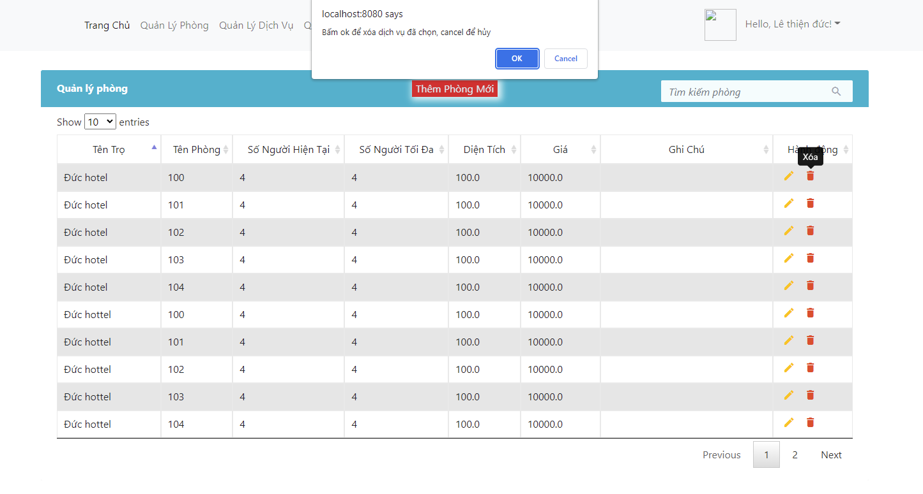
* **Function Details:** On the room management page, the user clicks on the icon to delete the room they want. The page will display a question for the user to confirm the deletion of the room. Click Ok to agree to cancel to cancel the room deletion

### e. Search room by host:

* **Function trigger**: Manage Room -> Enter content search to search box
* **Function description**: Search by the room information
* **Screen layout**: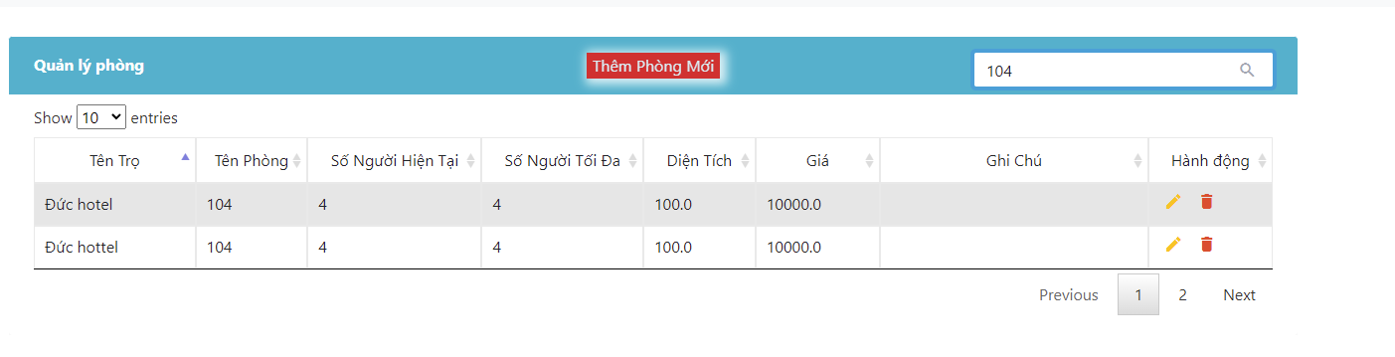
* **Function Details:** The user enters the information they need to find the page will display the rooms containing the information that the user entered in the search box

### d. Sort room by host

* **Function trigger**: Manage Room -> Click on the column you want to sort
* **Function description**: Sort list room by column
* **Screen layout**: 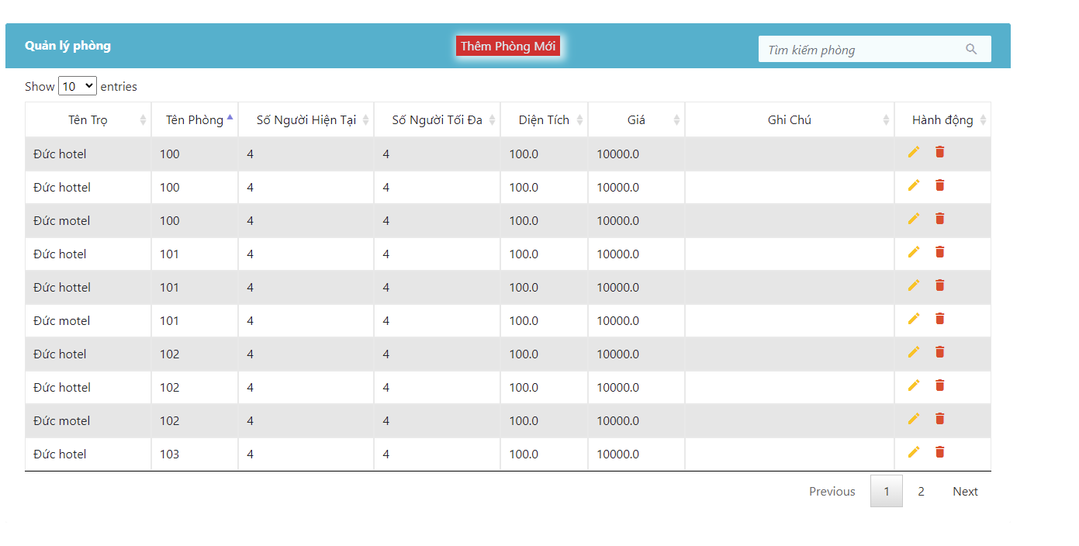
* **Function Details:** The user clicks on the column they want to sort (ascending and descending). After clicking the first time, it will sort in ascending order and twice in descending order the information in the column

## 11. Manage Services By Host

### a. View all Services by host

* **Function trigger**: home page -> Manage Services
* **Function description**: View, delete, update information of services
* **Screen layout**: 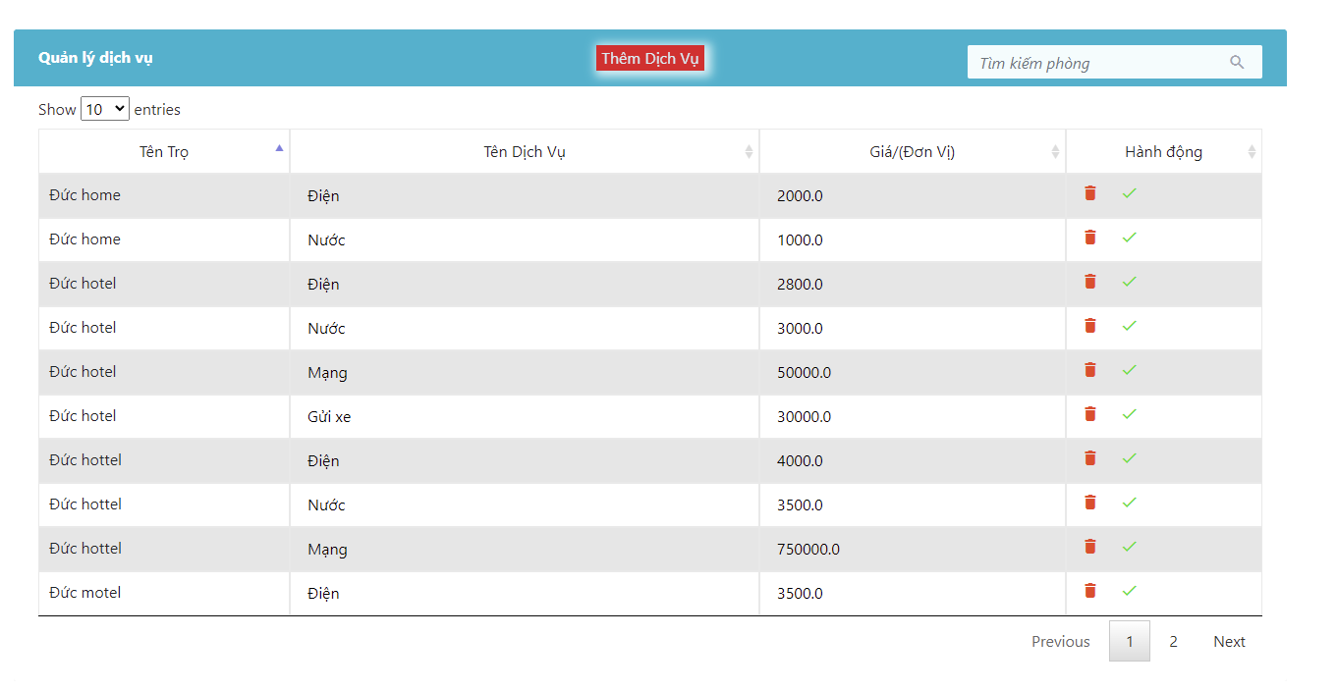
* **Function Details:** From the room management page, you can view the necessary information of a services and can perform add, edit and delete operations.

### b. Create new Services by host

* **Function trigger**: Mange Serivces -> Create New Services
* **Function description**: Create new services
* **Screen layout**: 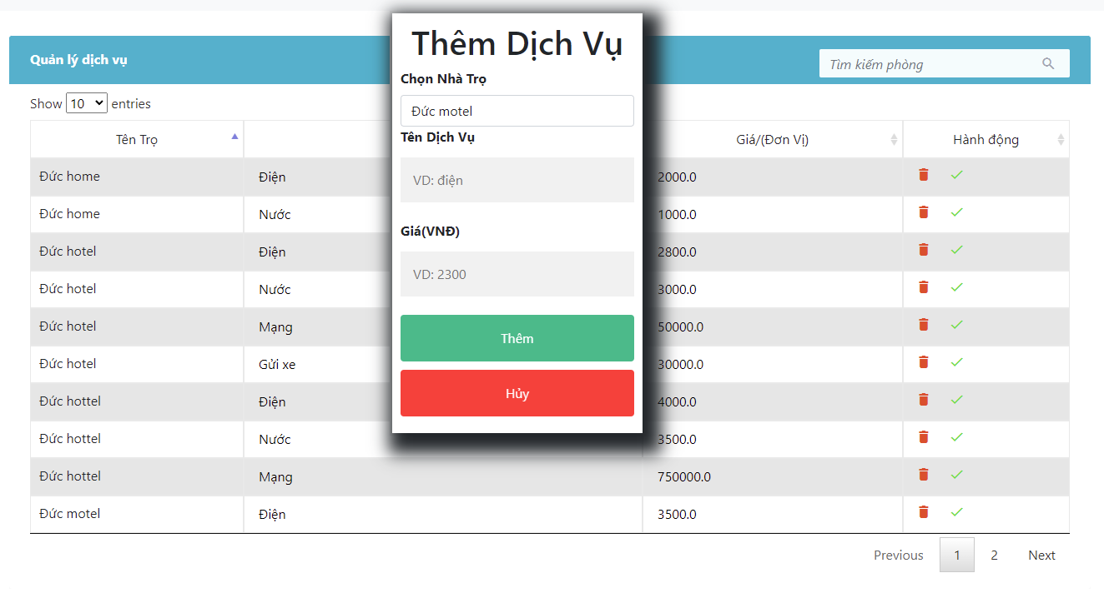
* **Function Details:** After the user clicks on the new service button, the web will display a pop-up window for the user to fill in the room information and click the add button to complete the creation of the new room.

### c. Update Services by host

* **Function trigger**: home page -> Manage Services -> Enter information you wan’t to edit
* **Function description**: Update information of services
* **Screen layout**: 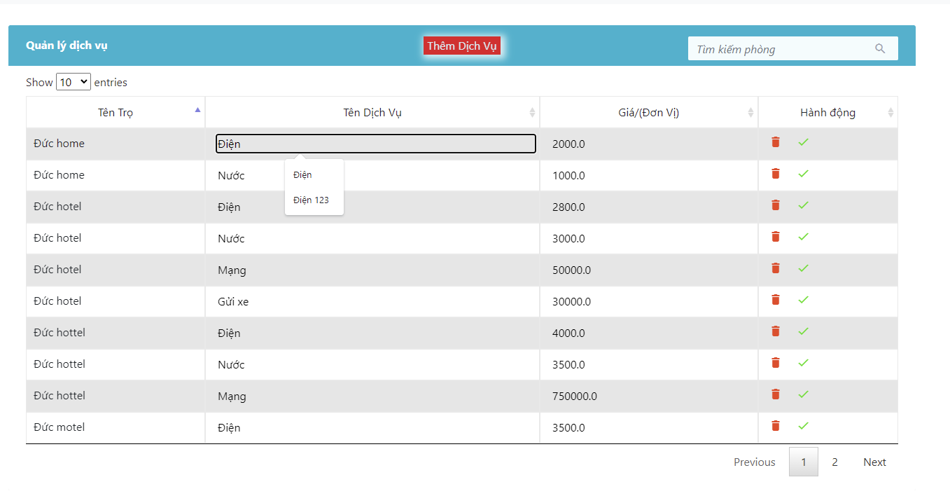
* **Function Details:** The user re-enters the information of the service they want to edit into the table and clicks on the 'V' icon to save the entered information.

### d. Delete Services by host:

* **Function trigger**: Manage Services -> icon delete and click to ok or cancel
* **Function description**: Delete serivces of motel
* **Screen layout**: 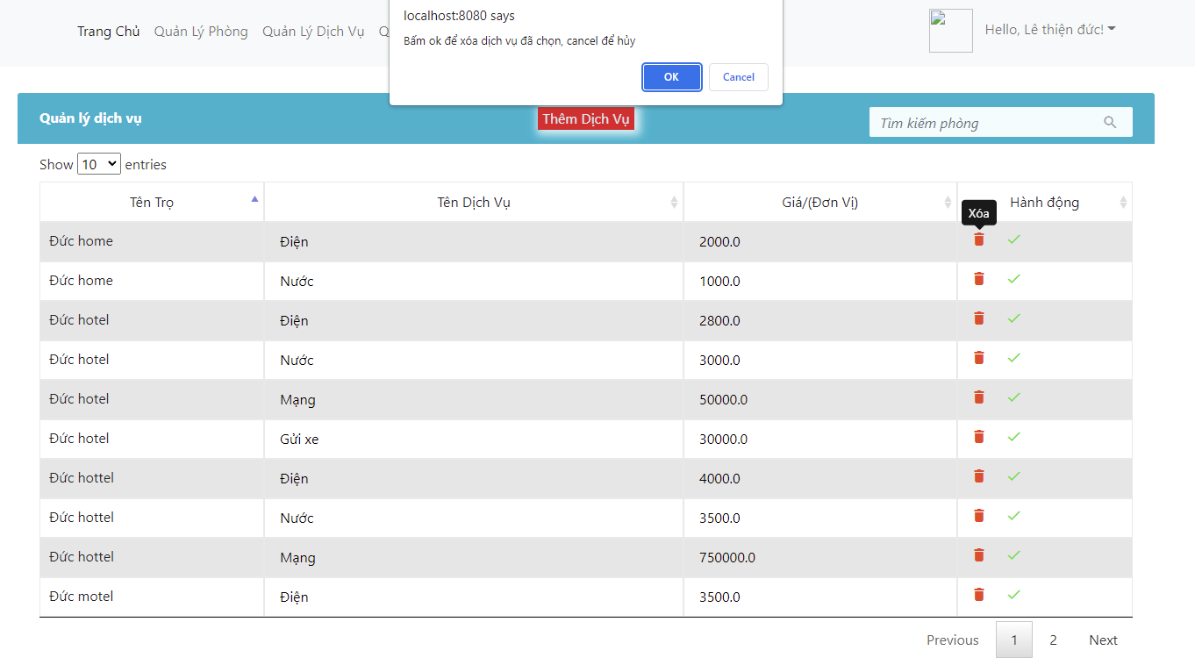
* **Function Details:** On the services manage page, the user clicks on the icon to delete the services they want. The page will display a question for the user to confirm the deletion of the services. Click Ok to agree to cancel to cancel the services deletion

### e. Search Services by host:

* **Function trigger**: Manage Services -> Enter content search to search box
* **Function description**: Search by the services information
* **Screen layout**: 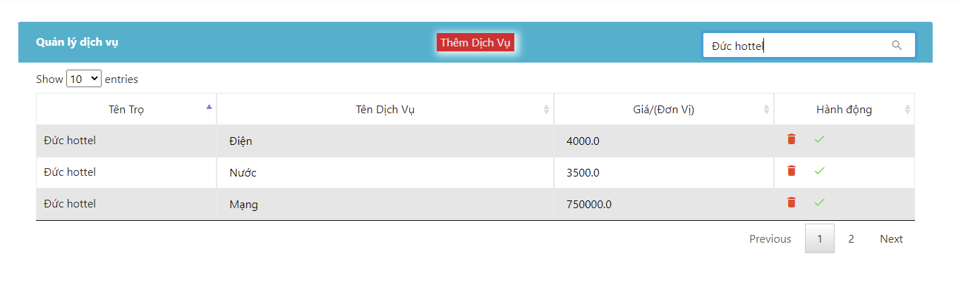
* **Function Details:** The user enters the information they need to find the page will display the services containing the information that the user entered in the search box

### f. Sort Services by host:

* **Function trigger**: Manage Services -> Click on the column you want to sort
* **Function description**: Sort list services by column
* **Screen layout**: 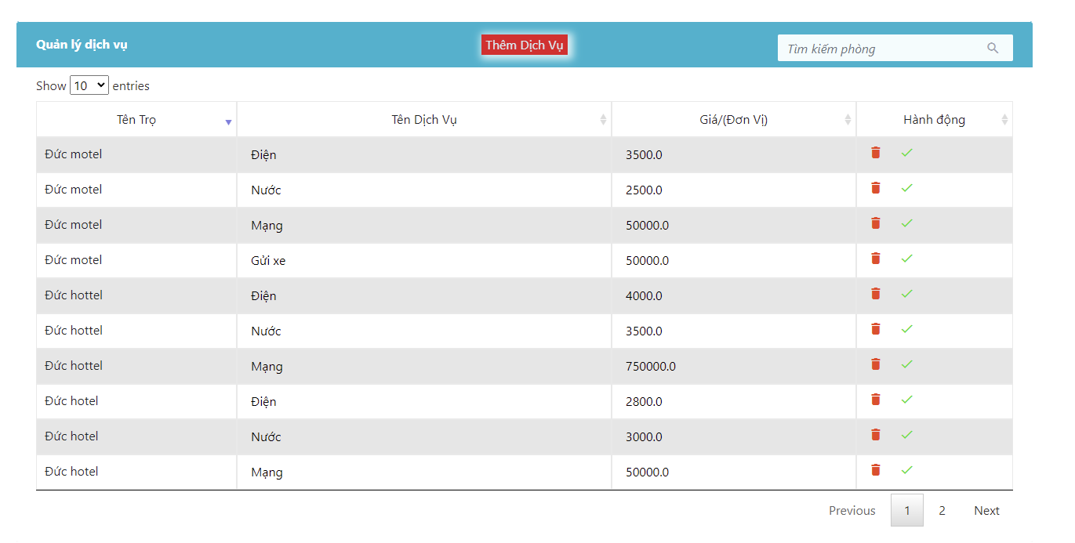
* **Function Details:** The user clicks on the column they want to sort (ascending and descending). After clicking the first time, it will sort in ascending order and twice in descending order the information in the column

## 12. Manage Bill By Host

### a. View all bill by host

* **Function trigger**: Click on manage bill -> this show all bill of motel that host own
* **Function description**: See all bill of motels that host own
* **Screen layout**:

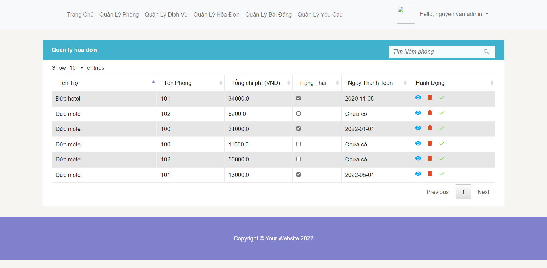

* **Function Details:** Account login with host role -> click to manage bill -> can view all bill that in motels they own

### b. Delete bill by host

* **Function trigger**: Delete bill
* **Function description**: Click the symbol of delete -> alert -> delete bill or not
* **Screen layout**:

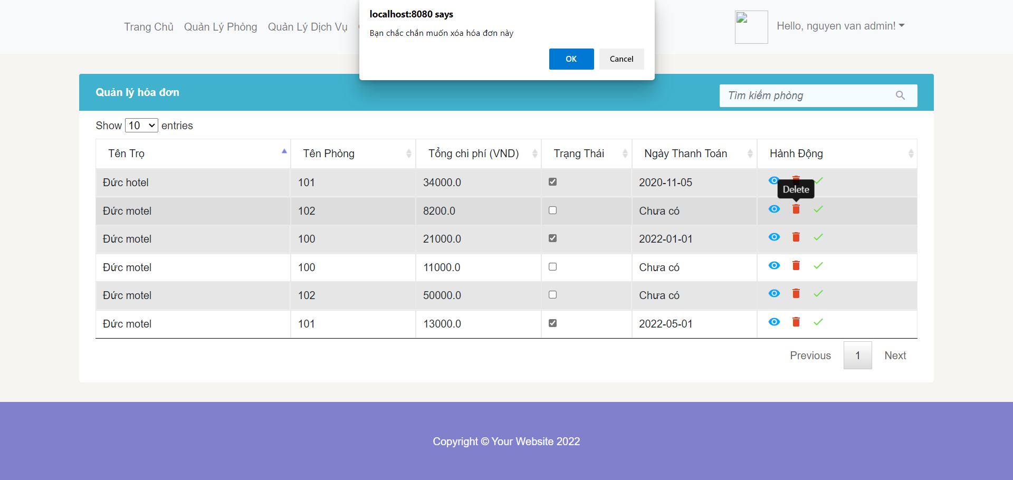

* **Function Details:** When host click the delete symbol -> a pop up window confirm -> if yes -> delete bill or not

### c. Update bill by host

* **Function trigger**: Update a bill is paid or not
* **Function description**: host will check to the checkbox if customer paid the bill
* **Screen layout**:

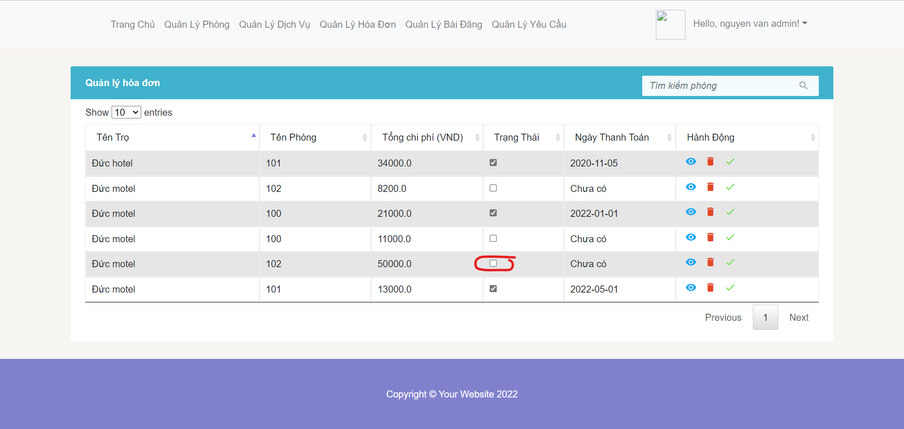

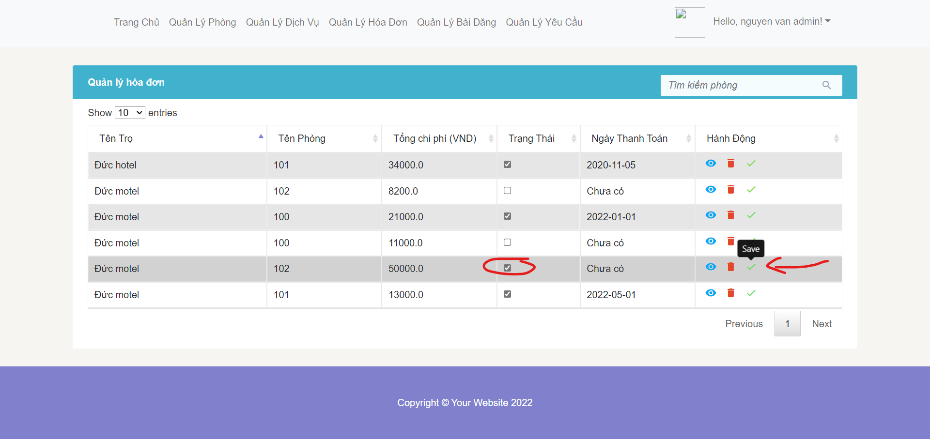

* **Function Details:** host will check after the bill is paid, system will update date that confirm the paid bill

### d. Sort bill by host

* **Function trigger**: sort the price, date motel name, room name by asc or desc
* **Function description**: host click to the table header-> sort by asc or desc
* **Screen layout**:

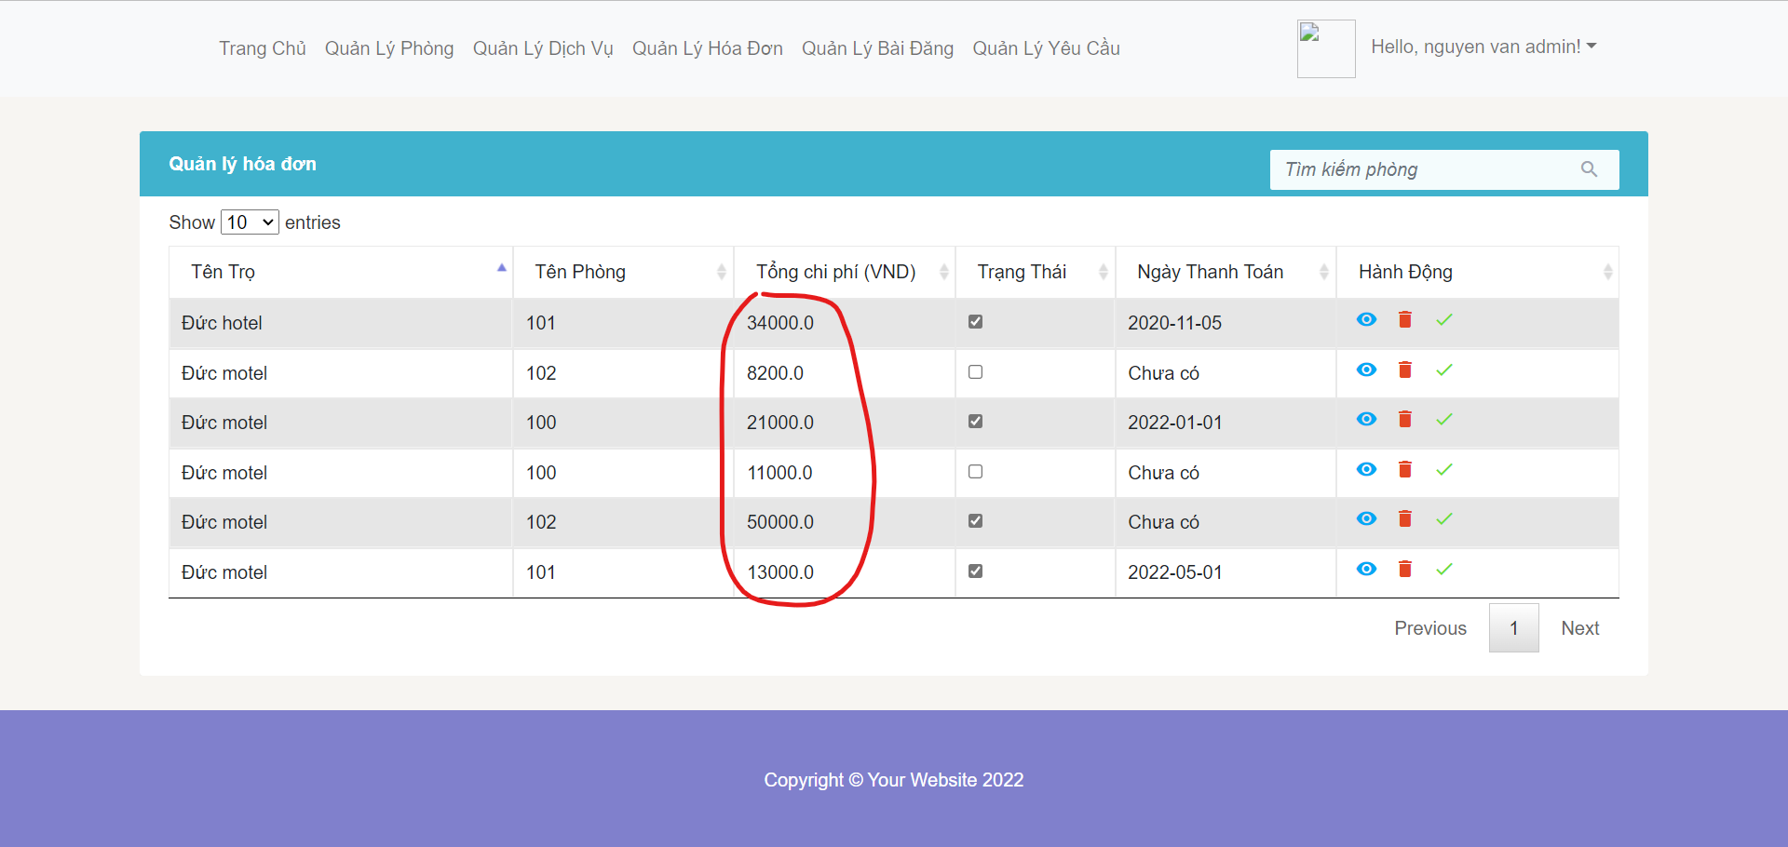

* **Function Details:** host can sort 4 fields by asc or desc depends on their options

### e. Search bill by host

* **Function trigger**: search bill by the room name
* **Function description**: enter the room name -> system will check and give the result
* **Screen layout**:

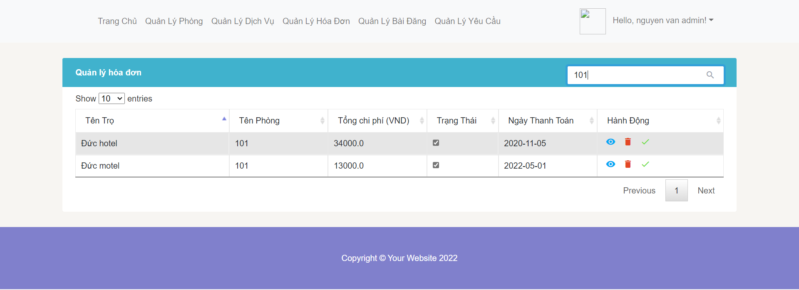

* **Function Details:** host can enter the room name to search bill that room name contains that name

### f. View bill detail by host

* **Function trigger**: view detail of the bill
* **Function description**: View all services in the bill
* **Screen layout**:

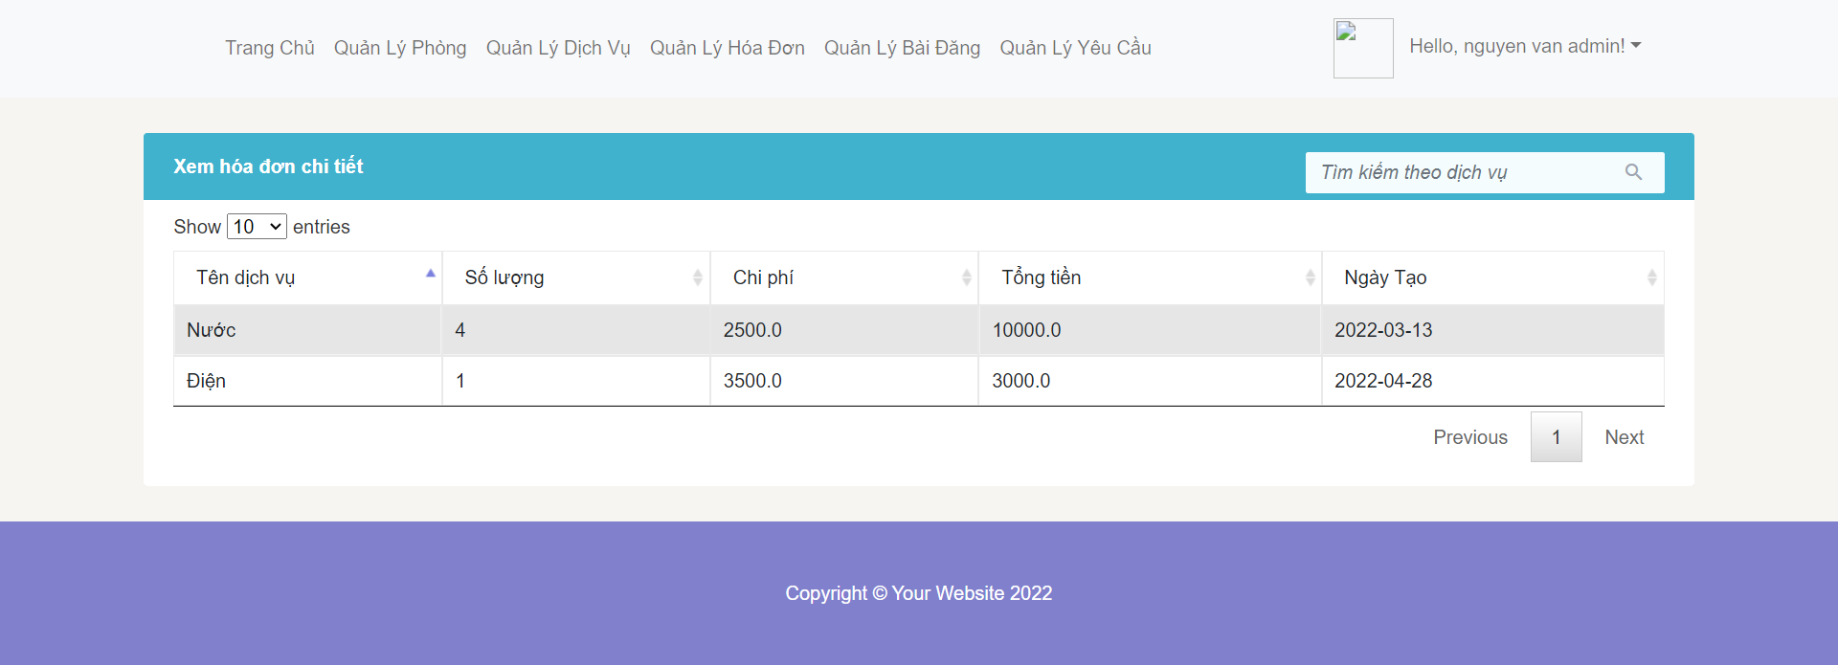

* **Function Details:** host click the eye symbol to see all services in the bill

## 13. Manage Request By Host

### a. View all request by host

* **Function trigger:** Click on manage requests, it will show the requirements of the inn that that person owns
* **Function description:** See all the requirements of the motel room
* **Screen layout:** 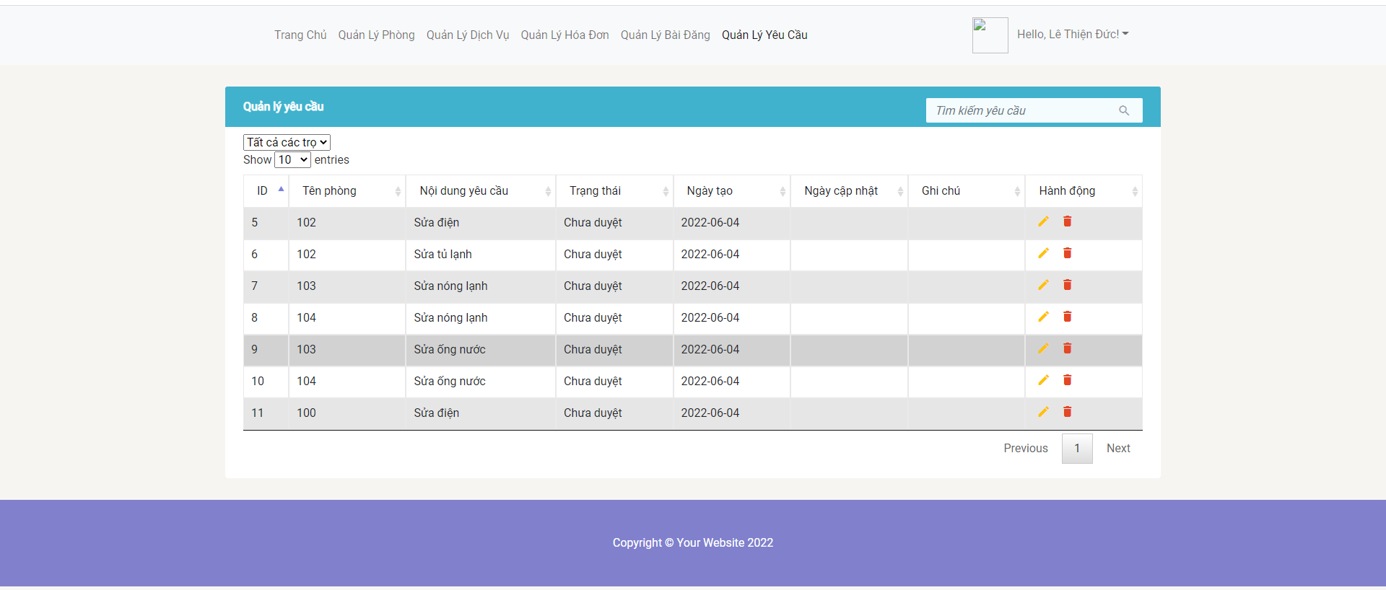
* **Function Details:** User has successfully logged in as an host, goes to the homepage and presses to manage requests, then the requirements of the inn will appear.

### b. Delete request by host

* **Function trigger:** Delete room request
* **Function description:** Delete request
* **Screen layout:** 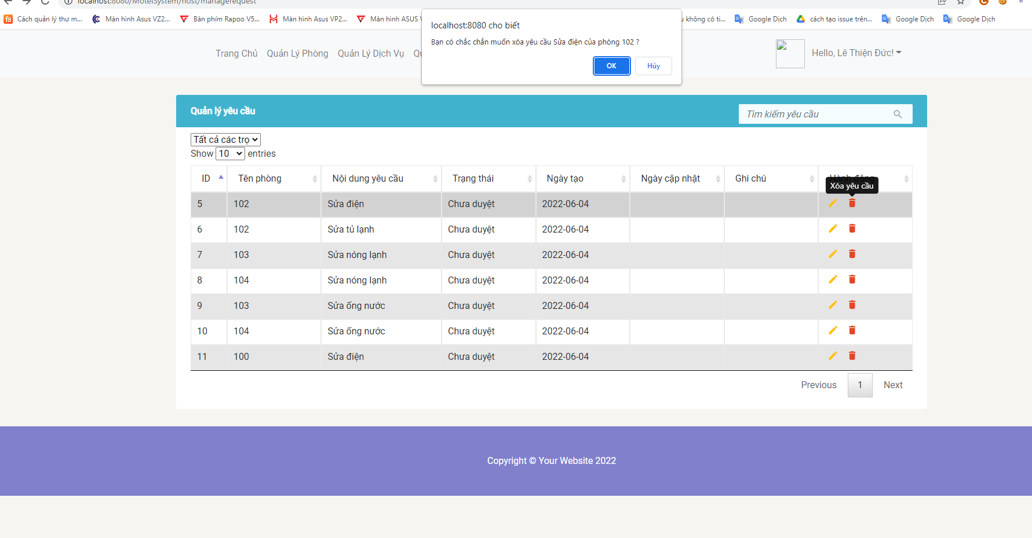
* **Function Details:** The landlord clicks on delete request and a question pops up, are you sure you want to delete it? If ok, the request will be deleted, otherwise the request will not be deleted

### c. Search request by host

* **Function trigger:** Search requests by all criteria
* **Function description:** Search request by everything in the table
* **Screen layout:** 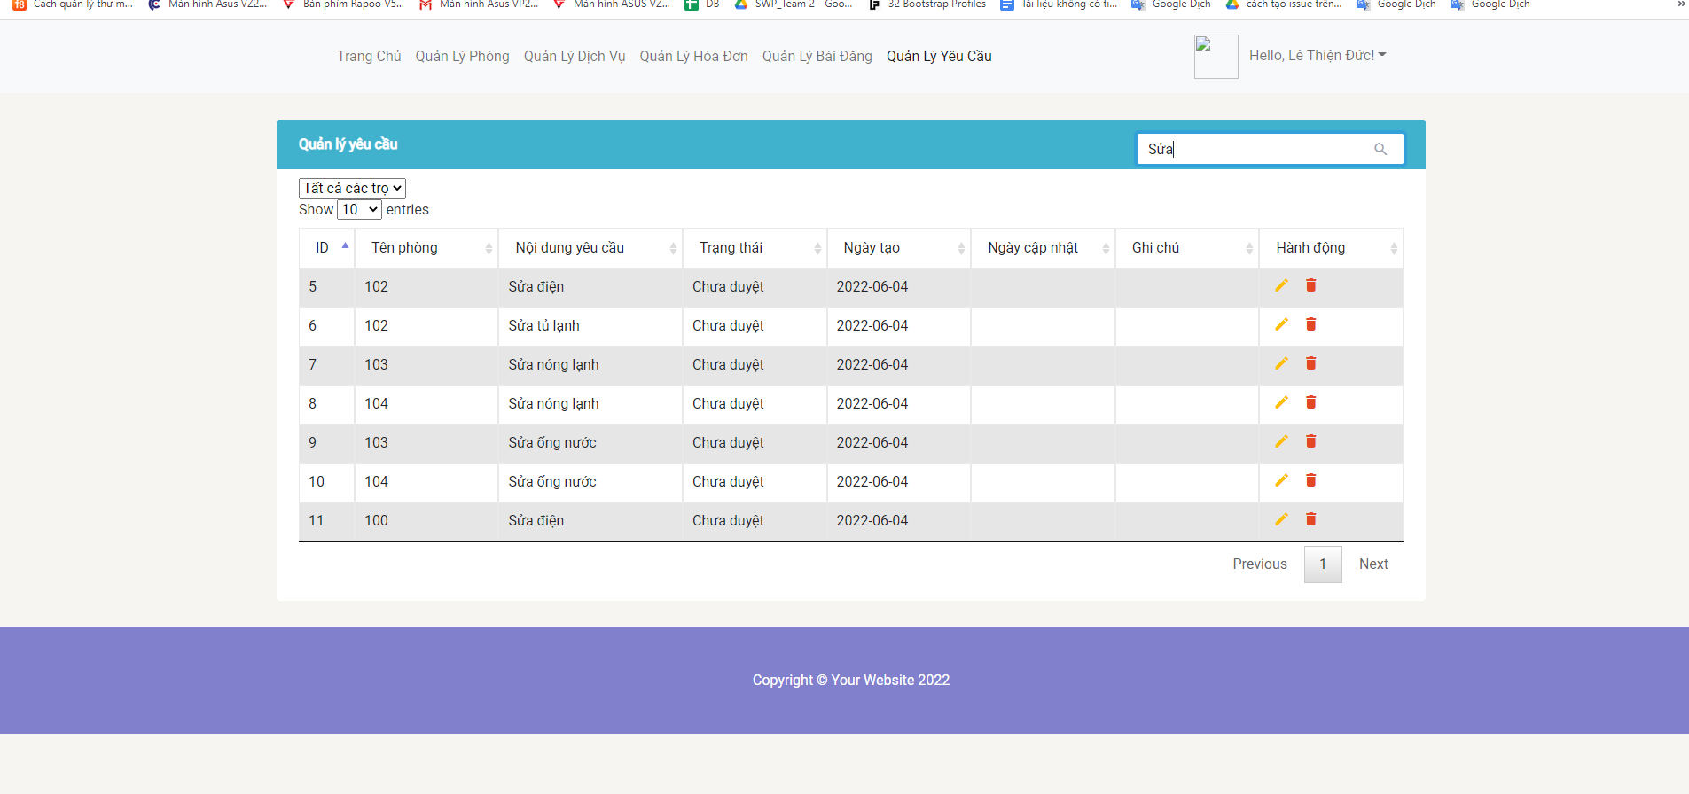
* **Function Details:** The landlord presses the content he wants to search into the search bar

### d. Sort request by host

* **Function trigger**: Display the number of row you want
* **Function description**: Display the number of row you want
* **Screen layout**: 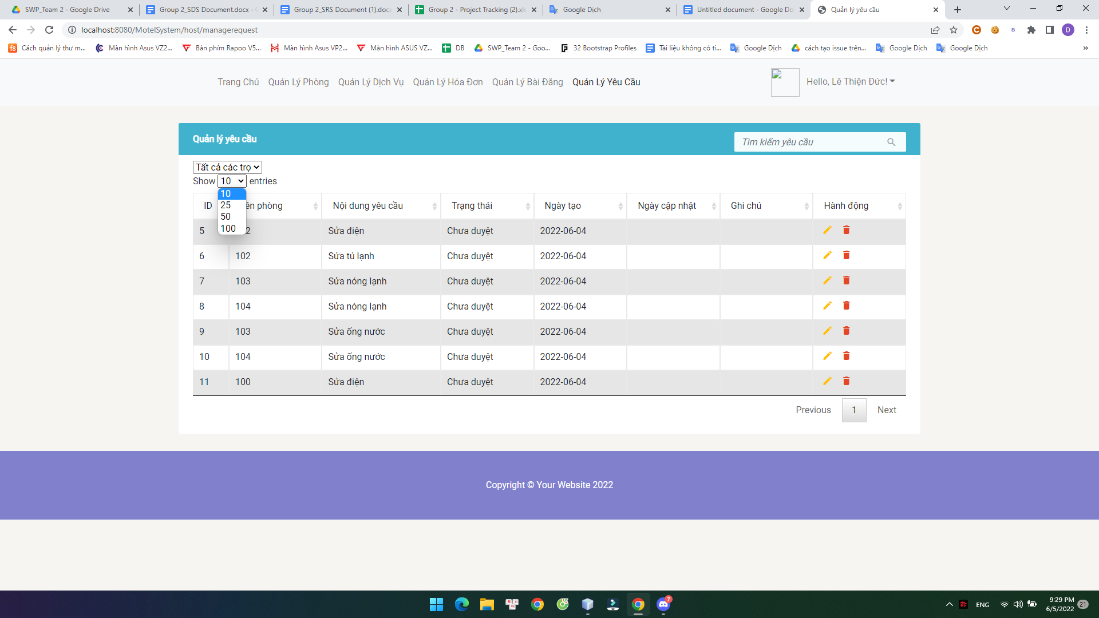
* **Function Details:** On the management page, ask the innkeeper to choose the number of goods you want to display

### e. Show details/Update of requests from rooms

* **Function trigger:** Clicking on view/update request will take you to the request update page
* **Function description:** See details and update request
* **Screen layout:** 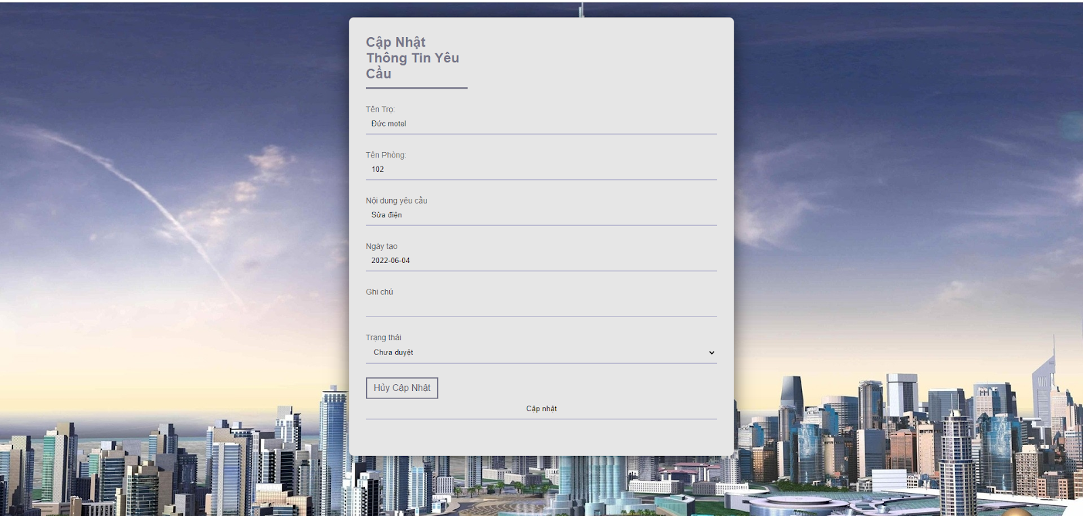
* **Function Details:** On the request management page the landlord selects (view/update request) will fly to the request detail page and can update them

**14. Filter post**

* **Function trigger**: When user select an index in select tag post create date and click on slide toggle panel item show address of motel
* **Function description**: view only posts that have motel address like user selected on slide toggle panel and with order selected in select tag create date
* **Screen layout**:

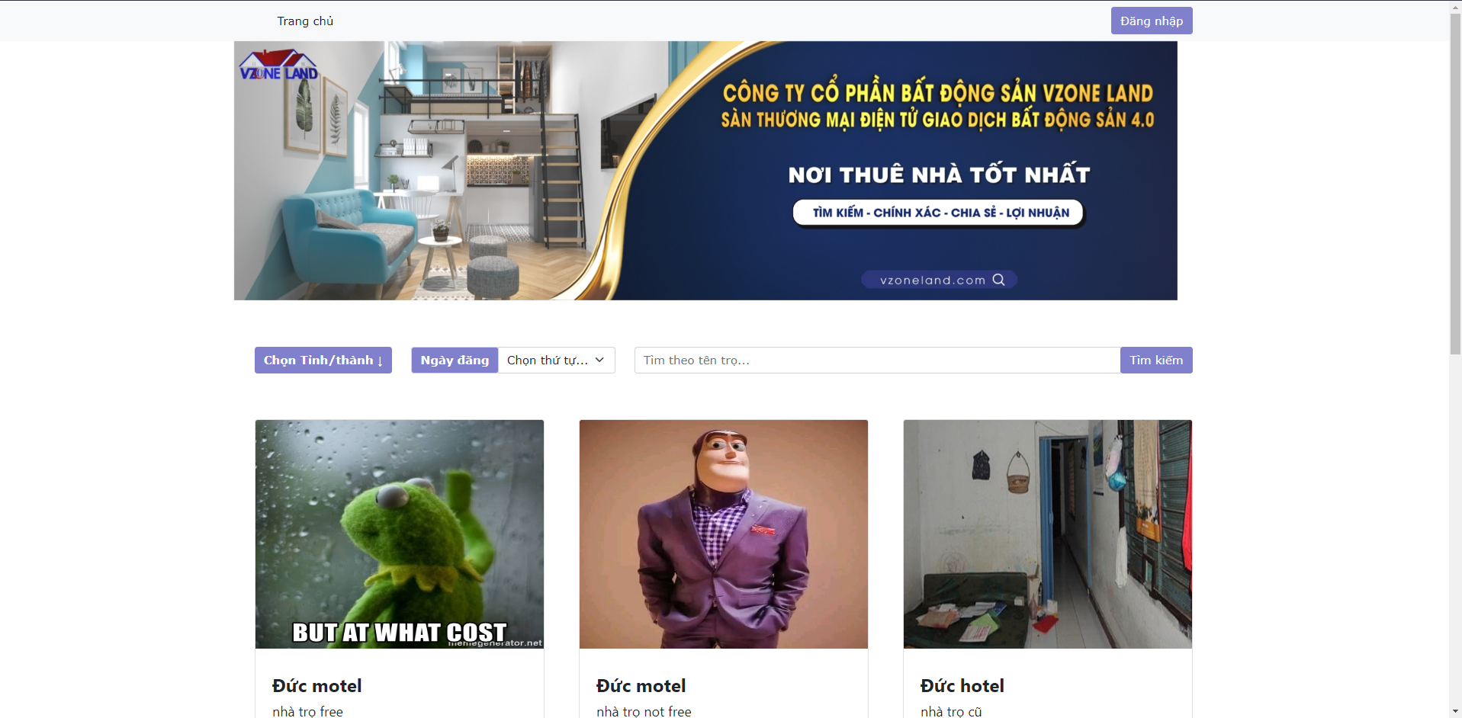

* **Function detail**: User select order of create date and click on item in panel have slide toggle, filter only post that match condition that user want, for specific, posts that have address of motel equal selected address in slide toggle panel, and with order by select tag name create date post.

## 15. Manage Post By Host

### a. View all post by host

* **Function trigger:** Click on manage post, redirect to manage post view and show list post of him
* **Function description:** See all post of host
* **Screen layout:**

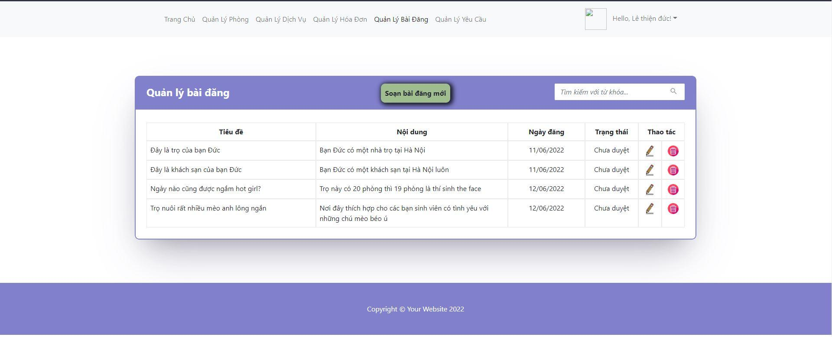

* **Function Details:** User has successfully logged in as an host, goes to the homepage and press manage post, then show list post of owner.

### b. Delete post by host

* **Function trigger:** Click icon delete in specific row of list post
* **Function description:** Delete post
* **Screen layout:**

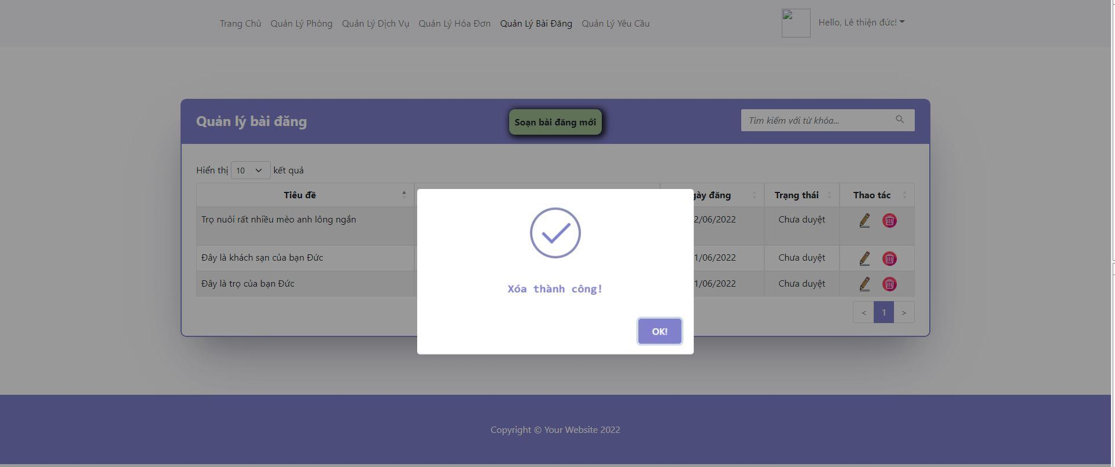

* **Function Details:** Host click on delete icon, alert shows question to host “Action can not be undone. Are you sure about that?”. Host click OK then delete post.

### c. Search post by host

* **Function trigger:** Search post by all criteria
* **Function description:** Search post by everything in the table
* **Screen layout:**

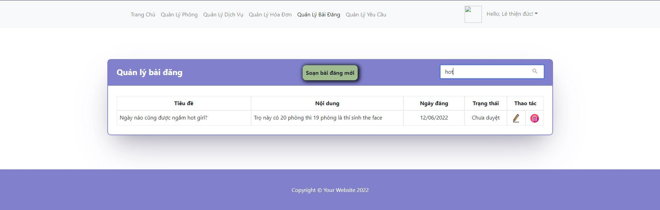

* **Function Details:** Host input text to search into search bar, then table will only show results that match search input.

### d. Sort post by host

* **Function trigger**: Host click on arrow icon on each column to sort row of table
* **Function description**: Click arrow up to sort column in ascending, down to sort column in descending
* **Screen layout**:

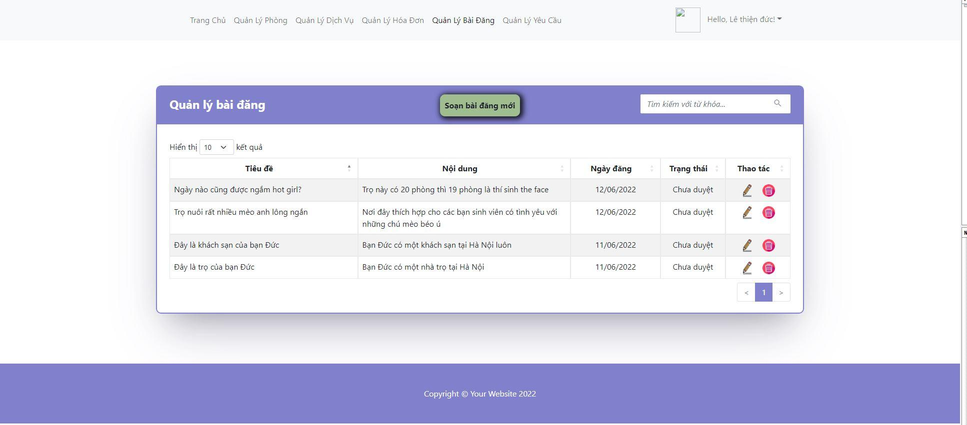

* **Function Details:** Click arrow up to sort column in ascending, down to sort column in descending

### e. Update of post by host

* **Function trigger:** Clicking on update icon
* **Function description:** Update existing post, which belongs to logged host.
* **Screen layout:**

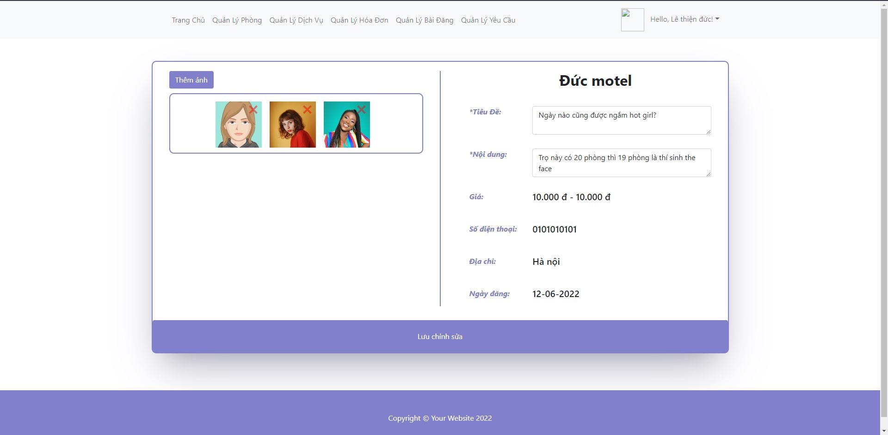

* **Function Details:** Get data inputted by host then update existing post in database by post id.

### f. Add new post by host

* **Function trigger:** Clicking on add new post icon, choose motel to create post then click continue button.
* **Function description:** Redirect host to form to add information for new post.
* **Screen layout:**

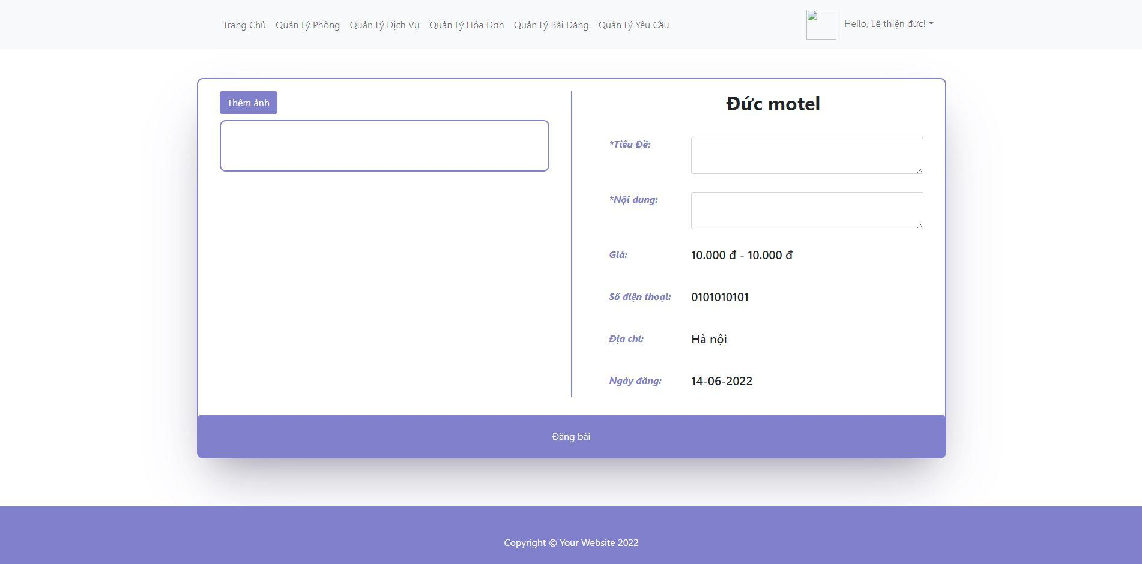

* **Function Details:** Get data inputted by host then add new post into database

## 16. Manage Motel By Host

### a. View all motel by host

* **Function trigger:** The host Click to “Trọ” and then can view all your motel
* **Function description:** See all the motels that belong to you
* **Screen layout:**

View all motels :

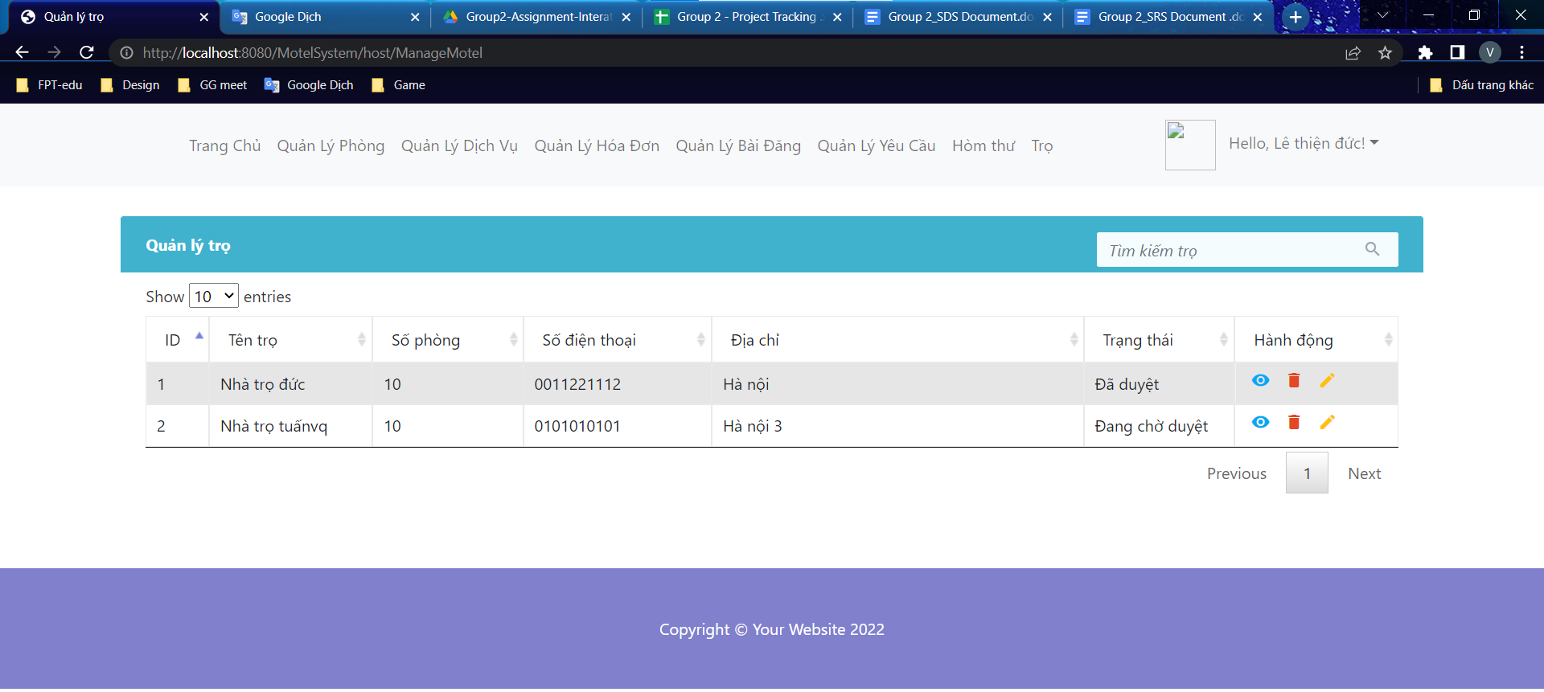

* **Function Details:** The hosts can view all motels and can click to edit or view detail of delete motel

### b. Update information for motel

* **Function trigger:** The motel owner click to pencil to edit some information of motel
* **Function description:** Update some information of motel
* **Screen layout:** 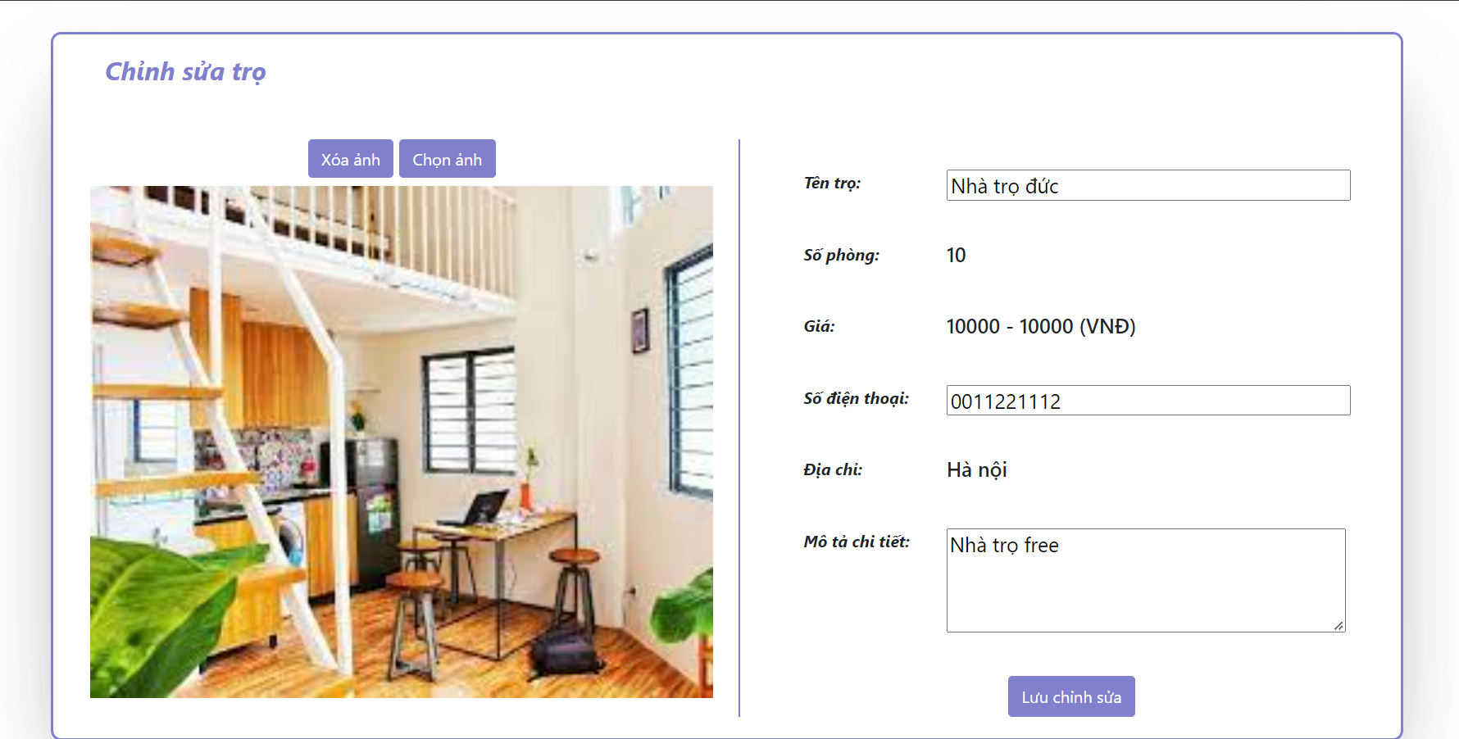
* **Function Details:** Display all information of motel and the motel owner can edit some information then click to save

### c. Delete motel by host

* **Function trigger:** Delete motel by host
* **Function description:** Delete motel
* **Screen layout:** 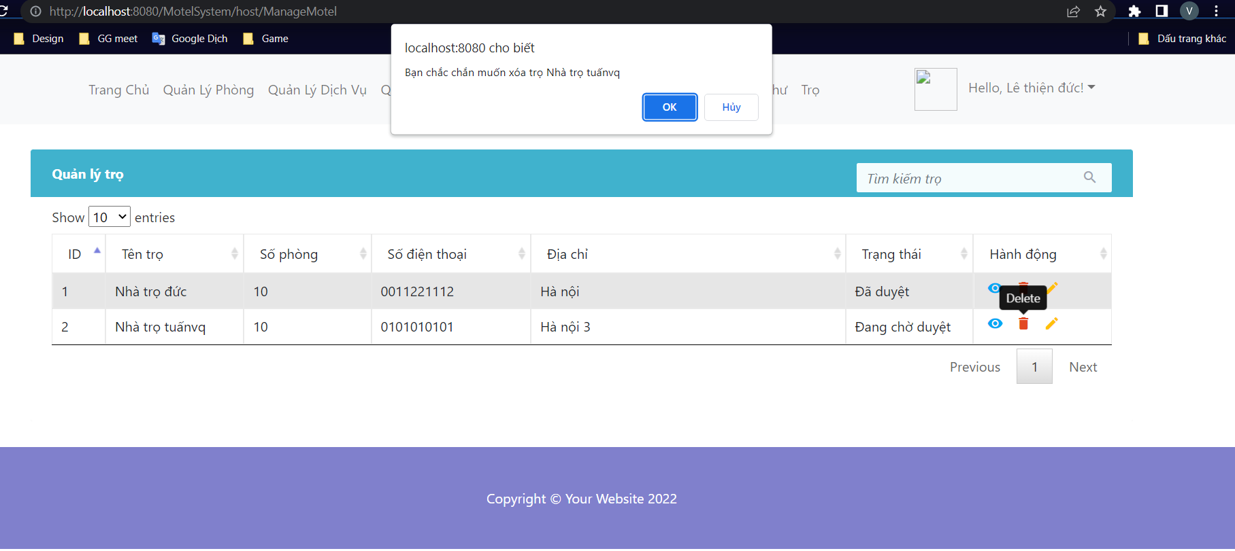
* **Function Details:** The motel owner clicks on delete motel and a question pops up, are you sure you want to delete it? If ok, the request will be deleted, otherwise the motel will not be deleted

### d. View detail information of motel

* **Function trigger:** The host click to eye icon to see more about one motel .
* **Function description:** Display all information of one motel that clicks .
* **Screen layout:**

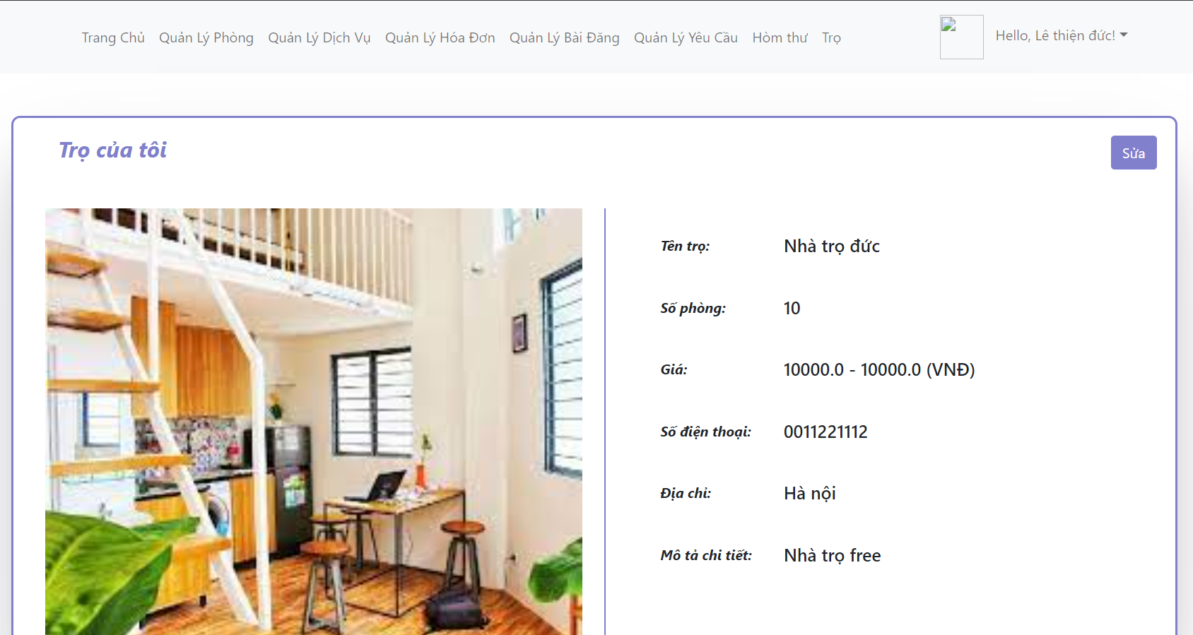

* **Function Details:** The motel owner want to see more information about one motel

### e. Search information of motel

* **Function trigger:** The host type keyword in the search box on the right corner of the motel view and click “Enter”.
* **Function description:** Search motel by keyword.
* **Screen layout:**

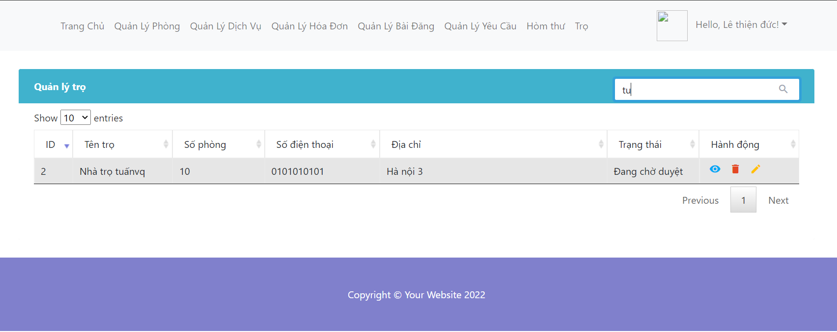

* **Function Details:** The want to search a motel then they can type the keyword in the search box on the right corner of the message view and click “Enter”.

### f. Sort by column

* **Function trigger:** The host clicks a triangle next to each column header.
* **Function description:** Sort motel by column
* **Screen layout:**

Before sort:

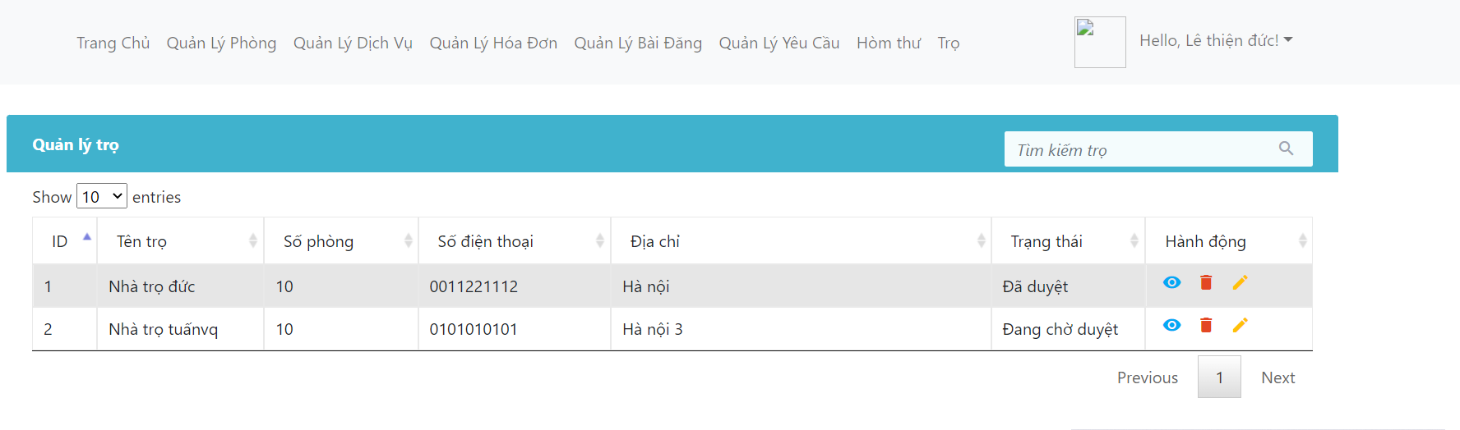

After sort:

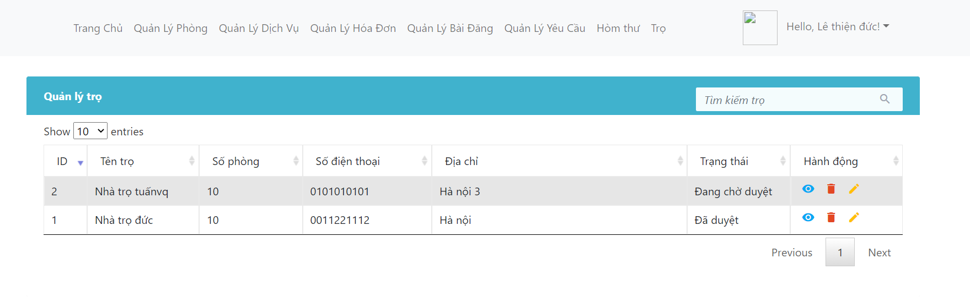

* **Function Details:** The host want to sort by each column and then click to triangle next to each column header.

### g. Add new motel

* **Function trigger:** The host click to “Thêm trọ” to add new motel .
* **Function description:** Register new motel action in system .
* **Screen layout:**

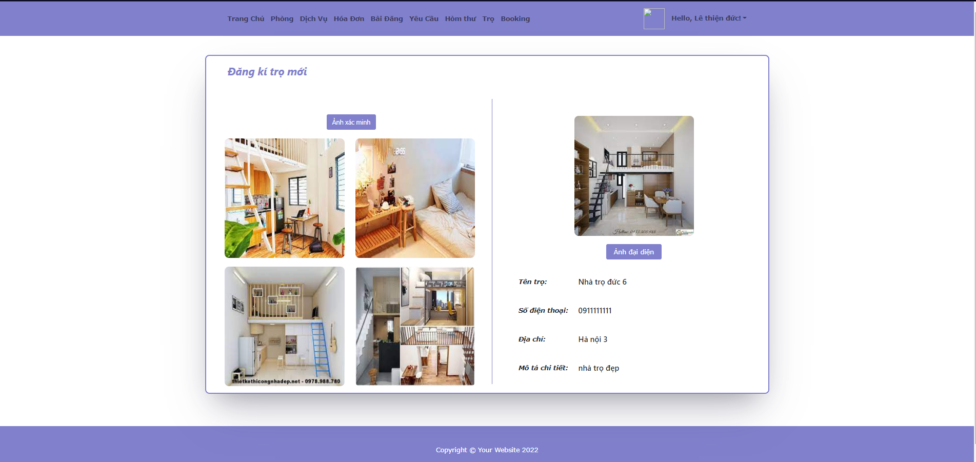

* **Function Details:** The host want to add new motel in sytem then they can click to “Thêm trọ” and fill enough information. Then admin have notify about add new motel of the host and admin will review and approve it.

## 17. Manage Message By Host and Customer

### a. View all message by host

* **Function trigger:** The host Click to “Hòm thư” and then can view all received and sent messages.
* **Function description:** View received messages from other hosts or customer then reply this message. Or send message for other hosts or customer.
* **Screen layout:**

View all received messages:

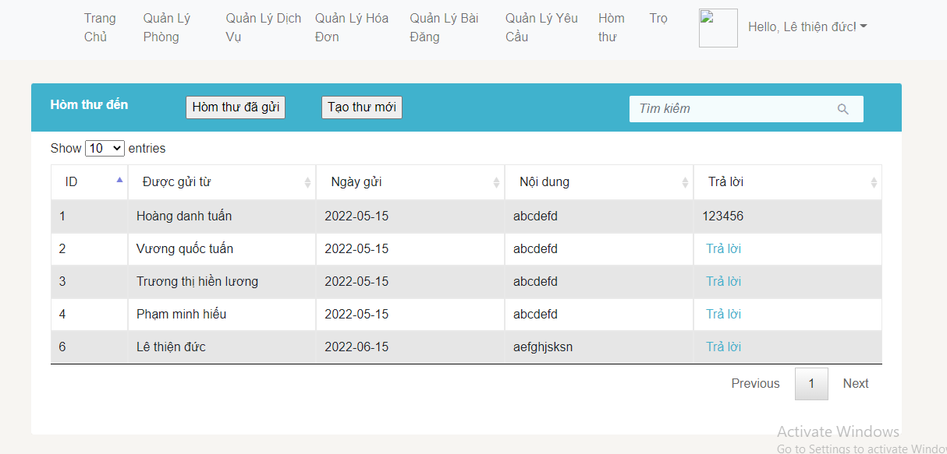

View all sent messages:

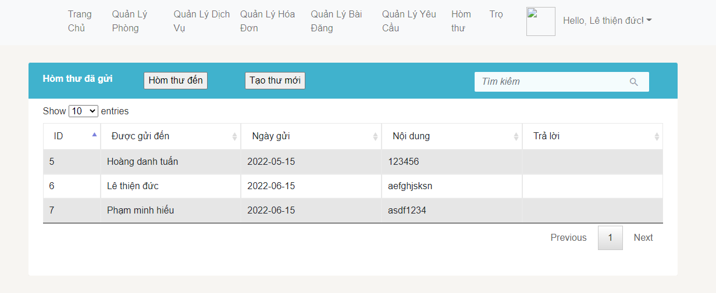

* **Function Details:** The hosts can view all received messages and can click to “Trả lời” to rep this message or click to button “Hòm thư đã gửi” to view all sent messages.

### b. Send message by host

* **Function trigger:** The host click to “Tạo thư mới” to send message to other user.
* **Function description:** Send message to other user in system.
* **Screen layout:**

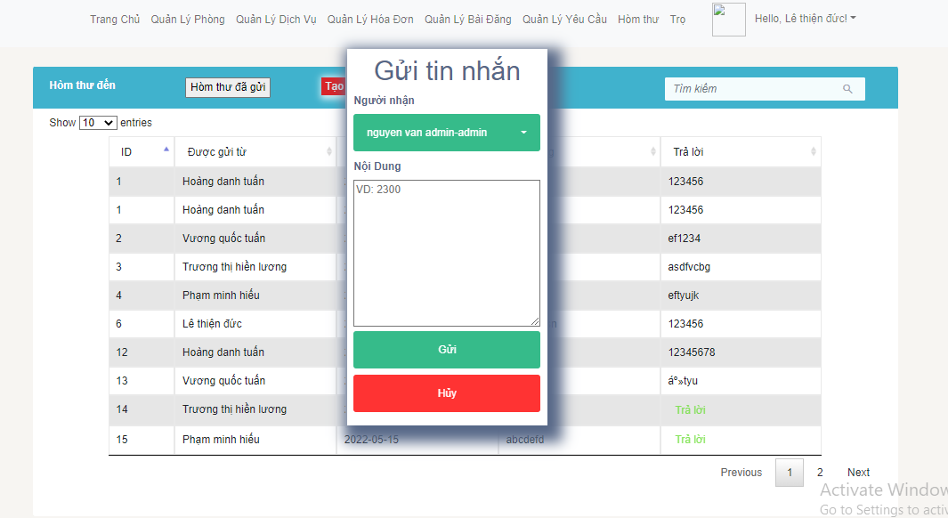

* **Function Details:** The host click to “Tạo thư mới” and then system wil display a screen for host choose receiver and type the content to send message to other user.

### c. Rep message by host

* **Function trigger:** The host click to “Trả lời” in any row on table of message received.
* **Function description:** Reply messages received from other user.
* **Screen layout:**

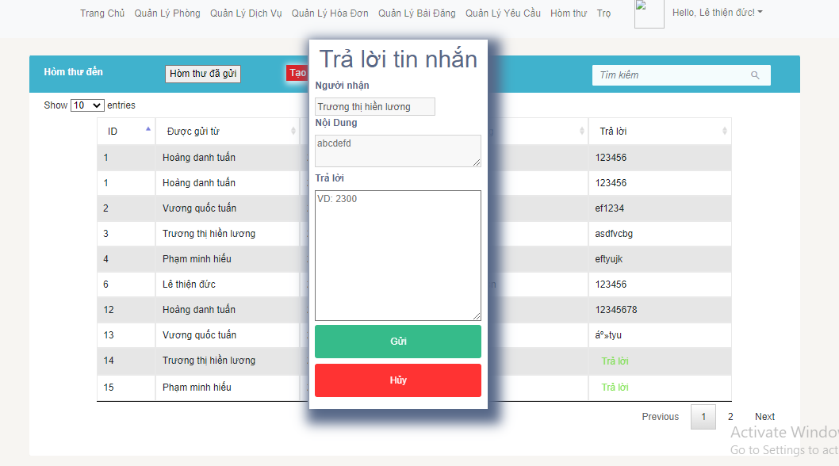

* **Function Details:** The host click to “Trả lời” to reply this message and then system will display screen for host type the text and click to “Gửi” to send message.

### d. Search message by host

* **Function trigger:** The host type keyword in the search box on the right corner of the message view and click “Enter”.
* **Function description:** Search message by keyword.
* **Screen layout:**

Before search:



After search:

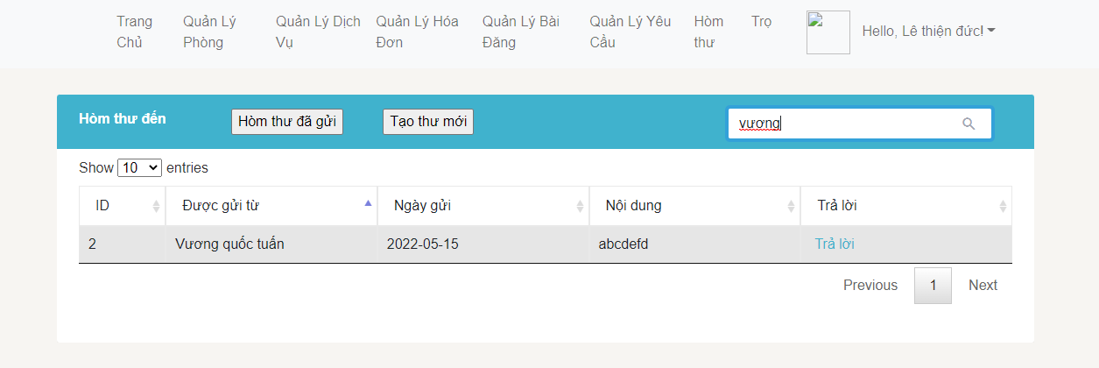

* **Function Details:** The want to search message sent by someone then they can type keyword in the search box on the right corner of the message view and click “Enter”.

### e. Sort message by host

* **Function trigger:** The host click to triangle next to each column header.
* **Function description:** Sort message by column
* **Screen layout:**

Before sort:



After sort:

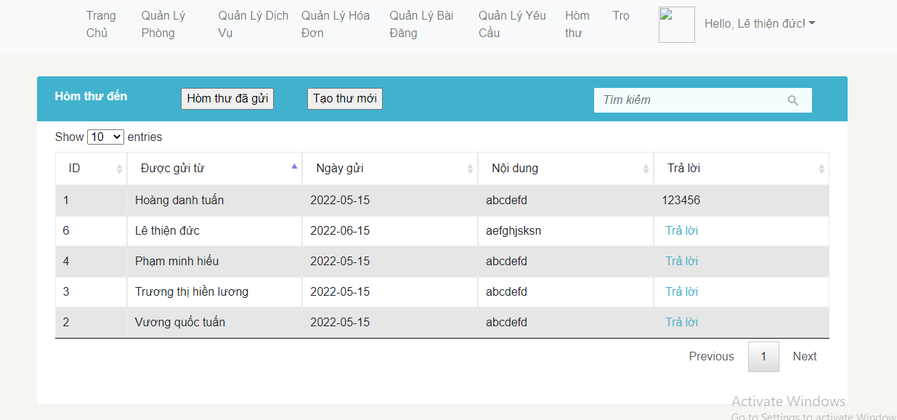

* **Function Details:** The host want to sort by each column and then click to triangle next to each column header.

## 18. Manage Request By Customer

### a. View all request by customer

* **Function trigger:** The customer Click to “Request” and then can view all request of room.
* **Function description:** View all request of room by account customer.
* **Screen layout:**

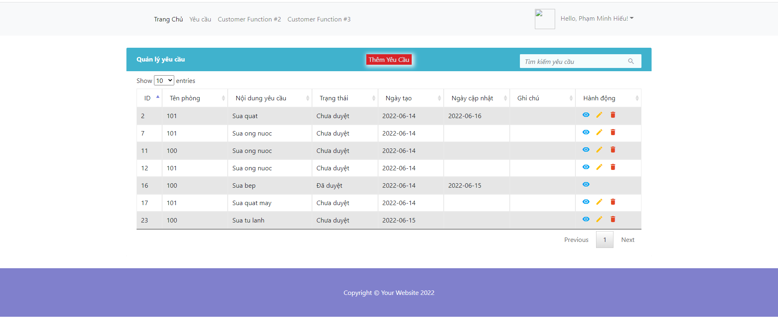

* **Function Details:** The customer can see all the requests of the rooms that the customer owns

### b. Add request by customer

* **Function trigger:** The customer click to “Add new request” to send host of motel
* **Function description:** Add new request by customer
* **Screen layout:**

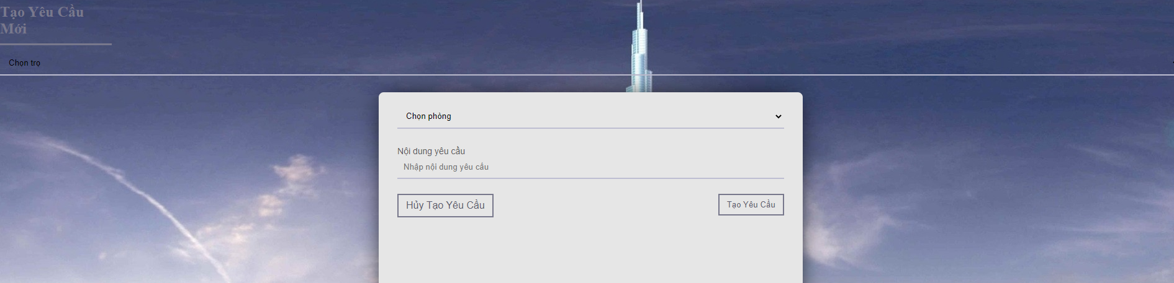

* **Function Details:** The customer click to “Add new request” and then the system will display a screen for the customer to add a new request.

### c. Update request by customer

* **Function trigger:** The customer click to “Update request” in any row on table of request.
* **Function description:** Update request of room.
* **Screen layout:** 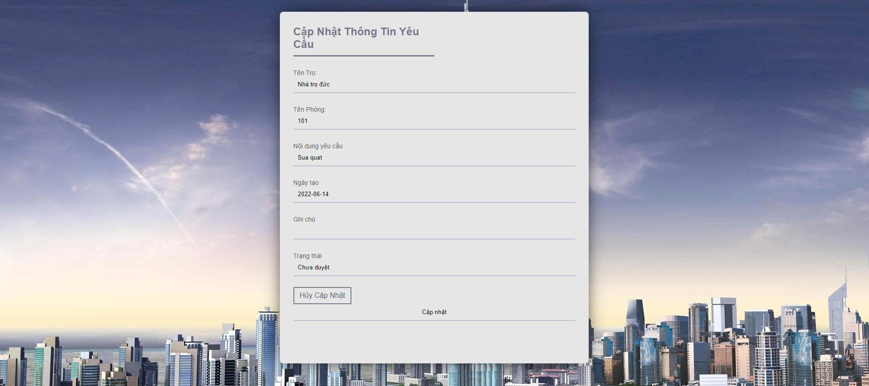
* **Function Details:** The customer click to “Update request” to the system will display a page where you can update the necessary requirements and press "update request" to be able to update successfully

### d. Delete request by customer

* **Function trigger:** The customer click “Delete request” in any row on table of request.
* **Function description:** Delete request
* **Screen layout:**

When click ‘delete’: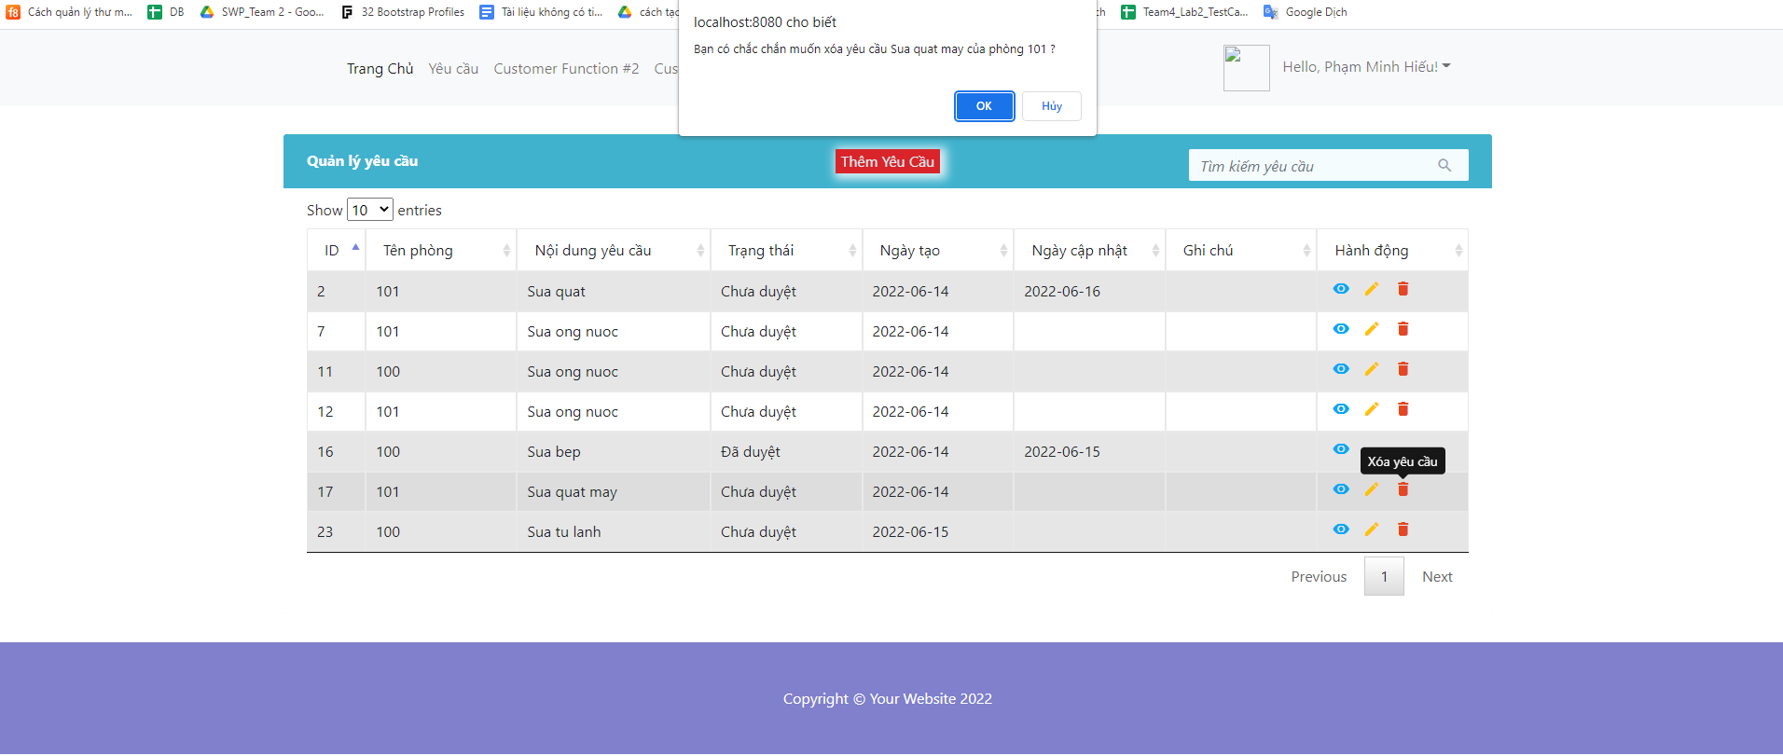

After delete: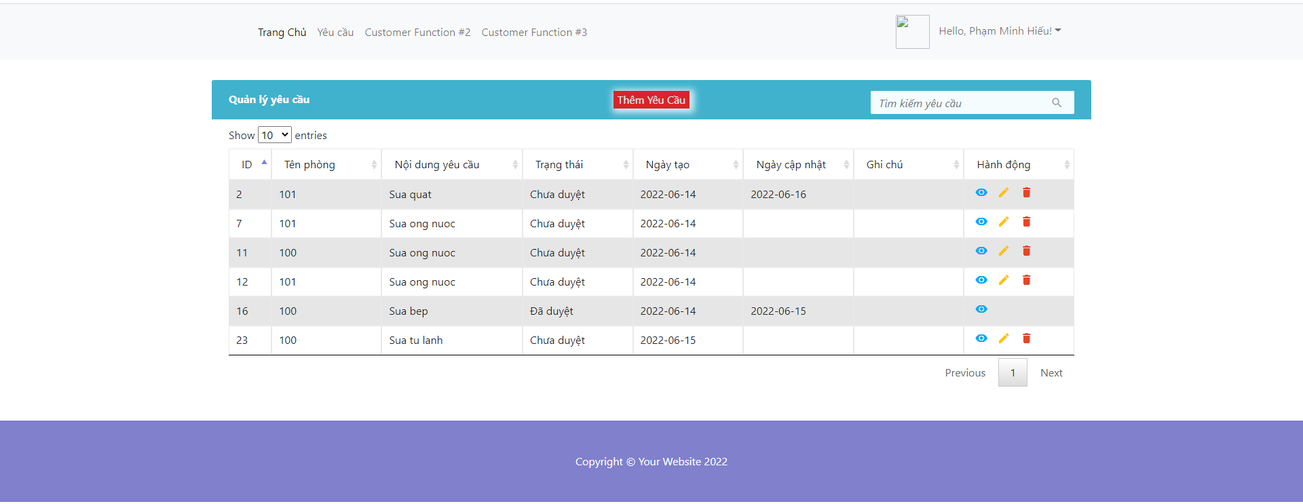

* **Function Details:** The customer click “Delete request”, the system will ask again "Are you sure you want to delete the request?" If so, the system will delete the request for you. Otherwise nothing will happen

### e. Search request by customer

* **Function trigger:** Enter what customers want to search for in the search bar
* **Function description:** Search request customer need.
* **Screen layout:**

Before search:

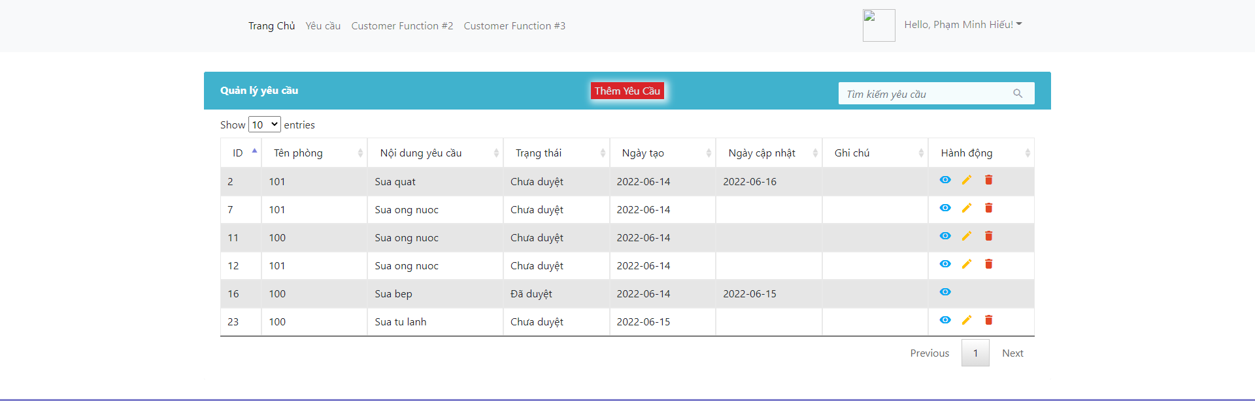

After search:

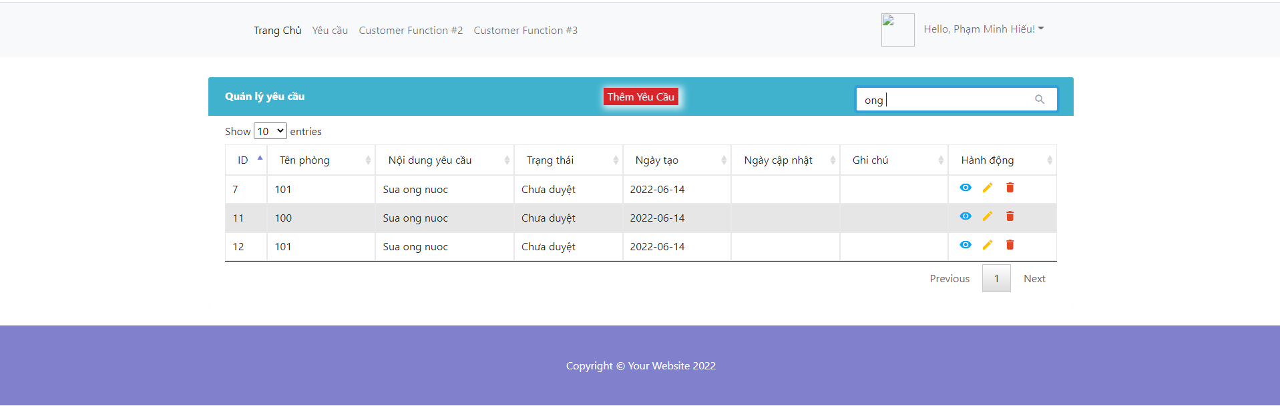

* **Function Details:** Enter what the customer wants to search for in the search bar. The system will return a list of things related to what you want to search

### f. Sort request by customer

* **Function trigger:** The host click to triangle next to each column header.
* **Function description:** Show number of sort request
* **Screen layout:**

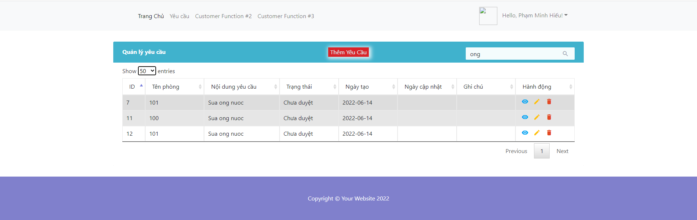

* **Function Details:** Show the same number of rows as in the sort bar

### g. View detail request by customer

* **Function trigger:** Customer click “View detail” in any row on table of request.
* **Function description:** View detail request
* **Screen layout:**

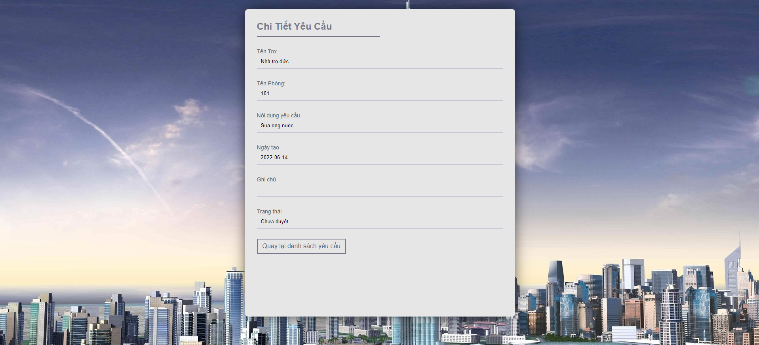

* **Function Details:** The customer click “View Detail”, the system will display detailed requirements for customers to see more carefully

## 19. Manager Booking By Host

### b. Add new account for room

* **Function trigger:** Host click the button “Add new account for room” in the list of Booking
* **Function description:** Add a new account to the hostel you want
* **Screen layout:**- After click button “Add new account for Room”

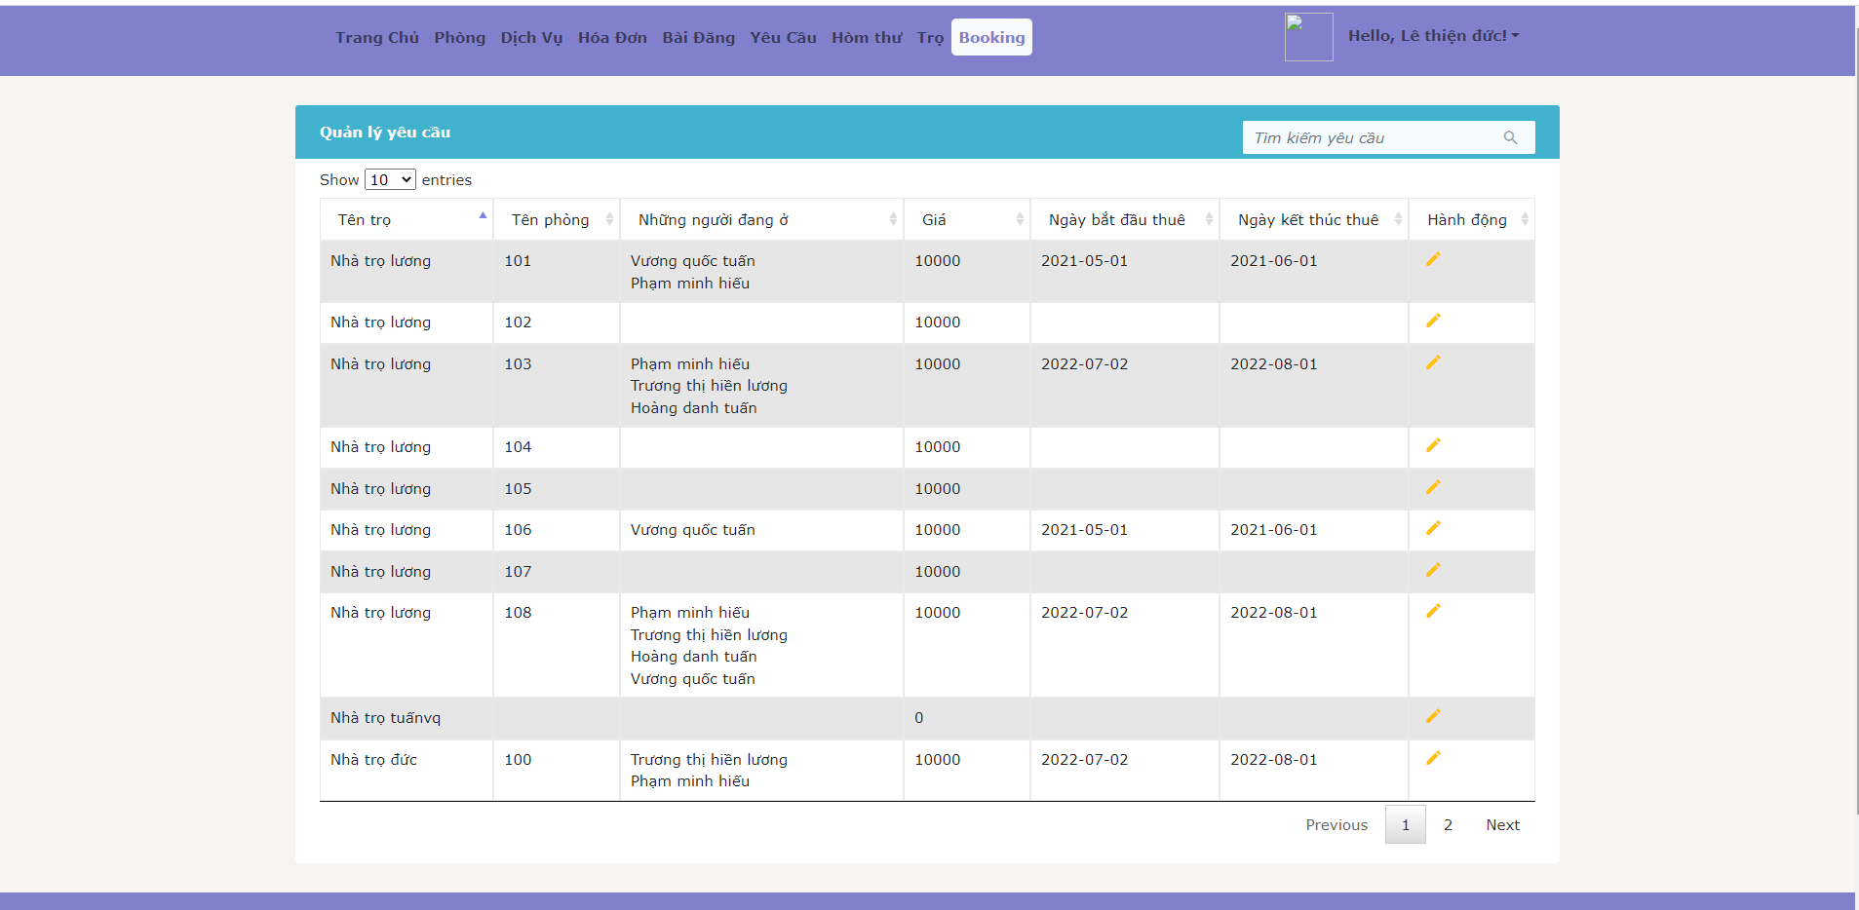 - After click “Add people for room”

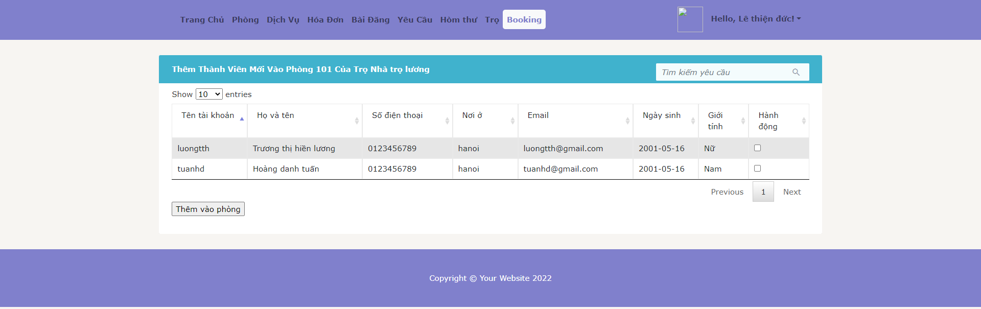 -After add successfully:



* **Function Details:** After the user presses the "Add people to new room" button, the screen will display a list of room information. Then the user clicks on the "Add people to the room" button, the screen will display all the user lists in the system. The innkeeper can choose one or more guests to enter his room. Then the innkeeper presses "Add to room" to complete the process of adding people to the room

## 20. Manage Bill By Customer

### a. View all bill by customer

* **Function trigger:** The customer Click to “Hóa đơn”
* **Function description:** View all bill payment or paid.
* **Screen layout:**

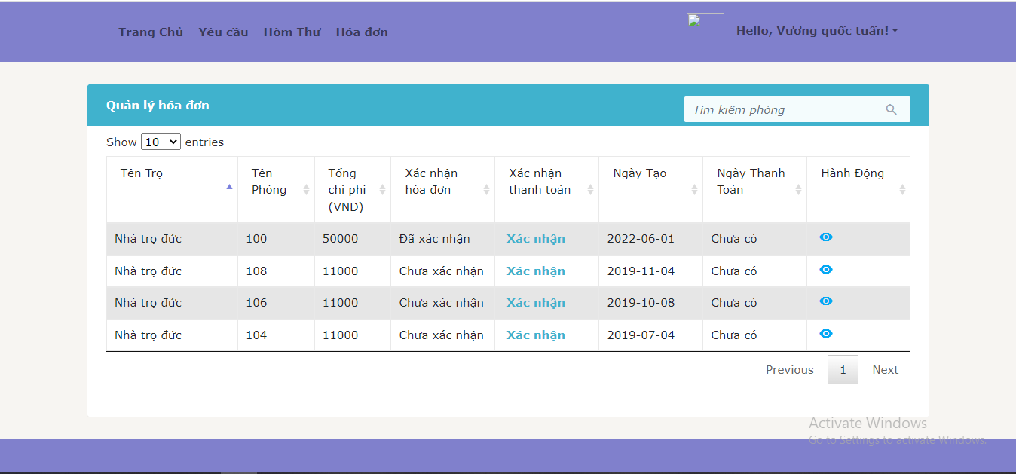

* **Function Details:** The customer can view all bill and can click to “Xác nhận” to confirm this bill is paid.

### b. View bill detail

* **Function trigger:** The host Click to “Hòm thư” and then can view all received and sent messages.
* **Function description:** View received messages from other hosts or customer then reply this message. Or send message for other hosts or customer.
* **Screen layout:**
* **Function Details:** The want to search bill then they can type keyword in the search box on the right corner of the bill view and click “Enter”.

### c. Confirm payment

* **Function trigger:** The customer Click to “Xác nhận” in column “Xác nhận thanh toán”.
* **Function description:** Confirm this bill is paid.
* **Screen layout:**

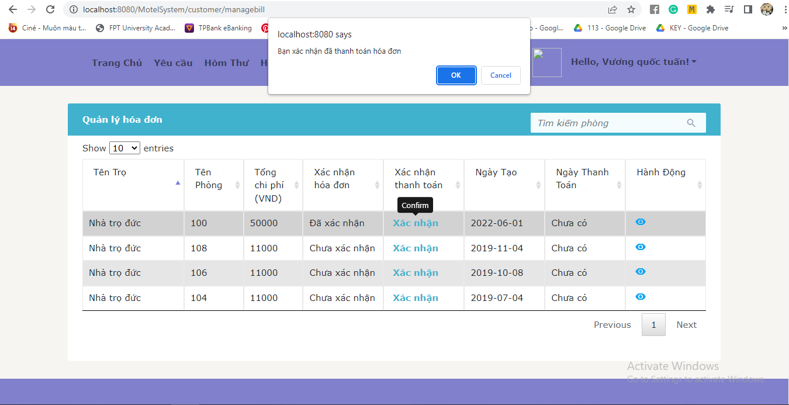

* **Function Details:** The customer click to “Xác nhận” and then click to “OK” to confirm this bill is paid.

### d. Search bill

* **Function trigger:** The customer type keyword in the search box on the right corner of the bill view and click “Enter”.
* **Function description:** Search bill by keyword.
* **Screen layout:**

Before search:



After search:

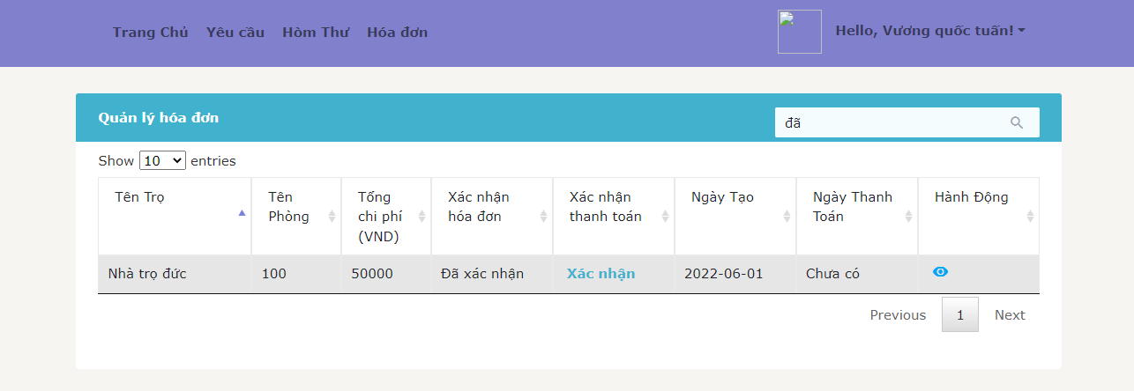

* **Function Details:** The want to search bill then they can type keyword in the search box on the right corner of the bill view and click “Enter”.

### e. Sort bill

* **Function trigger:** The customer click to triangle next to each column header.
* **Function description:** Sort bill by column.
* **Screen layout:**

Before sort:



After sort:

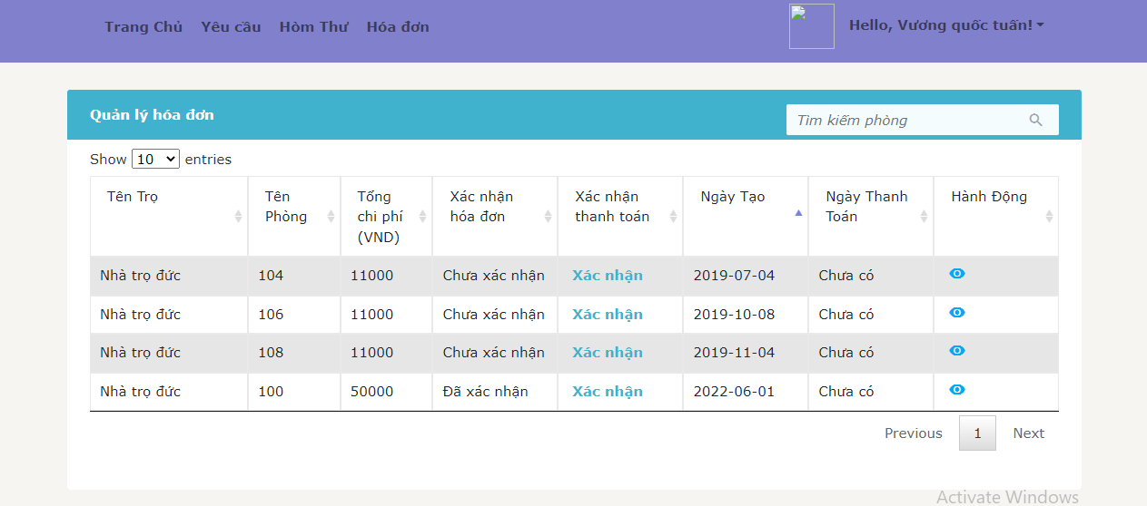

* **Function Details:** The customer want to sort by each column and then click to triangle next to each column header.

## 21. Register Motel

### a. Register Motel

* **Function trigger:** The customer Click to “Thêm trọ”
* **Function description:** The customer want to become a host and add new motel in system.
* **Screen layout:**

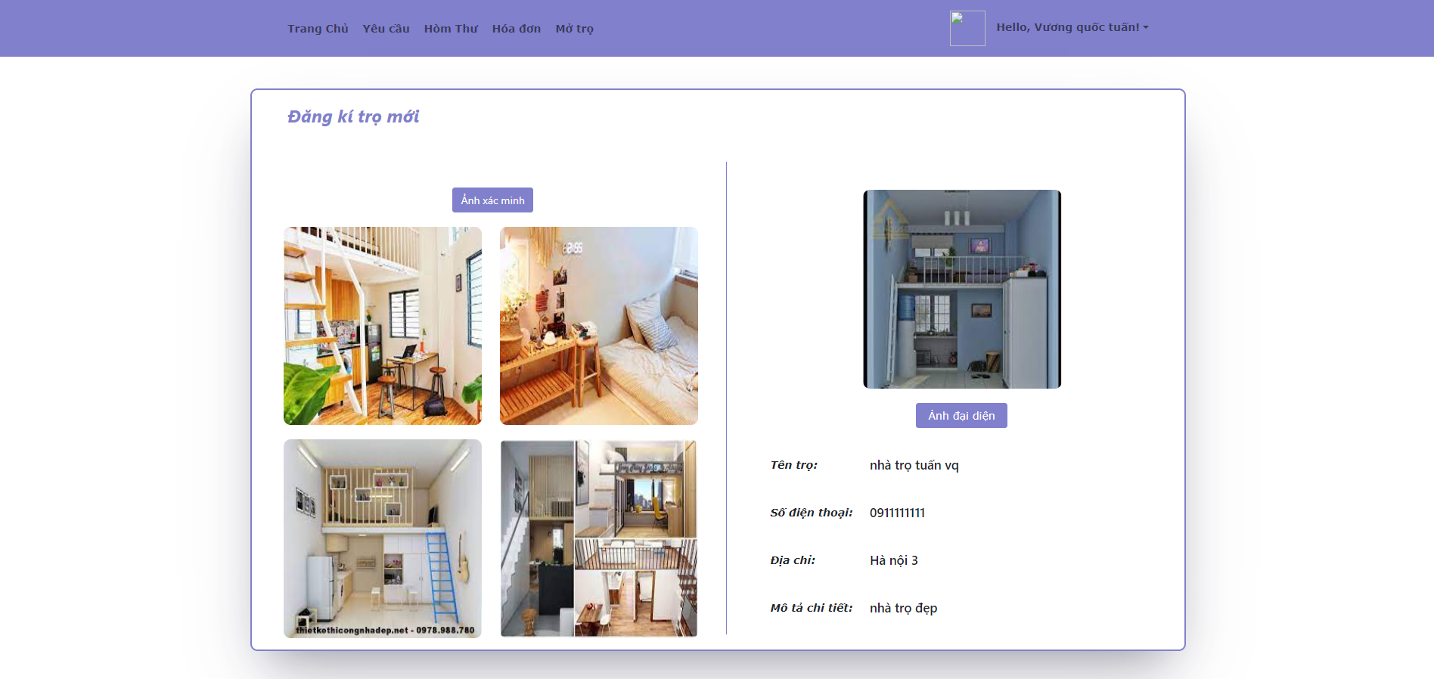

* **Function Details:** The customer want to become a host and add new motel in system. So that they can click to “Thêm trọ” and fill enough information and send to admin. Admin will review and approve about request become host and add new motel.